Sokoine University of Agriculture



PhD Thesis

Community Ecology of Rodents in a Natural and Agricultural Landscape- in Western Serengeti, Tanzania

Egidius James Rwebuga

May 2024
COMMUNITY ECOLOGY OF RODENTS IN A NATURAL AND AGRICULTURAL LANDSCAPE- IN WESTERN SERENGETI, TANZANIA

Thesis submitted to Sokoine University of Agriculture in Fulfilment of the
Requirements for the Degree of Doctor of Philosophy

Supervisors

Prof. Alfan A. Rija
Prof. Shombe N. Hassan
Prof. Loth S. Mulungu

Department of Wildlife Management
College Of Forestry, Wildlife and Tourism
Sokoine University of Agriculture, Morogoro, Tanzania

May, 2024

EXTENDED ABSTRACT

Rodents are beneficial ecologically as they act as food for other organisims including humans. However, about 17% of rodent species are problematic since they transmit zoonotic diseases, damage properties and depredate crops. Various strategies have been designed worldwide to control them but have proven futile due to limited knowledge on the animals’ biology, behaviour and ecology. This knowledge is essential for preparing integrated rodent conservation and management strategies. Also, no one single strategy can effectively be used to manage rodents in every part of the world, hence rodent ecological studies in as many local areas as possible are needed. Therefore, two ecological studies were carried out to generate information that would contribute to the formulation of effective strategies. The first study aimed to determine: i) spatio-temporal community structure (species composition, age and sex structure), ii) spatio-temporal population dynamics and breeding patterns and iii) influence of ecological factors (vegetation attributes, soil characteristics and seasonality) on abundance of a dominant rodent species M.natalensis. The second study aimed at investigating the dietary patterns of the dominant rodent species. These are the first detailed ecological studies in our study area.

The first study was conducted within Kijereshi Game Reserve and the surrounding Nyamikoma village in the western Serengeti using Capture-Mark-Recapture (CMR) technique from April 2020 to March 2022. Sherman live traps were used to trap rodents on a 3 consecutive night’s basis every month for twenty four months. Trapping was done in nine 70 x 70 m² permanent grids in the wooded grassland habitat within Kijereshi Game Reserve, and in fallow land and maize crop fields within Nyamikoma village land.

One year data collected from from 2020 April to March 2021 were used to investigate spatio-temporal community structure of rodents in the three habitats whereby 1,075 individuals were captured. They comprised eight 8 rodent species and one shrew species. Mastomys natalensis (76.6%) was the most whereas Acomys wilsoni (02%) occurred the least abundant species across habitats and the insectivorous animal was Crocidura cf. flavescens (11.1%). Species richness was highest in the wooded grassland and least in maize crop fields, probably due to mono-cultivation nature in the maize crop fields. Fallow land had a higher diversity (1.05) while maize fields had the lowest (0.35), suggesting presence of heterogeneity in fallow land habitats as compared to maize crop fields. A statistical difference in number of adults, subadults and juveniles was detected between habitats (F2, 102 = 3.09, P=0.05), and a marginally significant difference between seasons (F1, 102 = 3.743, p = 0.06). There were more Juveniles in the maize crop fields than in the wooded grassland habitat probably due to availability of food resources that favour their reproduction. On the other hand, there was a significant difference between numbers of females and males of M. natalensis captured across dry and wet seasons (F1, 64 = 8.311, p = 0.005) and the three habitats (F2, 64 = 6.9, p = 0.004). The study suggests that small scale comparisons of the community structures of small mammals between habitats can provide knowledge that is needed for conservation and control of small mammal species.

A two year period data on population dynamics and breeding patterns of M.natalensis revealed that, its abundance varied significantly across habitats ( Chi-squared = 8.922, df = 2, p-value = 0.012) and between seasons (W = 982.5, p-value<0.001). Females bred continuously throughout all seasons and there was no significant difference in the number of actively breeding females across habitats (Chi-squared = 3.52, df = 2, p-value = 0.172) and between seasons (W = 584, p-value =
0.472) probably due to presence of seeds/grains especially in maize crop fields throughout the year. However, in most cases breeding started to increase immediately after long rains in March/April except in the wooded grassland where there was a lag. Numerically, the M. natalensis abundance was higher in maize crop fields as compared to other habitats, but densities dropped similarly in all habitats during wet season. Nevertheless, the reasons for this is not yet clear as substantial food resources are available especially in the maize crop fields resulting from maize crops harvest of the second cropping season. Although, analysis of data on several selected ecological correlates, indicated that the latter have influence on the abundance of M.natalensis. For example, its abundance was significantly higher during the dry season and in farmlands than in wet season and protected areas (χ2= 79.393, df = 2, p < 0.001). Also, the abundance significantly associated positively with farmlands (p = 0.023) and sandy-clay-loam soils (p = 0.007). Hence, control of the animals might be effected between the months of November and January when densities are low and farmers should maximize maize production during this period which falls in their minor cropping. Also, soil type issue should be taken into consideration during farm site selection.

The second study was conducted in the same study site as the first one, to investigate on the dietary patterns of M.natelensis, whereby, kill traps (Victor kill trap (1.0 x 20.3 x 30.1 cm, Animal Trap Co., Lititz Pennal) baited with peanut butter mixed with maize bran/flour were used in three grids of 70 x 70 m². About 111 captured specimens were dissected, their stomachs removed and labelled, then preserved in containers (20 ml, glass bottle, HiSupplier_.com) containing 70% ethanol. The analysis of stomach contents was carried out by evenly spreading each stomach contents in a Petridish and categorised using a binocular dissecting microscope under 25 x and 50 x magnification, into various food categories. Overall, vegetative plant materials (41%) and
invertebrates (39.1%) dominated. During the wet season, invertebrates dominated in the wooded grassland, followed by fallow land and maize crop fields. On the other hand, seeds/grains were more eaten in maize crop fields than in other habitat types. Also, in the dry season, vegetative plant materials dominated the animal’s diet in maize crop fields suggesting that this rodent is an opprtunistice feeder.

Keywords: rodent- ecology, Mastomys - natalensis, Kijereshi, Nyamikoma, western -Serengeti

IKISIRI KUU

Panya wana umuhimu kiikolojia, kwani huliwa na wanyama wengine akiwamo binadamu. Hata hivyo, takribani asilimia 17 miongoni mwao hudhuru binadamu kwa kusambaza maradhi, kuharibu mali na kula mazao. Aghalabu, mikakati ya kupunguza idadi yao imeshindwa kukikidhi matarajio duniani kote, kufuatia maarifa finyu juu ya biolojia, tabia and ikolojia ya panya, na pia kutokuwapo na uwezekano wa mkakati mmoja kukidhi matarajio ya kila mahali. Hivyo, elimu ya ikolojia ya panya katika maeneo mengi iwezekanavyo ni muhimu ili kuandaa mikakati madhubuti ya uhifadhi na udhibiti wa idadi ya panya katika maeneo mbali mbali. Hivyo, tafiti mbili juu ya ikolojia ya panya zimefanyika ili kupata taarifa muhimu zitakazo saidia uandaaji wa mikakati hiyo. Tafiti ya kwanza inalenga kubaini i) mpangilio wa spishi za panya, umri na jinsia zao katika mazingira na majira tofauti, ii) mabadiliko katika idadi na mfumo wa uzalianaji wa panya katika mazingira na majira tofauti na iii) athari za kimazingira katika idadi ya panya. Tafiti ya pili ilihusu ung’amuzi wa mfumo wa ulaji na aina za vyakula vya panya katika mazingira na majira tofauti. Hizi ni tafiti za kwanza za kina kuwahi kufanyika katika eneo letu la utafiti.

Tafiti ya kwanza ilifanyika ndani ya Pori la Akiba Kijereshi na eneo la kijiji cha Nyamikoma jirani na Pori hilo lililoko Magharibi mwa Serengeti, kwa kutumia mbinu ya CMR (kamata, weka alama, achia) kuanzia mwezi April 2020 hadi March 2022. Mitego aina ya Sherman ilitumika kwa muda siku 3 kila mwezi kwa kipindi cha miezi 24. Utegaji panya ulifanyika katika maeneo tisa yenye upana wa mita 70 kwa 70 kila moja, katika nyika zenye miti ndani ya Pori la Kijereshi na kando kando ya mashamba na ndani ya mashamba ya mahindi kijijini Nyamikoma.

Taarifa za mwaka mmoja kutoka Aprili 2020 hadi March 2021 zilitumika kuchunguza mpangilio wa spishi za panya kwenye maeneo husika na kwa majira tofauti (masika na kiangazi) ambapo viumbe wapatao 1,075 wakijumuisha panya na kiruka njia (shrew) walikamatwa. Kati ya
viumbe hao, spishi za panya ni nane na kiruka njia ni moja. Spishi aina ya Mastomys natalensis (76.6%) ilikuwa na viumbe wengi zaidi wakati aina ya Acomys wilsoni (02%) wakiwa wachache zaidi. Idadi kubwa ya spishi ilipatikana katika nyika zenye miti ambapo mashambani kulikuwa na spishi chache zaidi, labda kwasababu kuna aina chache za mimea yaani mahindi katika kipindi kirefu cha mwaka. Pia kando ya mashamba kulikuwa na anuai ya panya kubwa zaidi (1.05) ambapo ilikuwa ndogo zaidi mashambani (0.35). Aidha, kitakwimu, idadi ya panya wenye umri mkubwa, umri wa kati na wachanga ilitofautiana katika maeneo ya utafiti (F2, 102 = 3.09, P=0.05) lakini tofauti ikiwa ndogo kati ya masika na kiangazi (F1, 102 = 3.743, p = 0.06). Panya wachanga walikuwa wengi zaidi mashambani kuliko kwenye nyika zenye miti pengine kwasababu ya upatikanaji wa chakula ambao huchochea kuzaliwa kwao. Aidha, kitakwimu, idadi ya majike na madume ya spishi ya M.natalensis ilitofautiana sana majira ya masika na kiangazi (F1, 64 = 8.311, p = 0.005) na pia katika mazingira walimokamatwa (F2, 64 = 6.9, p = 0.004). Kwamjibu wa utafiti huu mlinganisho wa ikolojia ya panya katika mazingira madogo madogo ya panya waweza kutupatia maarifa yanayotakiwa katika kuhifadhi na kuthibiti idadi ya panya.

Taarifa za miaka miwili katika muenendo wa idadi na uzalianaji wa M.natalensis zimeonesha kuwa idadi yao inatofautiana katika mazingira tofauti wanamopatikana ( Chi-squared = 8.922, df = 2, p-value = 0.012) na pia katika majira ya masika na kiangazi (W = 982.5, p-value<0.001). Majike yalionekana kuzaliana kipindi chote na pia hakukuwa na tofauti ya kitakwimu kati ya majike yanayozaliana na yasiyozaliana katika mazingira walikokamatwa (Chi-squared = 3.52, df = 2, p-value = 0.172) na pia majira ya masika na kiangazi (W = 584, p-value = 0.472), labda hii ni kwasababu ya upatikanaji wa mbegu hasa katika mashamba ya mahindi katika kipindi chote cha mwaka. Hata hivyo, wakati mwingi uzalianaji ulianza kushika kasi muda mfupi baada ya kuanza kwa mvua ndefu miezi ya Machi/Aprili isipokuwa katika nyika zenye miti ambako uzalianaji huo ulichelewa. M. natalensis walikuwa wengi zaidi
mashambani kulinganisha na mazingira mengine, lakini idadi hiyo ilipungua sawia katika mazingira yote wakati wa masika. Hata hivyo, hali hii haikujulikana chanzo chake ikizingatiwa kuwa kipindi hiki kina chakula cha kutosha hasa mashambani ambapo kuna mahindi ya musimu wa pili. Ingawaje, mchakato wa taarifa za kimazingira umeonesha kuwa mazigira yana athari katika idadi ya panya, mfano idadi ya panya ilikuwa juu zaidi kitakwimu wakati wa kiangazi na mashambani kuliko wakati wa masika na kwenye nyika zenye miti (χ2= 79.393, df = 2, p < 0.001). Pia idadi ya M.natalensis imeonekaa kuwa na mshikamano chanya mashambani (p = 0.023) na udongo wenye asili ya kichanga-mfinyanzi-tifutifu (p = 0.007). Hivyo, udhibiti wa panya ufanywe kati ya Novemba na January wakati idadi ya panya ikiwa ndogo na wakulima wawekeze zaidi kipindi hicho ambacho ni msimu wa pili wa kilimo, ili wavune mahindi mengi. Pia, nivyema uchaguzi wa maeneo ya kilimo ukazingatia aina za udongo.

Tafiti ya pili ilifanyika katika maeneo sawa na ya kwanza ikiwa na lengo la kuchunguza mfumo na aina ya vyakula vya panya aina ya M.natalensis. Katika tafiti hii mitego ya kuua (Victor kill trap) yenye chambo cha mchanganyiko wa unga wa karanga na mahindi, ilitumika kukamata panya ikiwa imepangwa katika mistari saba ya mita 70 kwa 70 kila mtego ukiwa umbali wa mita 10. Panya wapatao 111 walikamatwa na kutolewa matumbo, kuyaweka alama na kisha kuyahifadhi katika vichupa vya plastiki vyenye kemikali ya kuzuia kuoza (70% ethanol). Kisha, matumbo hayo yalipasuliwa na vilivyomo kumwagwa katika kisahani cha mviringo (Petridish ) ambapo vilitengwa katika makundi tofauti ya aina za vyakula kwa kutumia hadubini katika vipimo vya ukuzaji vya 25 x and 50 x. Kwa ujumla vyakula vyenye asili ya sehemu za mimea (Vegetative plant materials) (41%) na wadudu (inverterates) 39.1% vilipatikana zaidi. Wakati wa masika chakula cha aina ya wadudu kililiwa zaidi katika nyika zenye miti huku kikiliwa kidogo zaidi mashamb ani. Aidha, mbegu zililiwa zaidi mashambani
ikilinganishwa na kwingine. Pia, wakati wa kiangazi sehemu za mimea zililiwa zaidi mashambani labda kwasababu M.natalensis ni panya alae chakula chochote kinachopatikana.

Maneno muhimu: ikolojia –ya- panya, Mastomys - natalensis, Kijereshi, Nyamikoma, Kaskazini- mwa -Serengeti

DECLARATION

I EGIDIUS JAMES RWEBUGA, do hereby declare to the senate of Sokoine University of Agriculture that this thesis is my own original work done with the period of registration and that it has neither been submitted nor concurrently submitted in any other institution.


_________________ ____________
Egidius James Rwebuga Date
(PhD candidate).

The above declaration is confirmed by:


_________________ ____________
Prof. Shombe.N. Hassan. Date
(Main supervisor- retired).

_________________ ____________
Prof. Alfan A. Rija Date
(Co-supervisor).

_________________ ____________
Prof. Loth. A. Mulungu Date
(Co-supervisor- Deceased).

LIST OF PUBLISHED PAPERS / MANUSCRIPTS

Manuscript I: MANUSCRIPT I: Spatio – temporal structure of rodent communities on some landscapes of Western Serengeti, Tanzania, was submitted to the to African Zoology, Manuscript ID TAFZ-2023-0083. Submitted on 05-Dec-2023.................................................. 20
Manuscript II: MANUSCRIPT II: Population dynamics and breeding patterns in Mastomy natalensis in Western Serengeti, Tanzania, was submitted to Mammalia, manuscript ID Mammalia.2023.0126. was submitted on 06- Oct-2023……................................................ 50
PAPER I: Ecological Correlates of Population Abundance of a Pest Small Mammal Species (Mastomys natalensis) Inhabiting a Protected Area-Farmland Landscape in Western Serengeti, Tanzania. This paper Published to the Tanzania Journal of Forestry and Nature Conservation and published, https://www.ajol.info/index.php/tjfnc/article/view/24335published Mar 13, 2023........................................ 82

PAPER II: Dietary patterns of a crop pest mammal species (Mastomys natalensis) inhabiting agro-field-protected area interface in Western Serengeti. Published to the journa of Sustainability and Biodiversity Conservation and published. DOI: https://doi.org/10.5281 /zenodo.8352346. Received: 26 June2023/ Revised: 18August 2023/ Accepted: 01September2023/ Published online: September 2023......................... 93

COPYRIGHT

No part of this thesis may be reproduced, stored in any retrieval system, or transmitted in any form or by any means, without prior written permission of the author or Sokoine University of Agriculture in that behalf.

ACKNOWLEDGEMENTS

First and foremost, I thank God for giving me life, ability and strength to keep going even in the hard periods when I felt like giving up. I would also like to thank The African Centre of Excellence for Innovative Rodent Pest Management and Biosensor Technology Development (ACE IRPM & BTD) and Sokoine University of Agriculture for approving ethical research permit to conduct this study. In particular, I would like to thank my supervisors; Prof. Shombe N. Hassan, Prof. Alfan A. Rija and the late Prof. Loth A. Mulungufor the mentorship and support they accorded me over the four and a half year period. Special thanks to Prof. Apia Massawe and Prof. Rhodes Makundi for making financial facilitation possible and also for your advice and reviews of my PhD proposal and manuscripts. Also, I should show my appreciation to Professor Abdul Katakweba and Christopher Sabuni for always being available when I wanted advice during my PhD proposal preparation and manuscripts development. Thanks also go out to professor Fortunatus Makonda for assisting with vegetation identification in the fields, and Mr. Khalidi Kibwana for assisting during data collection in the field.

I also wish to thank my dear wife, children and other family members and friends for giving me moral support during the entire period of the study.

May God bless you all!

DEDICATION

I sincerely dedicate this work to my family members for your endless prayers and for enduring the lonely days and adversities when I was away for my studies.

TABLE OF CONTENTS

EXTENDED ABSTRACT ii
IKISIRI KUU vi
DECLARATION x
LIST OF PUBLISHED PAPERS / MANUSCRIPTS xii
COPYRIGHT xiv
ACKNOWLEDGEMENTS xv
DEDICATION xvi
TABLE OF CONTENTS xvii
LIST OF TABLES xix
LIST OF FIGURES xx
LIST OF ABBREVIATIONS, ACCRONYMS AND SYMBOLS xxii

CHAPTER ONE 1
1.0 GENERAL INTRODUCTION 1
1.1 Rodent Communities 1
1.2 Spatio-Temporal species composition, Age Structure and Sex Ratio 2
1.3 Rodent Population Ecological characteristics Over Time and Space 3
1.4 Influence of Ecological Factors on Abundance of Rodents 3
1.5 Food Categories of Rodents between different Seasons and habitats 4
1.6 Problem Statement and Justification 5
1.7 Objectives 8
1.7.1 General objective 8
1.7.2 Specific objectives 8
1.7.3 Hypotheses 9
1.7.4 Limitations of the study 9
REFERENCES 11

CHAPTER TWO 20
PAPER I 20
Spatio – temporal structure of rodent communities on some landscapes of Western Serengeti, Tanzania 20
AUTHOR'S INSTITUTIONAL AFFILIATIONS 20
ABSTRACT…………. 20
1.0 Introduction 21
2.0 Materials and Methods 24
2.1 Description of the Study Area and Sites 24
2.2 Sampling Design and Trapping of Rodents 26
2.3 Data analyses 27
2.3.1 Species composition, richness and diversity 27
2.3.2 Age structure and sex ratio 28
3.0 Results……….. 29
3.1 Species Composition, Richness and Diversity 29
3.2 Age Structure 33
3.3 Sex Ratio 35
4.0 Discussion 36
4.1 Species Composition, Richness and Diversity 36
4.2 Age Structure of the Dominant Species 38
4.3 Sex Ratio of the Dominant Species 39
5.0 Conclusion 40
References……….. 42

CHAPTER THREE 50
PAPER II………. 50
Population dynamics and breeding patterns in Mastomy natalensis in Western Serengeti, Tanzania 50
Abstract……… 50
1.0 Introduction 51
2.0 Materials and Methods 55
2.1 Description of Study Area 55
2.2 Sampling Design and Trapping of Rodents 57

2.2 Data Processing and Analysis 59
2.2.1 Population dynamics and breeding patterns 59
3.0 Results……. 60
3.1 Trend of abundance of M. natalensis across habitats and seasons 60
3.2 Effects of habitat types and trapping months on abundance of M. natalensis 61
3.3 Breeding patterns, relationship between rainfall and breeding patterns and the effect of habitat types and rainfall on the number of breeding females 64
3.4 Trend of total females across habitats and seasons 67
4.0 Discussion 68
5.0 Conclusions 72
Acknowledgments: 73
Reference 74

CHAPTER FOUR 82
PAPER III……. 82

CHAPTER FIVE 93
PAPER IV……. 93

CHAPTER SIX 114
6.0 GENERAL DISCUSSION, CONCLUSIONS AND RECOMMENDATIONS 114
6.1 General Discussion 114
6.2 General Conclusions 126
6.3 General Recommendations 128
REFERENCES 132

LIST OF TABLES

CHAPTER TWO
Table 1. List of small mammal species captured in the WG Game Reserve, and Fallow and Maize habitat types within the Kijereshi- Nyamikoma village agro-ecosystem in the Western Serengeti between April 2020 and March 2021. 30

CHAPTER THREE 50
Table 1: Effect of habitats and trapping months on abundance of M. natalensis basing on the density (MNA/ha) as revealed in the GLM model 62
Table 2: Generalized linear model results of the effect of habitats, trapping months and rainfall on the number of breeding females of M. natalensis 65

LIST OF FIGURES

FIGURE IN CHAPTER ONE
Figure 1: Conceptual framework showing drivers of rodent population outbreaks, their effects and the mitigation measures proposed in the current study 10

FIGURES IN CHAPTER TWO
Figure 1: Location of Kijereshi Game Reserve and Nyamikoma village 25
Figure 2. Species accumulation curve in all three habitat types across the twelve-month trapping period expressed in terms of cumulative number of species per number of individuals of rodents trapped in a given habitat type: WG = wooded grassland, Fallow =fallow land, Maize = maize crop fields. 31
Figure 3: Mean (± SE) monthly species richness in the three habitats for the twelve-month period. Key: SE = Standard Error. WG = wooded grassland, Fallow = fallow land, Maize = maize crop fields. 32
Figure 4. Mean (± SE) seasonal Shannon-Wiener index of diversity in the three habitat types. Key: SE = Standard Error, WG = Wooded grassland, Fallow = Fallow land, Maize = Maize crop fields, dry = Dry season and wet = Wet season. 33
Figure 5. Distribution of different age groups of individuals of M. natalensis in different habitats and months. Key: WG = wooded grassland, Fallow = fallow land, Maize = maize crop fields 34

Figure 6: Mean (± SE) monthly observed and expected proportion of female M.natalensis in different habitats. Key: SE = standard error, WG = wooded grassland, Fallow = fallow land, Maize = maize crop fields, Expected = an expected proportion when there is skewness 36

FIGURES IN CHAPTER THREE
Figure 1: Location of study sites within Kijereshi Game Reserve and Nyamikoma village……………..……....……55
Figure 2: Density of Mastomys natalensis in different months and habitat types in relation to rainfall patterns. 61
Figure 3: Upper plot (a) shows predicted values of M.natalensis densities (MNA/h) from January (1) to December (12). The lower plot (b) indicates predicted M.natalensis densities in each of the three habitat types (Fallow, Maize and WG). In all figures predicted MNA/h are for all months, both dry and wet seasons, for pooled data for January to December for all trapping years. 63
Figure 4: Predicted numbers of active breeding females in the three habitat types (Fallow, Maize and WG) for all months ..66
Figure 5: Fluctuations in number of breeding (active) and non- breeding (non-active) female Mastomys natalensis in different months, habitat types in relation to rainfall patterns 67
Figure 6: Fluctuation in abundance of female Mastomys natalensis in different habitat types and trapping months 68

LIST OF ABBREVIATIONS, ACCRONYMS AND SYMBOLS
% | Percent
6-MBOA | 6-Methoxy-2-benzoxazolinone
ACE IRPM & BTD | The African Centre of Excellence for Innovative Rodent Pest Management and Biosensor technology Development
AICc | the Akaike Information Criterion corrected for small sample size (AICc)
ANOVA | Analysis of Variance
CMR | Capture Mark Release
Df | Degrees of Freedom
Fallow | Fallow land
GLM | Generalized Linear Model
Ha | Hectare
Maize | Maize crop fields
MNA | the Minimum Number of Animals Known Alive in an area at a particular time.
P | Probability
PAST | Paleontological Statistics
SENAPA | Serengeti National Park
SUA | Sokoine University of Agriculture
Tukey | post hoc (HSD)
USA | United States of America
WG | Wooded Grassland
χ2 | Chi square

CHAPTER ONE

1.0 GENERAL INTRODUCTION

1.1 Rodent Communities
A community is a group of co-existing populations, whereas community ecology is the study of their interactions (Begon & Townsend, 1990). Rodents, which also exist in communities form the largest order of Mammalia, encompassing 2 277 of 5 422 living mammal species, that being equivalenet to approximately 42% of worldwide mammalian biodiversity (Kingdon et al., 2013). Of the 2 277 rodent species, 395 species (in 15 families and 98 genera) occur in Africa (Reeder, 2005). Rodents are indigenous to every continent except Antarctica and inhabit most small to large landbridge and oceanic islands, originally absent from Iceland, New Zealand and some oceanic and high Arctic islands(Kingdon, et al., 2013). Rodents play an important role in ecological processes given that they are rich in terms of number of species, widespread and sometimes abundant within particular habitats (Kingdon et al., 2013). The group is important in nutrient recycling, seed dispersing and habitat improvement through a process known as ‘ecological engineering’. The engineering process results into mixing of soils in different soil profiles with their faeces hence increased nutrients for vegetation (Fernández et al.,2014). However, some species of rodents are responsible for transmission of diseases to humans as they are reservoirs/hosts of zoonotic diseases (Gratz, 1997; Meerburg et al., 2009). Moreover, in Africa, 5 – 17 % of the rodent species are pests (Monadjem et al., 2015; Mulungu et al., 2017; Swanepoel et al., 2017) impacting negatively on crops in the field and stored products (Aplin et al., 2003) Therefore, studies with an intention to conserve and manage them are still needed. These studies include, understanding attributes such as community structure, population dynamics and breeding patterns, ecological factors governing their dynamics and dietary aspect of rodents of a specific ecosystem (Arellano et al., 2016) within local regions (Begon et al., 1990).

So far, little is known about what influences rodent communities in the natural ecosystem (Kijereshi Game Reserve) and the surrounding agro-ecosystems i.e. fallow land and maize crop field mosaics. Available information from the vicinity of Kijereshi Game Reserve in western Serengeti is by Senzota (1982) who studied only one rodent species, the grass rat (Arvicanthis niloticus), which was found to be abundant in woodland, scanty in open grassland and absent in the seasonally-flooded bottom part of the catena. However, crops in farmed lands surrounding Kijereshi Game Reserve attract certain rodent species in big numbers. Hence, a short-term study in the vicinity of the game reserve by Magige (2016), indicated highest diversity in cropped land ((Hꞌ = 0.84) and lowest in the Serengeti National Park (Hꞌ= 0.57). About eight rodend species: Aethomys kaiseri, Dendromus melatonis, Graphiurus murinus, Mastomys natalensis, Mus minotoides, Gerbilliscus robusta, Thallomys paedulcus and Zelotomys hildergardeae and one insectivourous species Crocidura sp were captured during the study.. Therefore, a long-term systematic study was needed to generate information on the essential population parameters of the rodent communities within the game Reserve and the surrounding agricultural land in Nyamikoma village land.

1.2 Spatio-Temporal species composition, Age Structure and Sex Ratio
Information on rodent community species composition is important for conservation and management of rodents. This is because each species of rodent occupies its own niche and at the same time conservation of a given species depends on the maintenance of its niche (Marino, 2003). Yihune and Bekele (2012) reported human interference and grazing pressure to have influence on the rodent community’s species composition. On the other hand, Makundi et al. (2009) reported co-existence of five rodent species in two different habitats and seasons due to their ability to partition their niches.
Moreover, the age structures and sex ratios of rodents are important ecological characteristics for conservation and management of rodents. For example, potential of reproducing new individuals decreases with increasing age (Leirs, 1994), which leads to skewed sex ratios and may bring about negative demographic consequences (Ancona et al., 2017). On the other hand, Mayamba et al. (2020) reported a parity male to female sex ratio of Mastomys natalensis in both wet and dry seasons. However, all cited works were conducted in different ecosystems, hence a study is needed to investigate these essential ecological characteristics in rodent species found in the natural-agro ecosystem where anthropogenic disturbance like crop cultivation is rampant, and the area floods twice a year (Personal Observation, 2018).

1.3 Rodent Population Ecological characteristics Over Time and Space
Communities of rodents are made of populations whose some of their essential ecological characteristics can be described by their population dynamics, breeding patterns, home ranges, survival rates and recruitments (Massawe et al., 2012). Different scholars studied these characteristics and came up with various findings. Va´zquez et al. (2000) found that densities of two rodent species, Peromyscus aztecus and Reithrodontomys fulvescens were influenced by different habitats and seasons. Massawe et al. (2012) reported that reproductive pattern of Grass rat, Arvicanthis neumanni is seasonal depending on rainfall patterns while Mlyashimbi et al. (2019) reported a continuous reproduction in M. natalensis in semi-arid areas due to availability of food and moisture. All these studies, however, were conducted at different places from Kijereshi Game reserve and its surroundings.

1.4 Influence of Ecological Factors on Abundance of Rodents
Rodent species abundance across landscapes are influenced by ecological factors such as soil types, nature and density of vegetation,
climatic conditions, diseases, predation and habitat exploitation by humans (Cramer and Willig, 2002). Absence of sufficient food and ground cover largely determine the number of individual rodents in a certain area due to less availability of food and increased predation risk (Hoffman & Zeller, 2005). Moreover, bushy vegetation provides safe sites for germination and growth of herbaceous vegetation, hence enhancing the diversity of rodent food resources which in turn attract more of these animals (Lentic & Dickman, 2005) . Therefore, this might lead to diversity of rodent species due to habitat variability caused by supply of different resources (Chidodo, 2019; Cramer & Willig, 2002). However, such studies were conducted in other areas different from land scape of Kijereshi Game Reserve and its surroundings. The game reserve is recovering from being human habitation and agricultural land hence ecological studies on rodents are needed to establish the status of their communities spatially and temporally in terms structure, species composition and diversity.

1.5 Food Categories of Rodents between different Seasons and habitats
According to Finke and Snyder (2008) resource-niche partitioning including food is vital to achieving greater biodiversity in a given habitat. Hence, knowing food categories of co-existing rodent species is important for establishing their diet niche breadths and overlaps which describe their food resource competition and /or partitioning status (Arellano et al., 2016). While Kitessa and Tsegaye (2015) reported that four rodent species, regardless of the proportional difference, consumed plant and animal matters Addisu and Bekele (2013) found out that 11 rodent species consumed plant matters and arthropods but in varied proportions. Mulungu et al. (2011) reported that dietary niche breadth of Girbilliscus vicinus was greater than that of Mastomys natalensis. These rodent species overlapped considerably in the food items consumed ranging from niche overlap of 0.77 – 0.89. Grains/seeds
featured high in the diet of M. natalensis while plant material occurrence was high in G. vicinus contributing to differences in diet partitioning, which may, in turn, facilitate their coexistence in fallow land. However, these studies were conducted in different areas from Kijereshi Game Reserve and its surroundings. Hence, a study is needed to investigate food categories of rodent communities found in this area.

1.6 Problem Statement and Justification
Rodents are well known worldwide for their economic and social ecological importance to man and other species. But, while they provide food to other species including man, thus important in the food web in many ecosystems (Fiedler, 1990), they are known to cause damages to food crops (Milan, 1990), and are host of vectors of diseases (Kilonzo et al., 1992). Also, some harbour disease pathogens like bacteria that cause zoonotic diseases such as leptospirosis caused by Leptospira bacterium, and toxoplasmosis caused by Toxoplasma gondii (Machang’u et al., 1997). Hence, rodents have been declared to be a cause of serious problems to human communities in Africa as a result of their involvement in the spread of diseases (Katakweba et al., 2012) and in the losses of crops through direct consumption (Mulungu et al., 2003; Bekele et al., 2003) and spoilage (Mdangi et al., 2013). Unsually large numbers of individuals of some rodent species, known as outbreaks, in a given locality are the ones thought to be the route cause of problems asscociated with these animals. For example, Taylor (1968) reported 20% damage to maize crop after the outbreak of rodents in Western Kenya. Earlier reports (Taylor, 1968) on economic losses due to rodents in Kenya indicated 20–30% damage to maize crops, and a 34–100% loss during rodent outbreaks. In Ethiopia, it has been estimated that rodents consume up to 26.4% of maize crop in most years (Bekele et al., 2003). In Northern Ethiopia, surveyed farmers estimated 9–44% pre-harvest yield losses in annual production of cereal crops due to rodent attacks (Meheretu et al., 2010), while Central
Ethiopia showed 26.4% loss of yield in maize (Bekele et al., 2003). In Tanzania, rodents are estimated to cause on average 15% yield loss (Makundi et al., 1991), which would mean the loss of around 382 673 tonnes per year of the actual yield (FAO statistics, 2014). According to Mulungu et al. (2005), there are about 31 rodent pest species involved in crop damage in Tanzania. However, the most important pest species are Mastomys natalensis, Arvicanthis spp. and Gerbilliscus spp. (Taylor and Green, 1976; Fiedler, 1994; Leirs et al.,1994), with M. natalensis being the most predominant rodent pest species (Leirs, 1995; Mulungu et al., 2011; Massawe et al., 2012). On the other hand, M. natalensis has been implicated with plague disease outbreaks in some parts of Tanzania such as Iringa, Singida, Kondoa, Rombo, Hai, Arumeru, Mbulu and Same Districts has been a threat to public health (Kilonzo et al.,2006).

There have been various claims as to what is responsible for rodent outbreaks in some localities. Fore xample, when investigating the effects of land preparation methods and cropping systems on population abundance of the Multimmate rat M. natalensis, Massawe et al. (2005) found higher rodent population peaks in dense vegetation cover practiced with slash and burn relative to tractor ploughed fields. Also, when investigating the influence of soil type on population abundance of rodents in crop fields with attention to M. natalensis, Massawe et al. (2008) found higher abundance of the species in loam-textured soils with a high percentage of sand, but lower abundance in the sandy–clay- soils. Moreover, a study on attributes for prediction of rodent burrows in the western Usambara Mountains exhibited comparatively more rodent burrows in hill- shades and slopes in higher elevations (Meliyo et al., 2014), whereas rainfall has been found to have an indirect effect on abundance of rodents due to increased availability of food during the rainy season (Mayamba et al., 2020, Jordão et al., 2010). Empirically, M. natalensis inhabits diverse habitats from natural
grassland, bushes, thickets to treed and disturbed areas including human settlements (Mulungu et al., 2011), but absent in rainforest (Happold, 2013), hence one of the commonest species in savannah habitats with densities reaching up to 1000 rats/ha in disturbed areas (Happold 2013).

It is also,well known that, many Africa’s protected areas in the tropics including Kijereshi Game Reserve, are progressively becoming vulnerable to human encroachment (Caro and Scholte, 2007). The encroachment is accompanied by anthropogenic land use and land cover changes, which have altered breeding and other population demographic parameters of small mammals including rodents (Cao et al., 2016). Alterations to natural habitats by land use can modify the constraints imposed by environmental structure and seasonality on the timing, synchrony and fecundity of breeding by rodents (Shilereyo et al., 2020) and hence, rendering a major challenge to their conservation and management. Therefore, precise information on essential rodent ecological characteristics and the way the animals are influenced by environmental factors is needed for effecting their conservation and management in many ecosystems (Cramer & Willig, 2002). However, little is known on these aspects from few studies that have been conducted in the vicinity of Kijereshi Game Reserve and its surroundings. Magige (2016) and Magige and Senzota (2006) reported on abundance, species composition and diversity in cropped and fallow areas and within the uncultivated Serengeti National Park. These studies, however, were short lived and could not explore other essential ecological parameters like population dynamics and breeding patterns. As a result, Kijereshi Game Reserve which is still recovering from human disturbance (TAWA, 2018), and other conservation stakeholders fall short of important information with which they can formulate well informed rodent conservation and management strategies. For example, studies have shown that different landscapes have different affinities to rodents (Mulungu et al., 2015). Nevertheless, Magige (2016)
recommended further studies in the area that would include several ecological characteristics like effects of seasonality and the influence of microhabitats on rodents. Hence, information from this study will fill some existing gaps, and form a basis for informed decision making with the aid of the generated information, for future long-term monitoring of rodent community in the area. Rodents remain key pests in cereal crop production (Yonas et al., 2010), despite continued efforts to control them, and the reason being partially attributed to a limited understanding of rodent pest ecology, behaviour and biology at small scale level (Tubin, 2004). The information generated from the current study is expected to impart the surrounding communities and elsewhere, with the knowledge on when rodent populations are low or high and hence plan their timely management at less costs.

1.7 Objectives

1.7.1 General objective
The general objective is to investigate rodent community ecological characteristics in maize crop fields, fallow lands and the woodland habitat within Kijereshi Game Reserve in the western Serengeti.

1.7.2 Specific objectives
i. To investigate spatio-temporal species composition, age structure and sex ratio of dominant rodent species
ii. To assess spatio-temporal rodent population characteristics (population dynamics and breeding patterns) of the dominant species
iii. To determine the influence of ecological factors (vegetation attributes, soil characteristics, and seasonality) on abundance of dominant rodent species.
iv. To establish rodent food categories between different seasons and habitats

1.7.3 Hypotheses
i. Habitat types and seasons have no influence on rodent species composition, age structure and sex ratio in the study area
ii. Habitat types and seasons have no influence on rodent population characteristics (ie population dynamics and reproduction)
iii. Habitat types and seasons have no influence on food categories of rodents in the study area
iv. Ecological factors and seasonality influence abundance of rodents across Kijereshi Game Reserve and neighbouring village landscapes

1.7.4 Limitations of the study
i. Limited financial resources for carrying out detailed vegetation characterization and molecular diet analysis

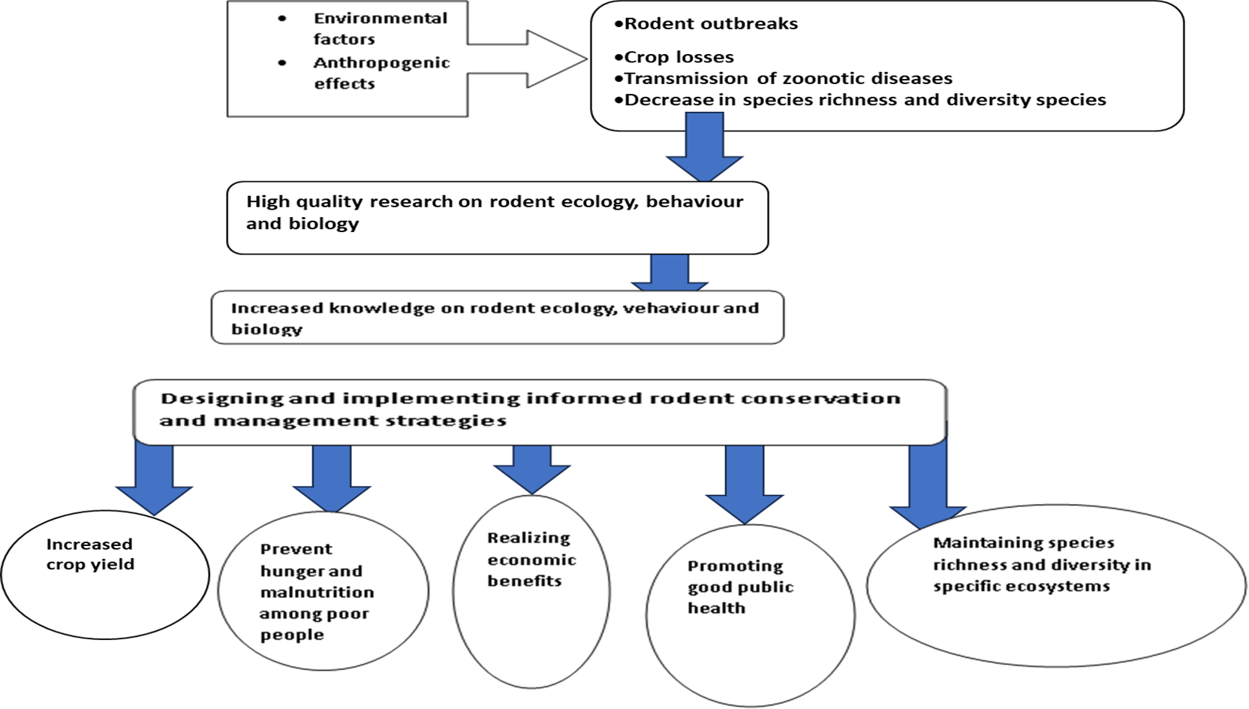

Figure 1: Conceptual framework showing drivers of rodent population outbreaks, their effects and the mitigation measures proposed in the current study

REFERENCES

Addisu, A. and Bekele, A. (2013). Habitat preferences, seasonal abundance and diets of rodents in Alage, Southern Ethiopia.
Ancona, S. F., Dénes, V., Krüger, O., Székely, T. and Beissinger, S. R. (2017). Estimating adult sex ratios in nature. Philosophical transactions of the royal society B. Biological Sciences, 372, 17 – 29.
Aplin, K. P., Brown, P. R., Jacob, J., Krebs, C. J. and Singleton, G. R. (2003). Field Methods for Rodent Studies in Asia and the Indo-Pacific. Australian Centre for International Agricultural Research.
Arellano, G., Uma~na, M. N., Mac, M. J., Loza. M. I., Fuentes, A., Cala, V. and Jørgensen, P. M. (2016). The role of niche overlap, environmental heterogeneity, landscape roughness and productivity in shaping species abundance distributions along the Amazon–Andes gradient. Journal of Global Ecology and Biogeography, 26(2), 191 – 202.
Begon, M., Harper, J. L. and Townsend, H. R. (1990). Ecology: Individuals, Populations and Communities. (2nd Ed.). Blackwell Scientiﬁc Publications.
Bekele, A., Leirs, H. and Verhagen, R. 2003. Composition of rodents and damage estimates on maize farms at Ziway, Ethiopia. In: Singleton, G. R., Hinds, L. A., Krebs, C. J. and Spratt, D. M. (eds), Rats, Mice and People: Rodent Biology and Management. Australian Centre for International Agricultural Research, Canberra, pp. 262–3.
Bernardo Va´zquezva´, L., Medelli´n, R. A., Medelli´n, M. and Cameron, G. N. (2000). population and community ecology of small rodents in montane forest of western mexico. In Journal of Mammalogy 81, Issue 1). https://academic.oup.com/jmammal/article/81/1/77/2372974

Borremans, B., Hughes, N. K., Reijniers, J., Sluydts, V., Katakweba, A. A. S., Mulungu, L. S., Sabuni, C. A., Makundi, R. H. and Leirs, H. (2014). Happily together forever: Temporal variation in spatial patterns and complete lack of territoriality in a promiscuous rodent. Population Ecology, 56(1), 109–118. https://doi.org/10.1007/s10144-013-0393-2
Chidodo, S. (2019). Rodent population in relation to habitat type and structure in North Uluguru Mountain, Morogoro-Tanzania. Dissertation for Award of Msc in Ecosystems Management Degree at Sokoine University of Agriculture.
Cramer, M.J. and Willig, M. R. (2002). Habitat heterogeneity, habitat associations and rodent species diversity in a Sand-Shinnery-Oak Landscape. Journal of Mammalia, 83, 743 – 753.
Deckers, J.A., Gulinck, H.T. & Leirs, H. (2014). Landform and surface attributes for prediction of rodent burrows in the Western Usambara Mountains, Tanzania. Tanzania Journal of Health Research 16 (3):1– 14. https://doi.org/10.4314/thrb.v16i3.5.
FAO Statistics 2014. Maize Production In Tanzania. http://www.FAO.org.
Fernández, J. A., Hafner, M. S., Hafner, D. J. and Cervantes, F. A. (2014). Conservation status of rodents of the families Geomyidae and Heteromyidae of Mexico. Revista Mexicana de Biodiversidad, 85, 576 – 588.
Fiedler, L. A. (1994). Rodent Pest Management In East Africa. FAO Plant Production and Protection Paper 123, FAO, Rome, Italy.
Fiedler, L.A. (1990). Rodents as a food source. Lincoln Proceedings of the Fourteenth Vertebrate Pest Conference. Vertebrate Pest Conference Proceedings collection. Denver Wildlife Research Centre.8pp.
Finke, D. L. and Snyder, W. E. (2008). Niche partitioning increases resource exploitation by diverse communities. Science, 321(5895), 1488–1490. https://doi.org/10.1126/science.1160854
Gratz, N. G. (1997). The burden of rodent-borne diseases in Africa south of the Sahara. Belgian Journal of Zoology, 127 Suppl, 71–84.

Hoffmann, A. and Zeller, U. (2005). Influence of variations in land use intensity on species diversity and abundance of small mammals in the Nama Karoo, Namibia. Belg. J. Zool., 135. 91-96
Jordão, J.C., Ramos, F.N. & Silva, V.X. (2010). Demographic parameters of Akodon montensis (Mammalia: Rodentia) in an Atlantic Forest remnant of South-eastern Brazil. Mammalia 74:395–400.
Kifumba, D. Didas, N. K., Mdangi, M.E. & Mulungu, L.S. (2020). Factors influencing the distribution and abundance of small rodent pest species in agricultural landscapes in Eastern Uganda. Journal of Vertebrate Biology, 69(2):20002-1
Kilonzo, B., Mbise, T., Mwalimu, D., & Kindamba, L. (2006). Observations on the endemicity of plague in Karatu and Ngorongoro, northern Tanzania. Tanzania Journal of Health Research, 8(1), 1–6. https://doi.org/10.4314/thrb.v8i1.14262
Kingdon, J., Happold, D., Hoffmann, M., Butynski, T., Happold, M. and Kalina, J. (eds). (2013). Mammals of Africa. Volume III: Rodents, Hares and Rabbits. Bloomsbury Publishing, London.
Kitessa, H. and Tsegaye, G. (2015). The reproductive and feeding ecology of rodents in Sekoru district, Southwest Ethiopia. Journal of Ecology and The Natural Environment, 7(6), 188–195. https://doi.org/10.5897/jene2015.0516
Leirs, H. (1994). Population ecology of Mastomys natalensis (Smith, 1834): implications for rodent control in Africa. PhD. Thesis. Submitted at University of Antwerp, p. 268.
Leirs, H. (1994). Population ecology of Mastomys natalensis (Smith, 1834): implications for rodent control in Africa. A report from the Tanzania–Belgium Joint Rodent Research Project (1986–1989). Agricultural Edition No. 35.

Leirs, H., Verhagen, R. and Verheyen, W. (1994). The basis of reproductive seasonality in Mastomys rats (Rodentia: Muridae). J. Trop. Ecol., 10(1): 55–66.
Lentic, M. and Dickman, C. R. (2005). The responses of small mammals to patches regenerating after fire and rainfall in the Simpson Desert. Austral Ecology, 30, 24 – 39.
Machang’u, R. S., Mgode, G. and Mpanduji, D. 1997. Leptospirosis in animals and humans in selected areas of Tanzania. Belgian J. Zool., 127: 97–104.
Magige, F. and Senzota, R. (2006). Abundance and diversity of rodents at the human-wildlife interface in Western Serengeti, Tanzania. African Journal of Ecology, 44(3), 371–378. https://doi.org/10.1111/j.1365-2028.2006.00641.x
Magige, F. J. (2016). Variation of Small Mammal Populations Across Different Habitat Types in the Serengeti Ecosystem . Tanzania Journal of Science, 42, 16–23.
Makundi, R. H., Massawe, A. W., Mulungu, L. S. and Katakweba, A. (2009). Species diversity and population dynamics of rodents in a farm-fallow field mosaic system in Central Tanzania. Journal of Ecology, 48, 313 – 320.
Makundi, R.H., Mbise, T.J. and Kilonzo, B.S. (1991). Observations on the role of rodents in crop losses in Tanzania and control strategies. Beiträge zur Tropischen Landwirtschaft und Veterinärmedizin, 4, 465–474. Mammalogy, Vol. 2 (Ed. E. E. Genoways). Plenum Publication Corporation, New York.
Marino, J. (2003). Threatened Ethiopian wolves persist in small isolated Afroalpine enclaves. Oryx, 37(1), 62–71. https://doi.org/10.1017/S0030605303000139
Massawe, A. W., Makundi, R. H., Mulungu, L. S., Katakweba, A. and Shayo, T. N. (2012). Breeding dynamics of rodent species inhabiting farm-fallow mosaic fields in Central Tanzania. Afr. Zool., 47(1), 128–37.

Massawe, A. W., Makundi, R. H., Mulungu, L. S., Katakweba, A. and Shayo, T. N. (2012). Breeding dynamics of rodent species inhabiting farmfallow mosaic fields in central Tanzania. African Zoology, 47(1), 128–137. https://doi.org/10.3377/004.047.0117
Massawe, A.P., W. Rwamugira, H. Leirs, R. H. Makundi and L. S. Mulungu. (2005). Influence of land preparation methods and vegetation cover on population abundance of Mastomys natalensis in Morogoro, Tanzania. Belg. J. Zool., 135 (supplement) : 187-190.
Massawe, A.W., Rwamugira, W., Leirs, H, Makundi, R.H., Mulungu, L., Ngowo, V. & Machang’u, R.S. 2008. Soil type limits population abundance of rodents in crop fields: case study of the multimammate rat Mastomys natalensis Smith, 1834 in Tanzania. Integrative Zoology 2008; 3:27–30.
Massawe, A.W., W. Rwamugira, H. Leirs, R. H. Makundi, L. Mulungu, V. Ngowo and R. Machang’u. (2008). Soil type limits population abundance of rodents in crop fields: case study of the multimammate rat Mastomys natalensis Smith, 1834 in Tanzania. Integrative Zoolog; 3: 27-30 doi: 10.1111/j.1749-4877.2008.00070.x
Mayamba, A., Byamungu, R. M., Vanden Broecke, B., Leirs, H., Hieronimo, P., Nakiyemba, A., Isabirye, M., Kifumba, D., Kimaro, D. N., Mdangi, M. E. and Mulungu, L. S. (2020). Factors influencing the distribution and abundance of small rodent pest species in agricultural landscapes in Eastern Uganda. Journal of Vertebrate Biology, 69(2). https://doi.org/10.25225/jvb.20002
Mdangi, M., Mulungu, L. S., Massawe, A. W., Eiseb, S. J., Tutjavi, V., Kirsten, F., Mahlaba, T. Malebane, P., von Maltitz, E., Monadjem, A., Dlamini, N., Makundi, R. H. and Belmain, S. R. (2013). Assessment of rodent damage to stored maize (Zea mays L.) on smallholder farms in Tanzania, Intern. J. Pest Manag., 59(1): 55–62.

Meerburg, B. G., Singleton, G. R. and Kijlstra, A. (2009). Rodent-borne diseases and their risks for public health Rodent-borne diseases and their risks for public health. In Critical Reviews in Microbiology (Vol. 35, Issue 3). https://doi.org/10.1080/10408410902989837
Meheretu, Y., Kiros, W., Deckers, S., Raes, D., Makundi, R. and Leirs, H. (2010).Farmers’ perspectives of rodent damage and management from the highlands of Tigray, Northern Ethiopia. Crop Prot.,29 (6): 532e539.
Meliyo, J.L., Massawe, B.H.J., Msanya, B.M., Kimaro, D.N., Hieronimo, P., Mulungu, L.S., Kihupi, N.I., Deckers, J.A., Gulinck, H.T. & Leirs, H. (2014). Landform and surface attributes for prediction of rodent burrows in the Western Usambara Mountains, Tanzania. Tanzania Journal of Health Research 16 (3):1– 14. https://doi.org/10.4314/thrb.v16i3.5.
Mesele Y. and Afework B. (2012). Diversity, Distribution and Abundance of Rodent Community in the Afro-alpine Habitats of the Simien Mountains National Park, Ethiopia. International Journal of Zoological Research, 8(4), 137. https://doi.org/DOI: 10.3923/ijzr.2012.137.149
Milan, P.P. (1990). Evaluation of control methods for rats in Philippines coconut plantation. In: Current
Mlyashimbi, E. C. M., Vanden Broecke, B., Mariën, J., Kimaro, D. N., Tarimo, A. J. P., Machang’u, R. S., Isabirye, M., Makundi, R. H., Massawe, A. W., Hieronimo, P., Kifumba, D., Leirs, H., Mdangi, M. E., Belmain, S. R. and Mulungu, L. S. (2019). Soil type influences population dynamics and survival of the Multimammate rat (Mastomys natalensis) in semi-arid areas in Tanzania. Crop Protection, 124. https://doi.org/10.1016/j.cropro.2019.05.023.

Monadjem, A., Taylor, P. J., Denys, C. and Cotterill, F. P. D. (2015). Rodents of sub-saharan Africa: A biogeographic and taxonomic synthesis. In Rodents of Sub-Saharan Africa: A Biogeographic and Taxonomic Synthesis. Walter de Gruyter GmbH.
Mulungu, L. S. (2017). Control of rodent pests in maize cultivation: the case of Africa. 317–338. https://doi.org/10.19103/as .2016.0002.18
Mulungu, L. S., Mahlaba, T. A., Massawe, A. W., Kennis, J., Crauwels, D., Eiseb, S., Monadjem, A., Makundi, R. H., Katakweba, A. A. S., Leirs, H. and Belmain, S. R. (2011). Dietary differences of the multimammate mouse, Mastomys natalensis (Smith 1834), across different habitats and seasonsin Tanzania and Swaziland. Wildlife Res., 38(7): 640–6.
Mulungu, L. S., Mahlaba, T. A., Massawe, A. W., Kennis, J., Crauwels, D., Eiseb, S., Monadjem, A., Makundi, R. H., Katakweba, A. A. S., Leirs, H. and Belmain, S. R. (2011). Dietary differences of the multimammate mouse, Mastomys natalensis (Smith, 1834), across different habitats and seasons in Tanzania and Swaziland. Wildlife Research, 38(7), 640–646. https://doi.org/10.1071/WR11028
Mulungu, L. S., Mrosso, F. P., A.A.S., K., Mdangi, M. E., Tesha, P. P. H., Ngowo, V., Mchomvu, M., and Kilonzo, B. S. (2015). Farmer ’ s knowledge , attitude and practice on rodent management in lowland irrigated rice in Central-eastern Tanzania. International Reserch Journal of Plant Science, 6(1), 7–14.
Mulungu, L. S., Ngowo, V., Mdangi, M. E., Kapingu, M., Mbukwa, E., Mgina, C. A., Mwatawala, M. W., Kichuki, M., Mwakalobo, A. S., Mgode, G. F., Centre, P. M., Centre, R. C., Security, F. and Sciences, A. (2017). Effectiveness of the Domestic Cat (Felis silvestris catus) Urine Extracts Odour against Commensal Rodents. Huria: Journal of the Open University of Tanzania, 24(2), 110–121.

Mulungu, L. S., Ngowo, V., Mdangi, M. E., Katakweba, A. S., Tesha, P., Mrosso, F. P., McHomvu, M., Massawe, A. W., Monadjem, A., Kilonzo, B. and Belmain, S. R. (2016). Survival and recruitment of the multimammate mouse, Mastomys natalensis (Smith 1834), in a rice agro-ecosystem. Mammalia, 80(2), 205–210. https://doi.org/10.1515/mammalia-2014-0150
Reeder, D. E. W. and D. M. (2005). Mammal Species of the World. A Taxonomic and Geographic Reference. Oxford University Press.
Senzota, R. B. (1982). The habitat and food habits of the grass rats (Arvicanthis niloticus) in the Serengeti National Park, Tanzania. In J. Ecol (Vol. 20).
Swanepoel, L. H., Swanepoel, C. M., Brown, P. R., Eiseb, S. J., Goodman, S. M., Keith, M., Kirsten, F., Leirs, H., Mahlaba, T. A. M., Makundi, R. H., Malebane, P., Von Maltitz, E. F., Massawe, A. W., Monadjem, A., Mulungu, L. S., Singleton, G. R., Taylor, P. J., Soarimalala, V. and Belmain, S. R. (2017). A systematic review of rodent pest research in Afro-Malagasy small-holder farming systems: Are we asking the right questions? PLoS ONE, 12(3), 1–20. https://doi.org/10.1371/journal.pone.0174554
Taylor, K. D. and Green, M. G. (1976). The influence of rainfall on diet and reproduction in four African rodent species. J. Zool., 180: 367–89.
Taylor, K.D. (1968). An outbreak of rats in agricultural areas of Kenya in (1962). East African Agricultural and Forestry Journal, 34 : 66-7B.S. Kilonzo, R.H. Makundi, T.J. Mbise. (1992). A decade of plague epidemiology and control in the Western Usambara mountains, north-east Tanzania. Acta Tropica. 50 (4) 323-329
Tubin, F. M. (2004). Pest control: Rodents, in agricultural societies, from Encyclopedia of Life Support Systems (EOLSS), developed under the Auspices of the UNESCO. Eolss Publishers, Oxford, UK.

Yonas, M., Welegerima, K., Deckers, S., Raes, D., Makundi, R. and Leirs, H. (2010). Farmers’ perspectives of rodent damage and management from the highlands of Tigray, Northern Ethiopian. Crop Protection, 29(6), 532–539. https://doi.org/10.1016/ j.cropro.2009.12.006

CHAPTER TWO

PAPER I

SUMBMITTED TO AFRICAN ZOOLOGY

Spatio – temporal structure of rodent communities on some landscapes of Western Serengeti, Tanzania

AUTHOR'S INSTITUTIONAL AFFILIATIONS
Egidius J. Rwebuga^{1,2,3*}, Loth S. Mulungu†, Alfan A. Rija¹, Shombe N. Hassan¹
¹Department of Wildlife Management, Sokoine University of Agriculture, Morogoro, Tanzania.
²The African Centre of Excellence for Innovative Rodent Pest Management and Biosensor Technology Development (ACE IRPM & BTD).
3Pest Management Centre, Sokoine University of Agriculture, Morogoro, Tanzania.
*Correspondence: E-mail: jegidius@yahoo.com
Tell: +255 0784 80 25 65
† Deceased

ABSTRACT
Rodents play an important role ecologically, socially and economically. Hence studies on aspects which have bearing on their population ecology is important in many countries south of the Sahara, including Tanzania. In this study, we aimed to determine the spatio – temporal variation in rodent species diversity and richness of rodents, and also in sex ratio and the age structure of the dominant rodent species, Mastomys natalensis. The study was conducted in the Kijereshi Game Reserve – Nyamikoma village landscape in western Serengeti – Tanzania. We captured 1,075 individuals through monthly Capture –
Mark – Recapture technique from April 2020 to March 2021 in the wooded grassland, fallow land and maize crop fields comprising eight rodent species and one shrew species. The most abundant rodent species across habitats was Mastomys natalensis. While fallow land had the highest species richness, maize crop fields had the lowest. Also, fallow land had the highest diversity while maize crop fields the lowest. Numbers of adults, subadults and juveniles varied significantly between wooded grassland and maize crop fields, but marginally between seasons. More females and subadults were captured during May and August while maize crop fields had more adults than the wooded grassland, except in the months of February and March. Also, there were more Juveniles in the maize crop fields than in the wooded grassland habitat, suggesting differential reproduction rates between the two habitats. Further, the sex ratio varied between maize crop fields and wooded grassland. May, August and November had more females
in the wooded grassland habitat as compared to maize crop fields, suggesting presence of more females that were searching for food in the area during these months of the year. This information is vital for devising a proper ecological management plan. Rodent control can be effected by clearing vegetation in fallow lands surrounding maize crop fields and attracting mesocarnivores and birds of prey to the crop fields.

Keywords: Kijereshi, Nyamikoma, community – structure, rodents, Western – Serengeti

1.0 Introduction
Small mammal community structures have been altered due to agriculture and other human activities that are changing natural habitats on various landscapes around the world including Tanzania (Ewers & Didham, 2006; Devictor and Julliard, 2008; Shilereyo et al., 2020). Changes in species diversity and abundance may have negative impacts on conservation and the public economy (Stenseth, et al., 2003). For example, the current exclusion of specialist rodent species
from communities is giving rise to increasing numbers of pest species that harm crops (Stenseth, 2003; Umetsu & Pardini, 2007). This could lead to an alteration of the natural prevalence of zoonotic pathogens in wild reservoirs, which poses health risks to the public (Thompson, 2013).

The fragmentation and degradation of natural habitats are also known to have negative effects on other small mammal community demographic parameters like age structures and sex ratios (Schowalter, 2006). Age structure reflects the proportions of individuals at different life stages and it is an important indicator of population status (Schowalter, 2006). Growing populations animals generally have larger proportions of individuals in a younger age-classes while declining populations usually have smaller proportions of such individuals in these age classes. Contrarily, stable populations have relatively more individuals in reproductive age – classes (Schowalter, 2006).

Further, the sex ratio is an important demographic parameter underpinning population fluctuations in mammals (Oli & Dobson, 2003). Normally, mammalian species produce approximately equal numbers of males and females, resulting in a balanced sex ratio (Rosenfeld & Roberts, 2004). Strongly skewed sex ratios have significant implications for population dynamics (Setsaas, 2007; Ndibalema, 2009; Marealle, 2010). Sex ratios can be influenced by seasonality and land use. For example, Malizia (2001) and Shilereyo et al. (2020) reported a skewed adult sex ratio towards males across most land use types and seasons, but towards females in the pastoral than the agricultural land in the North-eastern part of the Serengeti ecosystem, Tanzania. However, Omogbeme and Oko (2018) reported a non-significantly skewed sex ratio in both dry and wet seasons in Nigeria.

Kijereshi Game Reserve has recently been under intensive anthropogenic pressures like farming, wild fires, and wood collection by neighbouring communities before its gazettement in 1994 (TAWA,
2018). The activities may favour a shift in status of the variables influencing population structure of rodent populations (Katesa & Tsegaye, 2015; Rovollo-Cadima, 2020), under different habitats or land use. To date, little is known about the community structure of small mammals including rodent species found within this area. Happold et al.(2013) identified about 30 small mammalian species (21 rodents and 9 insectivores) in the Greater Serengeti Ecosystem while Byrom et al. (2015a) reported about 40 small mammalian species in the same ecosystem, though how such rodents are organized at local scales is not well understood. Some studies elsewhere have indicated that while some rodent communities exhibit fairly species evenness in their communities, others show species dominance in their diversity (Magige, 2016; Avenant & Cavallini, 2007). For example, Mastomys spp has been described as a generalist species, which dominates small mammal communities in various habitat types including protected natural savannahs and agro-ecosystems (Magige, 2016; Avery, 1992) and also during and just after disturbance of given habitats, for example during and after fire burning (Manyonyi et al., 2020).

In this study, we aimed to describe and compare the community structure of rodent species found in the wooded grassland (WG) within the protected Kijereshi Game Reserve, which is presently recovering from anthropogenic stress, and Nyamikoma village agro-ecosystem area, which is featured by a mosaic of fallow land and maize crop fields as a result of the small scale cultivation. We hypothesize that the small mammal community structure varies spatially and temporally owing to varying biotic and abiotic conditions in the three habitat types (Kitessa & Tsegaye, 2015).

In this study, rodent community structure is defined as species diversity, composition, sex ratio and age structure (Revollo-Cadima et al., 2020). Hence, we compared the former three parameters and later on, we specifically analyzed the last two with attention to Mastomys natalensis,
as it was the most abundant species in all three habitats: wooded grassland (WG), fallow land (Fallow) and maize crop fields (Maize). Also, M. natalensis dominated in both wet and dry seasons throughout the study period. To understand the community structure of rodent species and how they are related to different habitat types and seasonality, we focused our research on two questions: (1) How do diversity, species composition and richness vary among different habitat types and seasons, and (2) Are there significant differences in sex ratio and age structure of the dominant species, M. natalensis in different habitats and seasons? Answering these two questions, is essential for formulating sound conservation and management strategies for small rodents in the landscapes.

2.0 Materials and Methods

2.1 Description of the Study Area and Sites
The study was conducted within Kijereshi Game Reserve and the neighbouring Nyamikoma village within Busega and Bariadi Districts in Simiyu Region. The area is part of the western Greater Serengeti ecosystem, but the Game Reserve covers 65.7 km², and is located at 2º16´49.06´´S and 33º58´ 47.16.´´E (Figure 1). On the northern side, Kijereshi Game Reserve shares the boundary with the Serengeti National Park. Overall, the Game Reserve is surrounded by six villages, which are Lukungu, Mwabayanda, Mwakiroba, Kijilishi, Senta and Nyamikoma. The Reserve is characterized by three vegetation types: the riverine forest (covering 9.4% of the reserve area), grassland (25.1%) and wooded grassland (65.5%) (Gunda et al., 2022). Basically, the soil within the landscapes is primarily sandy – clay – loam, and the area receives an annual rainfall of about 750 – 850 mm (McSherry, 2015), characterized by bimodal rainfall patterns with short rains from November to January and long rains from March to May (Campbell, 1995).

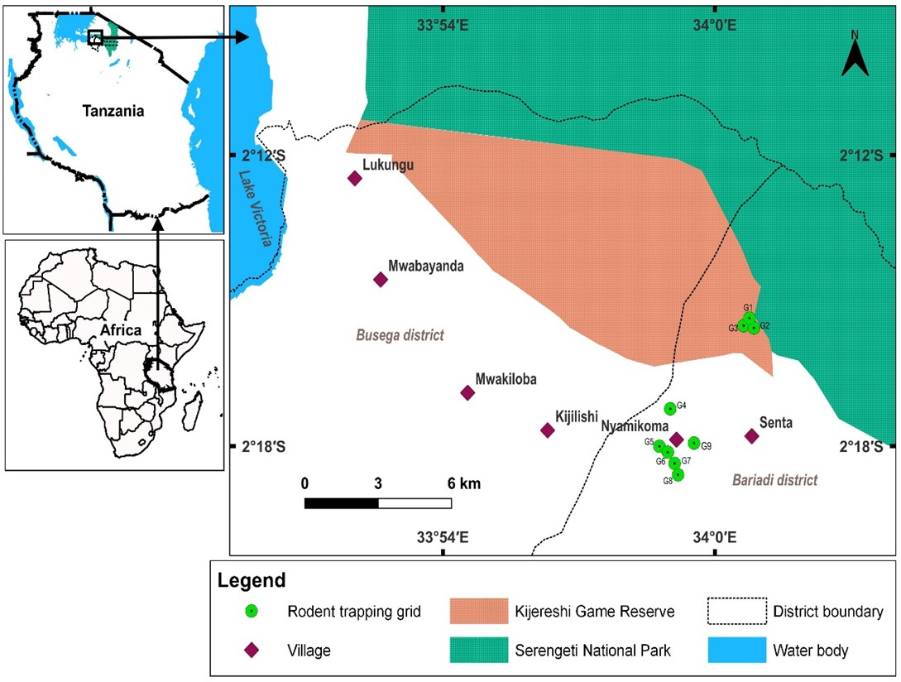

Figure 1: Location of Kijereshi Game Reserve and Nyamikoma village

The study site within Kijereshi Game Reserve is characterized by grasses, which include Sporobolus ioclados, Chrysochloa orientalis Microchloa kunithii, and Sporobolus nervosa. Also there are forbs like Commelina spp, Portulaca spp, and Indigofera hochstetteri, Justicia matamensis and sedges like cyperacea (McSherry, 2015). Some of the trees and shrubs found in the reserve include Vachellia tortilis, Senegalia senegalensis, Solanum incunum, Balanites aegiptiaca, Ziziphus mucoranota, Vachellia seyal, Vachellia dropenorobium, Abrus precatorius, Grewia falax, Commiphora spp, Cordia monoica, Euphobia spp, Salvadora persia and Agave spp. The fallow land fields were
covered by a number of perennial and annual vegetation including invasive species like Opotuntia spp, Lantana camara and Datura stromonium. Other vegetation included grasses – Gramineae, which are common in disturbed soils and uncultivated fallow lands. They included Panicum maximum, Digitaria scalarum, Bidens pilosa, Cynodon dactylon, and Commellina bengelensis (Rwebuga et al., 2023). The fallow lands surrounded cultivated fields, which, during the wet season, were planted with maize crops (Rwebuga personal observation, 2020). Various weeds were encountered in the fields, including Cynodon dactylon, Digitaria scalarum, Bidens pilosa, Panicum maximum, and Commellina bengelensis. Fragments of mixed crop gardens comprising legumes, bananas, sweet potato, cotton and paddy also surrounded these cultivated study fields (Rwebuga et al., 2023).

2.2 Sampling Design and Trapping of Rodents
Capture-Mark–Recapture – CMR– technique was used to study rodents from April 2020 to March 2021. A total of nine permanent 70 × 70 m randomly trapping grids (three in the wooded grassland (WG) within the Game Reserve (cultivation prohibited); and other three in the maize crop field (Maize) as well as in the fallow land (Fallow) within Nyamikoma village land were established. Maize crop fields had ongoing maize crop cultivation throughout the study period whereas fallow lands had no cultivation for the minimum of two years back and throughout the trapping period of our study. The size of the grids corresponds with the approximate size of the farmer’s field (Mulungu et al., 2015). A distance of 300 m and above was set between each CMR grid, since this distance is enough to prevent overlaps of small rodents from different communities (Mulungu et al., 2015).

Each grid consisted of seven parallel lines, 10 m apart, and seven trapping stations per line, which also were 10 m from each other, making a total of 49 stations per grid. One Sherman LFA live trap (8 × 9 × 23 cm, H.B. Sherman Traps Inc., Tallahassee, FL, USA) was placed
at each trapping station, and all were set for three consecutive nights at intervals of four weeks for a total of twelve trapping months. Traps, baited with peanut butter mixed with bran/maize flour, were placed in the afternoon and inspected in the morning and left open during the day and night whereas bait lost to other organism like ants were replaced with new ones (Makundi et al., 2010). We treated all captured animals in compliance with the 1964 Helsinki Declaration (7th revision) and guidelines of the American Society of Mammalogists (Sikes and Gannon, 2011). Also, our research study adhered to the ethical regulations of the Sokoine University of Agriculture, Tanzania, and all procedures for acquiring permits from the local authority to carry out research in our study areas (Mulungu et al., 2015). On the first day of capture, all animals were marked by toe clipping using an established coding system (Borremans et al., 2014). For each capture, the trap station was recorded along with the small mammal’s sex, weight and reproductive condition (males as scrotal or non-scrotal and females as perforate or imperforate vagina, lactating or pregnant through palpation) (Mulungu et al., 2015). All trapped rodents were identified to the species level as per Kingdon et al. (2013) and Monadjem et al. (2015). Thereafter, they were released at the same location of capture.

2.3 Data analyses

2.3.1 Species composition, richness and diversity
We pooled data from all the three grids of each of the three major habitat types: wooded grassland, fallow land and maize crop fields. Thereafter, the pooled data for each habitat type were analyzed separately. When sex ratio and species diversity data were tested for normality using the Shapiro – Wilk test, they assumed a p-value > 0.05 hence further analyzed using the Analysis of Variance – ANOVA – technique because they met the assumption of normality. However, age class and abundance indicated a p-value < 0.05, hence log-transformed and then analyzed with the ANOVA technique. Species composition
was expressed as the percentage of individuals of each species over the total abundance of all species captured. Paleontological Statistical software PAST (Hammer et al., 2001) was used to calculate diversity measures: Species richness and Shannon-Wiener Diversity Index. Also, a species accumulation curve was obtained for the three habitat categories using PAST software. The monthly differences in the small mammal richness between WG, Maize and Fallow were tested with analysis of variance (ANOVA). Where the ANOVA test indicated significant differences, the Tukey post hoc (HSD) test was used to detect a group of variables whose means were different. Species richness was considered as the number of species in each of the three habitat types. Species diversity estimations were made by the Shannon-Wiener Index (Shannon, 1948), which considers even the rare species, with the following formula:-
$$H^{I} = -\sum_{i=1}^{ R}{piInpi}$$
Where: H^{I}= Shannon’s diversity index
In= Natural logarithm
p_{i=}The proportion of the entire community made up of species i
R= Number of different species in the corresponding species list

2.3.2 Age structure and sex ratio
Age structure and sex ratios could be determined for the dominant species, Mastomys natalensis because it was the only species with enough numbers of individuals that could be categorized into juveniles, sub-adults and adults following the relationship between age and body weight (Leirs & Verheyen, 1995). Also, it was the only species with enough individuals for spatio – temporal comparisons in terms of sex ratios. Individuals weighing < 20g were classified as juveniles, those weighing < 24g as sub–adults and the ones weighing ≥ 24g as adults (Leirs et al., 1994) . On the other hand, the sex ratio is defined as the
proportion of females in the whole population and was done in favour of females (Mulungu et al., 2013). Male rodents were ignored as they can be active throughout the season and one male can encounter many females in one season (Mulungu et al., 2014). Consequently, the sex ratio was determined as the proportion of the number of females Mastomys natalensis to the total number of individuals captured (Mdangi et al., 2013). To test if sex ratios varied within habitats and seasonality or their interactions, the data were analyzed through analysis of variance – ANOVA using PAST software (Hammer et al., 2001). Habitats and months were independent factors while sex ratios were dependent variables. The means separation was done using the Tukey post – hoc test to explain the significant difference in means of sex ratios between habitats and months or their interactions.

3.0 Results

3.1 Species Composition, Richness and Diversity
From the 2,268 trapping nights, 1,075 small mammalian individuals equal to trap success of 47.4%, were captured. These comprised of eight rodent, and one insectivorous species, Crocidura cf. flavescens (Table 1). While Mastomys natalensis was the most abundant rodent species in all habitats and seasons, four of the nine small mammalian species were rarely caught during the whole study period. Those were Saccostomus compestris, Acomys wilson, Mus minotoides and Rattus rattus (Table 1).

Table 1. List of small mammal species captured in the WG Game Reserve, and Fallow and Maize habitat types within the Kijereshi- Nyamikoma village agro-ecosystem in the Western Serengeti between April 2020 and March 2021.

Species | Total number of individuals  (% contribution in WG) | Total number of individuals  (% in Fallow ) | Total number of individuals  (% contribution in Maize ) | Overall in number  (% contribution overall)
Mastomys natalensis | 132 (68.4) | 278 (69) | 412 (91) | 822 (76.5)
Arvicanthis niloticus | 18 (9.3) | 36 (9) | 2 |  |  | 83 (7.7)
Gerbilliscus vicinus | 2 (1) | 12 (3) | 3 |  | 17 (1.6 )
Crociduracf. flavescens | 33 (17.1) | 54 (13) | 32 (7) | 119 (11.1)
Saccostomus mearnsi | 1 (1) | 12 (3) | 2 | 15 (1.4)
Acomys wilsoni | 2 (1) | 0 | 0 | 2
Mus minutoides | 2 (1) | 1 | 0 | 3
Rattus rattus | 3 (2) | 0 | 0 | 3
Aethomys kaiseri | 0 (0) | 9 (2) | 0 | 9 (0.8)
Total captured | 193 | 402 | 451 | 1,075
Total trap nights | 756 | 756 | 756 | 2,268
Species richness | 8 | 7 | 5 | 9
Shannon-Wiener Diversity Index | 1.02 | 1.05 | 0.35
Key: WG = wooded grassland, Fallow = fallow land, Maize = maize crop fields

Species accumulation curves indicate that during the twelve months of data collection, more species of rodents were obtained in the WG, less in Fallow and least in Maize. However, in all cases, asymptotes could not be reached during the whole period of the study (Figure 2).
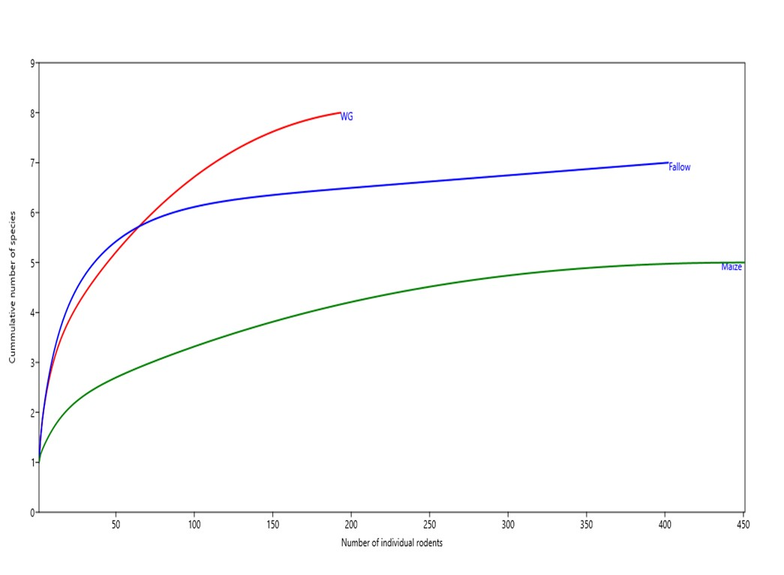

Figure 2: Species accumulation curve in all three habitat types across the twelve-month trapping period expressed in terms of cumulative number of species per number of individuals of rodents trapped in a given habitat type: WG = wooded grassland, Fallow =fallow land, Maize = maize crop fields.
Essentially, species richness varied numerically across months and habitats (Figure 3) whereas diversity was statistically significant between habitats (F_{2, 30} = 8.423, p = 0.001) and seasons (F_{1, 30 = 6.631,} p = 0.015). The Tukey post hoc (HSD) test revealed a significant difference in species richness between WG and Maize (p = 0.005) and between Fallow and Maize crop fields (p = 0.003). Diversity was higher both in the WG and Fallow in the wet season, but higher in the Maize during the dry season (Figure 4). Nevertheless, the interaction between habitat types and seasons was statistically non – significant (F2, 30 = 1.552, p = 0.228).

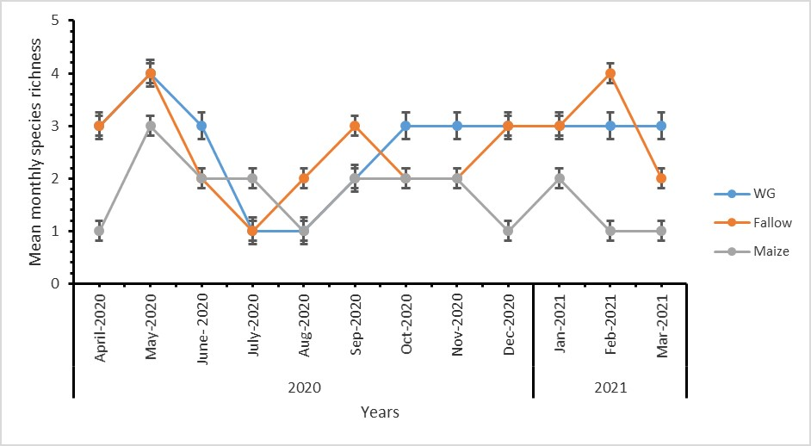

Figure 3: Mean (± SE) monthly species richness in the three habitats for the twelve-month period. Key: SE = Standard Error. WG = wooded grassland, Fallow = fallow land, Maize = maize crop fields

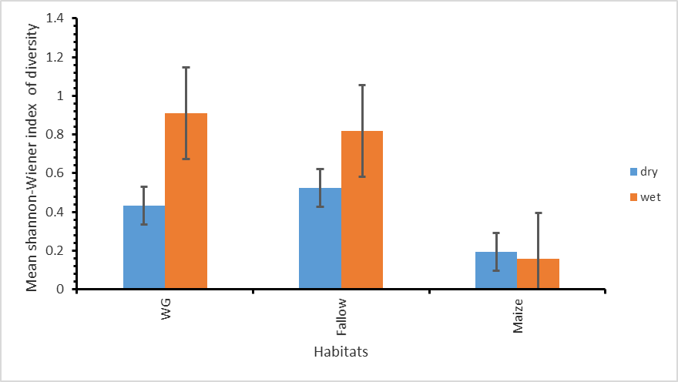

Figure 4: Mean (± SE) seasonal Shannon-Wiener index of diversity in the three habitat types. Key: SE = Standard Error, WG = Wooded grassland, Fallow = Fallow land, Maize = Maize crop fields, dry = Dry season and wet = Wet season.

3.2 Age Structure
There was a significant difference in the numbers of adults, subadults and juveniles between habitats (F_{2, 102} = 3.09, P = 0.049), and marginal statistical difference between seasons (F_{1, 102} = 3.743, p = 0.055). Tukey post hoc test revealed a statistical difference in the numbers of adults, subadults and juveniles between WG and Maize crop fields (p = 0.042). According to Figure 5, Maize had more adults than WG except for the months of February and March. Also, there were more Juveniles in the Maize than in the WG. Seasonally, numbers of adults, subadults and juveniles varied more in the WG than in the Maize crop fields. In the
WG, juvenile could not be trapped for a longer period of the wet season (April, May, December, January, February and March) as compared to the dry season (October and November). Subadults were present during the wet season only (April, May, January, February and March). Also, in the Maize crop fields, subadults could not be captured for a longer period during the wet season (April, January and March) than in the dry season (June and August) while juveniles could not be trapped in January only (Figure 5).

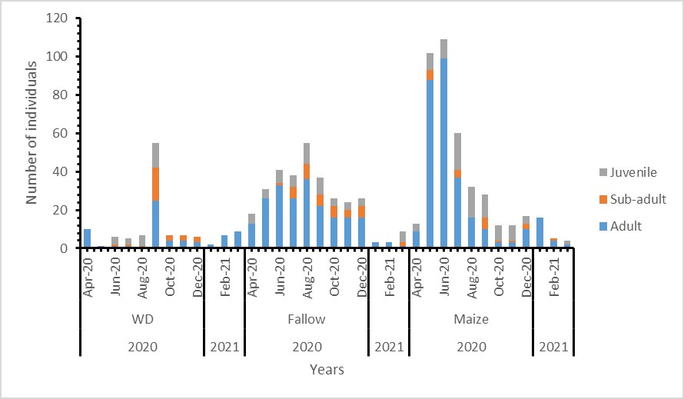

Figure 5: Distribution of different age groups of individuals of M. natalensis in different habitats and months. Key: WG = wooded grassland, Fallow = fallow land, Maize = maize crop fields

3.3 Sex Ratio
Numbers of females and males of M. natalensis captured varied significantly between dry and wet seasons (F_{1, 64} = 8.31, p = 0.005) and across the three habitat types (F_{2, 64} = 6.9, p = 0.004). Tukey post hoc test revealed difference in the male and female numbers between Maize and WG (P = 0.003). As depicted in figure 6 below, during the months of May, August and November, there were more females in the WG than in the Maze. Also, the number of females fluctuated between the wet and dry seasons. WG had more females in equal durations for both wet (May 2020 and February 2021) and dry (August and November 2020) seasons. Likewise, there were fewer females in equal periods for dry (June, July and October 2020) and wet (December 2020, January and March 2020) seasons in all habitat types. Moreover, Maize had more females in equal periods; wet (May 2020 and February 2021) and dry (July and October 2020). However, fewer females were captured for longer duration in the wet season (December 2020, January and March 2021) than in the dry season (only in September 2020). Fallow had more females for a longer period in the dry season (June, July, August and October 2020) than in the wet season ((January and February 2020) (Figure 6). On the other hand, fewer females were observed for a longer period in the wet season (April, May and December 2020) as compared with the dry season (September and November 2020) in all habitat types. The interaction between the habitat types and seasons was statistically non-significant (F_{2, 64} = 8.31, p = 0.445).

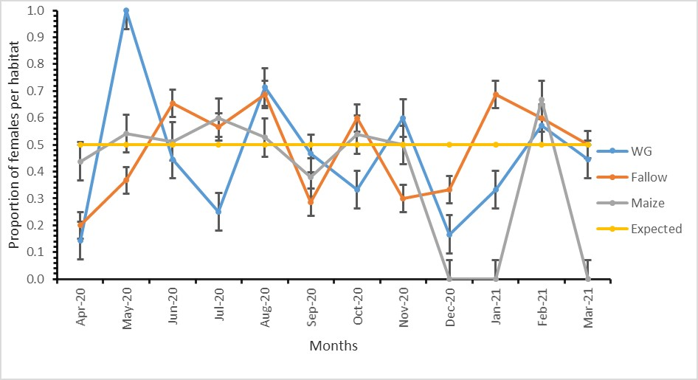

Figure 6: Mean (± SE) monthly observed and expected proportion of female M.natalensis in different habitats. Key: SE = standard error, WG = wooded grassland, Fallow = fallow land, Maize = maize crop fields, Expected = an expected proportion when there is skewness

4.0 Discussion

4.1 Species Composition, Richness and Diversity
During the twelve-month period of study, eight species of rodents and one insectivore species (nine species in total) were recorded. However, four of them were very rarely caught during the whole study period. The species considered as rare in the current study were also reported to be rare in the previous long-term studies, implying their patchy and localized distribution (Byrom et al., 2015b; Kingdon et al., 2013).

Therefore, the species richness reported by the present study, which only covered less than 0.5% of the whole ecosystem is a comparatively good representative of the ecosystem (Sinclair et al., 2007; TAWA, 2018). The accumulation curves (non-asymptotic) for all the habitat types (Figure 2), suggest that more effort could have led to capture of more species if the study had continued over twelve months period. There is also a possibility of more species to have been captured if multiple-trapping techniques had been used, instead of the single technique (CMR), whereby only one trap was used per trap station in each of the habitats type for only three trapping nights per month. This supposition matches well with results by Stephens and Anderson (2014) who found out that, Sherman live traps and pitfall traps combined captured significantly more species than either trap type used independently. The combined data records over the period of 48-years (from 1962 to 2010) for the great Serengeti ecosystem (our study area included) revealed about 40 species of small mammals (Byrom et al., 2015b; Kingdon et al., 2013). According to Byrom et al. (2015b) the reported findings for the ecosystem were a result of studies conducted in ten different habitats, using different combined trapping techniques for three to ten nights a month.

Spatial variations in the small mammal species composition was observed, with Mastomys natalesis occurring across all habitats, but more in maize crop fields than elsewhere. These results are similar to findings by Kessy et al. (2023) who reported dominance of M.natalensis in some habitats and seasons. This is probably, conforming to the hypothesis that Mastomys sp are able to survive in a wide range of environmental conditions, and are often the most numerous mice in savanna habitats and agricultural fields (Kingdon et al., 2013; Makundi et al., 2007).

However, the highest richness was recorded in the wooded grassland and the lowest in maize crop fields. Also, richness was higher in months that fall in the rainy season, probably portraying their response to the availability of food and vegetation cover as it was reported in the previous studies (Makundi et al., 2010). On the other hand, drier months had reduced small mammal richness, similar to findings that were reported in Ethiopia by Cao et al. (2016), and this is probably because of decreased cover and limited heterogeneity in available food items (Ofori et al., 2013). Further, the small mammal species diversity was spatially higher in fallow land and lowest in maize crop fields, while on temporal scale, diversity was higher in the wooded grassland and fallow land in the wet season, but higher in the maize crop fields during the dry season. The results are in agreement with Chidodo et al. (2020) who reported that habitat characteristics influence the diversity of rodents. Some habitats may offer more vegetation for food and shelter for breeding as well as protection of the rodents from possible predation as compared with others (Shilereyo et al., 2020).

4.2 Age Structure of the Dominant Species
The age structure of M. natalensis varied significantly among adults, subadults and juveniles. There was a statistical difference in the numbers of adults, subadults and juveniles of the dominant rodent species M. natalensis between habitats, similar to results reported by Tkadlec and Zejda (1998). In the month of September, there were more adults, subadults and juveniles in the wooded grassland habitats than in other months as was reported by Attuquayefio et al. (2013). This probably is because it is the peak of breeding for most individuals, and is far more pronounced in the wooded grassland than in other habitats as the compensation for deaths of rodent individuals that had died during the rainy season. Most part of our study area falls in a low land, which comparatively floods easily and this leads to more deaths of rodents as was observed by Jacob (2003). In maize crop fields, there

were more numbers of adults during the months of May, June and July 2020. Similar results were observed by Attuquayefio et al. (2013). Probably this suggests that higher numbers of adults are often caught more than juveniles and subadults as age tends to affect trappability. Normally, juveniles do not move far from their nests, hence decreasing their probability of encountering traps (Golley, 2009).

4.3 Sex Ratio of the Dominant Species
The sex ratio of a dominant rodent species M.natalensis was biased towards males in the wooded grassland habitats for seven months: April, June, September, October, December, January and March 2020. The same phenomenon was found in fallow land habitat for three months: April, July 2020 and December 2020 whereas in the maize crop fields, the bias was for five months: April, May, September 2020, January and March of the other year (2021). However, the sex ratio bias of M. natalensis shifted towards females for four months in each habitat type. In the wooded grassland, it was in May, August, November 2020 and February 2021 whereas in fallow land, the biasness was detected in May, June, August and October 2020, and June, July, August and November 2020 in the maze crop fields. The months were distributed into different seasons. April, May, December 2020, January, February, March 2021 and November 2020 fall in the wet season while June, July, August, September and October 2020 fall in the dry season (Norton-Griffiths, 1975; Ritchie, 2008). These results are in line with findings by other investigators and probably the two sexes were influenced differently by several factors including seasonality and habitat types. Mlyashimbi et al. (2019) reported more males of M. natalensis compared to females during the dry season and attributed the pattern to factors like search for food and mates, or individuals which were just in transit as males of this species are known for exhibiting larger home ranges. On the other hand, Wolf (2002) reported differential capture between male and female sexes of rodent species simply because of varying conditions of traps used (i.e. clean or dirty). Further,
Namukonde et al. (2017), Babale (2018) and Sellers (2016) observed differences in the capture of female and male rodents resulting from environmental factors such as fire and vegetation types that determined the presence or absence of a rodent of a given sex in a certain locality and time.

5.0 Conclusion
The study shows high rodent species diversity in fallow and within the protected wooded grassland habitats, while there is less diversity in the cultivated maize crop fields. The comparisons in community structures of small mammals between habitats showed spatial and temporal variations in species diversity and composition. Also, there were differences in terms of age structure and sex ratio for M. natalensis. Hence, these findings suggest that small-scale comparisons of the community structures of small mammals between habitats can provide knowledge that is needed for the conservation of small mammal species. The wooded grassland and fallow land habitats had more species diversity as compared to maize crop fields and hence might be ideal places for rodent gene propagation. Maize crop fields had substantial numbers of adults and juvenile rodents. Hence rodent control that includes clearing of vegetation in fallow lands surrounding maize crop fields and encouraging mesocarnivoures and birds of prey to visit their crop field might be effective. Generally, far less species richness was recorded during our study probably because a single type of trap was used and few habitats were considered. Further, in many areas the rodents fluctuate greatly from year to year hence information obtained depended on a year of study. Therefore, in future studies, more habitat types should be chosen and multiple trapping at one trapping station engaged to improve the capture of rodent species individuals. Also an extended period of time that covers more than two years should be considered in order to capture spatio-temporal variations in species richness and abundance of the rodent species in the study area.

Acknowledgments
We are extremely grateful to the African Centre of Excellence for Innovative rodent pest Management and Biosensor Technology Development-ACE II for sponsoring this project, the Tanzania Wildlife Management Authority for providing a research permit into Kijereshi Game Reserve and the Sokoine University of Agriculture for approving a research permit. We are also thankful to Professor Fortunatus B.S. Makonda for doing the vegetation sampling and analysis and Mr Khalidi Kibwana from SPMC for assisting with data collection in the field.

Author contributions
All authors conceived the study and designed methodology. EJR collected data, conducted analysis and wrote original drafts of the manuscripts. AAR analysed and reviewed original draft manuscripts, SNH reviewed the manuscripts. SNH, LM and AAR supervised the research. All authors read and approved final version of the manuscript for publication.

Funding
This research was funded by The African Centre of Excellence for Innovative Rodent Pest Management and Biosensor Technology Development. The Sokoine University of Agriculture, Tanzania-ACEII-Credit No. 5799-TZ.

Data available on request from the authors

Conflicts of Interest
The authors declare no conflict of interest.

References
Attuquayefio, D. K., Garshong, R. and Attuquayefio, D. (2013). Aspects of the Ecology of Rodents in the Owabi Wildlife Sanctuary, Ghana: Sex-ratio, Age Structure and Reproductive Characteristics. In Article in Asian Journal of Applied Sciences. https://www.researchgate.net/publication/318661594
Avenant, N.L and Cavallini, P. (2007). Correlating rodent community structure with ecological integrity, Tussen-die-Riviere Nature Reserve, Free State province, South Africa. Integrative Zoology, 2, 212–219. https://doi.org/https://doi.org/10.1111/j.1749-4877.2007.00064.x.
Avery, D. M. (1992). Man and/or climate? Environmental degradation and micro mammalian community structure in South Africa during the last millennium. South African Journal of Science, 88, 483–489. https://doi.org/https:// doi/pdf/10.10520/AJA00382353_9912.
Babale, A., Joshua, A., Elena, M. and Pierre-Michel, F. (2018). Forest disturbance and seasonal food availability influence a conditional seed dispersal mutualism. Biotropica., 50(750–757). https://doi.org/https://doi.org /10.1111/btp.12570?.
Borremans, B., Hughes, N. K., Reijniers, J., Sluydts, V., Katakweba, A. A. S., Mulungu, L. S., Sabuni, C. A., Makundi, R. H. and Leirs, H. (2014). Happily together forever: Temporal variation in spatial patterns and complete lack of territoriality in a promiscuous rodent. Population Ecology, 56(1), 109–118. https://doi.org/10.1007/s10144-013-0393-2
Byrom, A. E., Nkwabi, A. J. K., Metzger, K., Mduma, S. A. R., Forrester, G. J., Ruscoe, W. A., Reed, D. N., Bukombe, J., McHetto, J. and Sinclair, A. R. E. (2015a). Anthropogenic stressors influence small mammal communities in tropical East African savanna at multiple spatial scales. Wildlife Research, 42(2), 119–131. https://doi.org/10.1071/WR14223

Byrom, A. E., Nkwabi, A. J. K., Metzger, K., Mduma, S. A. R., Forrester, G. J., Ruscoe, W. A., Reed, D. N., Bukombe, J., McHetto, J. and Sinclair, A. R. E. (2015b). Anthropogenic stressors influence small mammal communities in tropical East African savanna at multiple spatial scales. Wildlife Research, 42(2), 119–131. https://doi.org/10.1071/WR14223
Campbell, K. and Hofer, H. (1995). People and wildlife: spatial dynamics and zones of interaction. In: Serengeti II: Dynamics, Management, and Conservation of an Ecosystem (Eds A. R. E. Sinclair and P. Arcese). The University of Chicago Press.
Cao, C., Shuai, L. Y., Xin, X. P., Liu, Z. T., Song, Y. L. and Zeng, Z. G. (2016). Effects of cattle grazing on small mammal communities in the Hulunber meadow steppe. PeerJ, 2016(8). https://doi.org/10.7717/peerj.2349
Chidodo, S., Kilawe, C.J., Mnyone, L.L., Broecke, B.V. and Mulungu, L. S. (2020). Factors affecting the composition of rodent assemblages in the North Uluguru Mountains. Journal of Vertebrate Biology, 69, 1–10. https://doi.org/https://doi.org/10.25225/jvb.20047
Devictor V and Julliard R, J. F. (2008). Distribution of specialist and generalist species along spatial gradients of habitat disturbance and fragmentation. Oikos, 117, 507–514. https://doi.org/https://doi.org /10.1111/j.2008.0030-1299.16215.x
Ewers, R.M. and Didham, R. K. (2006). Confounding factors in the detection of species responses to habitat fragmentation. Biological Review, 81, 117–142. https://doi.org/https://doi.org 10.1017/S1464793105006949.
Golley, F.B., Petrusewicz, K. and Ryszkowski, L. (2009). Small Mammals: Their Productivity and Population Dynamics (2nd ed). . Cambridge University Press.
Gunda, D. M., Chambi, D. and Eustace, A. (2022). Do vegetation, disturbances, and water influence large mammal distribution? Geology, Ecology, and Landscapes, 6(2), 150–158. https://doi.org/10.1080/24749508.2020.1809060

Hammer, D. A. T., Ryan, P. D., Hammer, Ø. and Harper, D. A. T. (2001). Past: Paleontological Statistics Software Package for Education and Data Analysis. In Palaeontologia Electronica (Vol. 4, Issue 1). http://palaeo-electronica.orghttp//palaeo-electronica.org/2001_1/past/issue1_01.htm.
Jacob, J. (2003). Trappability of rodents in single-capture and multiple capture traps in arid and open environments: Why don’t Ugglan traps work? https://www.researchgate.net/publication/242271320
Kessy, S. T., Makundi, R. H., Sabuni, C., Massawe, A. W. and Rija, A. A. (2023). Rodent abundance, diversity and community structure in a bubonic plague endemic area, northern Tanzania. Mammalia, 87(5), 488–498. https://doi.org/10.1515/mammalia-2023-0012.
Kingdon, J., Happold, D., Butynski, T., Hoffmann, M., Happold, M. and Kalina, J. (2013). Mammals of Africa. Bloomsbury Publishing, London. pp. 78.
Kitessa, H., & Tsegaye, G. (2015). The reproductive and feeding ecology of rodents in Sekoru district, Southwest Ethiopia. Journal of Ecology and The Natural Environment, 7(6), 188–195. https://doi.org/10.5897/jene2015.0516.
Leirs, H., Verheyen, W. (1995). Population Ecology of Mastomys natalensis (Smith, 1834). Implications for Rodent Control in Africa.’ Agricultural Editions No. 35.
Leirs, H., Verhagen, R., & Verheyen, W. (1994). The basis of reproductive seasonally in Mastomys rats (Rodentia: Muridae) in Tanzania. In Journal of Tropical Ecology (Vol. 10).
Makundi, R. H., Massawe, A. W. and Mulungu, L. S. (2007). Reproduction and population dynamics of Mastomys natalensis Smith, 1834 in an agricultural landscape in the Western Usambara Mountains, Tanzania . Integrative Zoology, 2(4), 233–238. https://doi.org/10.1111/j.1749-4877.2007.00063.x.

Makundi, R. H., Massawe, A. W., Mulungu, L. S. and Katakweba, A. (2010). Species diversity and population dynamics of rodents in a farm-fallow field mosaic system in Central Tanzania. African Journal of Ecology, 48(2), 313–320. https://doi.org/10.1111/j.1365-2028.2009.01109.x
Malizia, L. (2001). Seasonal fluctuations of birds, fruits and flowers in a subtropical forest of Argentina. The Condor 1, 03, 45–61. https://doi.org/https://doi.org/10.1093/condor/103.1.45
Manyonyi, A. M., Mariki, S. B., Mnyone, L. L., Belmain, S. R. and Mulungu, L. S. (2020). Effects of prescribed burning on rodent community ecology in Serengeti National Park. Journal of Vertebrate Biology, 69(2). https://doi.org/10.25225/jvb.20001
Marealle, W.N, Fossøy, F., Holmern, T., Stokke, B.G. and Røskaft, E. (2010). Does illegal hunting skew Serengeti wildlife sex ratio? Wildlife Biology, 16, 419–430. https://doi.org/https://doi.org 10.2981/10-035
McSherry, M. E. (2015). "Human-Managed vs. Natural Grazing Systems: Exploring Effects of Livestock and Wildlife Grazing at Multiple Scales. https://surface.syr.edu/etd/335
Mdangi, M., Mulungu, L. S., Massawe, A. W., Eiseb, S. J., Tutjavi, V., Kirsten, F., Mahlaba, T., Malebane, P., von Maltitz, E., Monadjem, A., Dlamini, N., Makundi, R. H. and Belmain, S. R. (2013). Assessment of rodent damage to stored maize (Zea mays L.) on smallholder farms in Tanzania. International Journal of Pest Management, 59(1), 55–62. https://doi.org/10.1080/09670874.2012.744495
Mlyashimbi, E. C. M., Vanden Broecke, B., Mariën, J., Kimaro, D. N., Tarimo, A. J. P., Machang’u, R. S., Isabirye, M., Makundi, R. H., Massawe, A. W., Hieronimo, P., Kifumba, D., Leirs, H., Mdangi, M. E., Belmain, S. R. and Mulungu, L. S. (2019). Soil type influences population dynamics and survival of the Multimammate rat (Mastomys natalensis) in semi-arid areas in Tanzania. Crop Protection, 124. https://doi.org/10.1016/j.cropro.2019.05.023

Monadjem, A., Taylor, P. J., Denys, C. and Cotterill, F. P. D. (2015). Rodents of sub-saharan Africa: A biogeographic and taxonomic synthesis. In Rodents of Sub-Saharan Africa: A Biogeographic and Taxonomic Synthesis. Walter de Gruyter GmbH.
Monica, S., Flora, J. M., Joseph, O. O. and Eivin, R. (2020). Small mammal community demography and reproductive seasonality under protection, pastoralism and agriculture in the Serengeti Ecosystem, Tanzania. International Journal of Biodiversity and Conservation, 12(4), 253–269. https://doi.org/10.5897/ijbc2020.1397
Mulungu, L. S., Lagwen, P. P., Mdangi, M. E., Kilonzo, B. S. and Belmain, S. R. (2014). Impact of spatio-temporal simulations of rat damage on yield of rice (Oryza sativa L.) and implications for rodent pest management. International Journal of Pest Management, 60(4), 269–274. https://doi.org/10.1080/09670874.2014.967326
Mulungu, L. S., Ngowo, V., Mdangi, M., Katakweba, A. S., Tesha, P., Mrosso, F. P., Mchomvu, M., Sheyo, P. M. and Kilonzo, B. S. (2013). Population dynamics and breeding patterns of multimammate mouse, Mastomys natalensis (Smith 1834), in irrigated rice fields in Eastern Tanzania. Pest Management Science, 69(3), 371–377. https://doi.org/10.1002/ps.3346
Mulungu, L. S., Sixbert, V., Ngowo, V., Mdangi, M., Katakweba, A. S., Tesha, P., Mrosso, F. P., McHomvu, M., Kilonzo, B. S. and Belmain, S. R. (2015). Spatio-temporal patterns in the distribution of the multi-mammate mouse, Mastomys natalensis, in rice crop and fallow land habitats in Tanzania. Mammalia, 79(2), 177–184. https://doi.org/10.1515/mammalia-2014-0006
Namukonde, N., Kuebler, D. and Ganzhorn, J. U. (2017). Differential Effects of Fire on Small Mammal Communities in the Busanga Flood Plain, Zambia. Tropical Conservation Science, 10. https://doi.org/10.1177/1940082917725439

Ndibalema, V. G. (2009). A comparison of sex ratio, birth periods and calf survival among Serengeti wildebeest sub‐populations, Tanzania. African Journal of Ecology, 47, 574–582.
Norton-Griffiths. M ; Herlocker. D and Pennycuick . L. (1975). The patterns of rainfall in the Serengeti ecosystem, Tanzania. African Journal of Ecology., 13, 347–374. https://doi.org/https://doi.org /10.1111/j.1365-2028.1975.tb00144.x.
Ofori, B.Y., Attuquayefio, D.K. and Gbogbo, F. (2013). Terrestrial small mammal community structure in an anthropogenically-altered moist semi-deciduous forest zone in Ghana. Int. J. Dev. Sust, 2, 1156–1168. https://doi.org/ID: IJDS13011801
Oli, M. K. and Dobson, F. S. (2003). The relative importance of life-history variables to population growth rate in mammals: Cole’s prediction revisited. American Naturalist, 161(3), 422–440. https://doi.org/10.1086/367591
Omogbeme, M. and Oko, C. (2018). Population dynamics of Rodents and Insectivores in lowland tropical rainforest ecosystem of Okomu National Park, Edo State, Nigeria. Journal of Applied Sciences and Environmental Management, 22(3), 318. https://doi.org/10.4314/jasem.v22i3.5
Revollo-Cadima, S. G., Rico C., A., Pacheco, L. F. and Salazar-Bravo, J. (2020). Community structure and abundance of small rodents at the wave front of agroforestry and forest in Alto Beni, Bolivia. Ecología En Bolivia , 55(1), 16–25.
Ritchie, M. (2008). Global Environmental Changes and Their Impact on the Serengeti. In: Seregeti III: Human Impacts on Ecosystem Dynamics. https://doi.org/DOI- 10.7208/chicago/9780226760353.003.0006
Rosenfeld, C. S. and Roberts, R. M. (2004). M i n i r ev i ew Maternal Diet and Other Factors Affecting Offspring Sex Ratio : A Review. 1070(June), 1063–1070. https://doi.org/10.1095/biolreprod.104.030890.

Rwebuga, E. J., Mulungu, L. S., Rija, A. A. and Hassan, S. N. (2023). Ecological correlates of population abundance of a pest small mammal species ( Mastomys natalensis ) inhabiting a protected area-farmland landscape in western. 92(1), 159–169.
Schowalter, T. . (2006). Insect Ecology (Second Edition). Academic Press.
Sellers, L., Long, R., Baldwin., R. A. (2016). Impact of field border plantings on rodents and food safety concerns. Proc. Vertebr. Pest. Conf., 27, 150–155. https://doi.org/https://doi.org/ 10.5070/V427110590.
Setsaas, T.H., Mwakalebe, H.T., Tokke, G.S. and Røskaft, E. (2007). How does human exploitation affect impala populations in protected and partially protected areas? – A case study from the Serengeti Ecosystem, Tanzania. Biol. Conserv., 136, 563–570. https://doi.org/https://doi.org 10.1016/j.biocon.2007.01.001.
Shannon, C. E. (1948). A mathematical theory of communication. Bell Systems Technical Journal, 27, 379–423. https://doi.org/https://doi.org/10.1002/j.1538-7305.1948.tb01338.x
Shilereyo, M., Flora, J. M., Joseph, O. O. and Eivin, R. (2020). Small mammal community demography and reproductive seasonality under protection, pastoralism and agriculture in the Serengeti Ecosystem, Tanzania. International Journal of Biodiversity and Conservation, 12(4), 253–269. https://doi.org/10.5897/ijbc2020.1397
Sikes, R. S. and Gannon, W. L. (2011). Guidelines of the American Society of Mammalogists for the use of wild mammals in research. Journal of Mammalogy, 92(1). https://doi.org/10.1644/10-MAMM-F-355.1
Sinclair, A. R. E., Mduma, S. A. R., Hopcraft, J. G. C., Fryxell, J. M., Hilborn, R. and Thirgood, S. (2007). Long-term ecosystem dynamics in the serengeti: Lessons for conservation. Conservation Biology, 21(3), 580–590. https://doi.org/10.1111/j.1523-1739.2007.00699.x

Stenseth, N. C., Leirs, H., Skonhoft, A., Davis, S. A., Pech, R. P., Andreassen, H. P., Singleton, G. R., Lima, M., Machang’u, R. S., Makundi, R. H., Zhang, Z., Brown, P. R., Shi, D. and Wan, X. (2003). Mice, rats, and people: The bio-economics of agricultural rodent pests. Frontiers in Ecology and the Environment, 1(7), 367–375. https://doi.org/10.1890/1540-9295(2003)001[0367:MRAPTB]2.0.CO;2
Stephens, R. B., & Anderson, E. M. (2014). Habitat associations and assemblages of small mammals in natural plant communities of Wisconsin. Journal of Mammalogy, 95(2), 404–420. https://doi.org/10.1644/13-MAMM-A-025
TAWA. (2018). Tanzania Wildlife Management Authority-TAWA- Kijereshi Game Reserve.
Thompson, R. C. A. (2013). Parasite zoonoses and wildlife: One health, spillover and human activity. International Journal for Parasitology, 43(12–13), 1079–1088. https://doi.org/10.1016/j.ijpara.2013.06.007
Tkadlec, E and Zejda, J. (1998). Small rodent population ¯uctuations: The eects of age structure and seasonality.
Umetsu, F., & Pardini, R. (2007). Small mammals in a mosaic of forest remnants and anthropogenic habitats - Evaluating matrix quality in an Atlantic forest landscape. Landscape Ecology, 22(4), 517–530. https://doi.org/10.1007/s10980-006-9041-y
Wolf, M. and G. O. B. (2002). Relationship of previous trap occupancy to capture of white-footed mice (Peromyscus leucopus). Journal of Mammalogy., 83, 728–733. https://doi.org/https://www.jstor.org/stable/1383536.

CHAPTER THREE

PAPER II

SUBMITTED TO MAMMALIA JOURNAL

Population dynamics and breeding patterns in Mastomy natalensis in Western Serengeti, Tanzania
AUTHOR'S INSTITUTIONAL AFFILIATIONS

Egidius J. Rwebuga^{1,2,3*}, Loth S. Mulungu†, Shombe N. Hassan¹ , Alfan A. Rija¹
¹Department of Wildlife Management, Sokoine University of Agriculture, Morogoro, Tanzania.
²The African Centre of Excellence for Innovative Rodent Pest Management and Biosensor Technology Development (ACE IRPM & BTD).
3Pest Management Centre, Sokoine University of Agriculture, Morogoro, Tanzania.
*Correspondence: E-mail: jegidius@yahoo.com
Tell: +255 0784 80 25 65
† Deceased

Abstract
The multimammate rodent Mastomys natalensis is known to cause crop losses to farmers due to limited control measures resulting from complexity in its population dynamics. We studied factors driving the population fluctuation and breeding patterns of this species in Western Serengeti, northern Tanzania to generate information to inform the control measures for this species. Rodent population and breeding data were collected over two years using the Capture-Marker-Recapture
technique. Consistent with other studies elsewhere, we hypothesized that M. natalensis abundance would vary spatially and seasonally depending on food availability. We found the density of M. natalensis was highest in the maize crop fields and lowest in the wooded grassland and was higher during the dry season, than the wet season. M. natalensis females bred continuously, but showed no significant difference in breeding females across habitats and between seasons. Further, there was a weak negative correlation between rainfall and the number of breeding females suggesting low survival perhaps due to flooding in the study area. Comparatively, the density of M. natalensis, was higher in maize crop fields, in all seasons, than other habitat types, but dropped markedly between October and January, suggesting that this period could be a good timing for the rodent control.

Key words: Population-dynamics, breeding-patterns, rainfall-patterns, Mastomys- natalensis, Kijereshi-Game-Reserve, western-Serengeti

1.0 Introduction
The pestiferous rodent mammals are widely distributed throughout the forests, savannahs, grasslands and agricultural landscapes across sub-Saharan Africa (Colangelo et al., 2013; Jacob and Brown, 2000; Monadjem et al., 2015). These rodents and other small mammals are ecologically important to ecosystems as seed predators, ecosystem engineers, nutrient cyclers and prey species (Bergstrom et al., 2018), and cause considerable economic and health problems to man through destroying crops causing hunger, and through spreading pathogens causing diseases by acting as hosts and reservoirs of disease pathogens, hence causing overall socio-economic impact on humans (McCauley et al, 2015).

Many Africa’s protected areas in the tropics are progressively becoming vulnerable to human encroachment (Caro and Scholte, 2007). The encroachment is featured by anthropogenic land use and land cover changes, which have altered breeding and other population demographic parameters of small mammals including rodents (Cao et al., 2016). Alterations to natural habitats by land use can modify the constraints imposed by environmental structure and seasonality on the timing, synchrony and fecundity of breeding by rodents (Monica et al., 2020).

The relationship between Mastomys spp population dynamics and other rodent community species diversity, crop depredation and transmission of zoonotic diseases is well documented (Makundi et al., 2010; McCauley et al., 2015). For example, birth, death, immigration and emigration are the four primary ecological events known to influence the dynamics of a population (Tarsi & Tuff, 2012). The four parameters can be formulated into a simple equation that expresses the phenomenon; “Change in Population Density = (Births + Immigration)-(Deaths + Emigration)” (Tarsi & Tuff, 2012). All other factors, either biotic or abiotic in nature are considered as secondary, and exert their impact on population density by influencing one (or more) of the variables on the right-hand side of the above equation. Such factors are broadly categorized as density independent or exogenous factors, e.g., volcanic eruption, and density dependent or endogenous factors, e.g., competition (Bendik & Dries, 2018).

Endogenous factors cause changes in a dynamic variable (e.g., the per capita growth rate), which in turn is affected by those changes (Previtali et al, 2009). In contrast, exogenous factors may influence the per capita growth rate, but are not affected in turn by those changes (Previtali et al., 2009). Further, influences on population fluctuations can occur synchronously over large spatial scale due to a response to some
landscape processes (Massawe et al., 2011; Ranta et al., 1995; Utrera et al., 2000), or over a small scale on small localized areas, suggesting the contribution of local rather than landscape processes (Bowman et al., 2000; Krohne and Burgin, 1990). Changes in species diversity and abundance may lead to negative impacts on conservation and public economy (Stenseth et al., 2003). For example, exclusion of specialist rodent species from communities may give rise to higher population sizes of pestiferous species (Stenseth et al., 2003; Umetsu and Pardini, 2007) and increased spread of zoonotic diseases (Thompson, 2013) enhanced by compromised dilution effect (McCauley et al., 2015).

Various investigators have specifically proposed possible mechanisms by which M. natalensis increases in population size so rapidly and sometimes getting to outbreaks, which are unusual occurrences of large numbers of rodents in one season or in some years (Leirs et al., 1996a). For instance, (Telford, 1989) and (Leirs, 1992) claimed that large litter size, several litters per season, increased survival and quick maturation are some of the demographic factors that favour high population turnover of M. natalensis. Other researchers claim that increase in numbers of rodents to the levels of outbreaks in maize-dominated mosaic habitats, is influenced by rainfall pattern (Leirs, 1995; Linn 1991). As such, reproduction of Mastomys in an area with bimodal rainfall pattern is considered to be normally affected by irregularities in rainfall patterns (Leirs et al., 1989; Telford, 1989).

Breeding of Mastomys has been reported to start in the second peak of the rainy season (March-May), and lasts throughout the dry season until the end of September (Christensen, 1993; Leirs et al., 1990). According to Leirs et al. (1996) depending on the location of the study site, if the first peak of the rainy season (let say, October-December) is low, the young will remain sexually immature until March, and densities will decrease drastically due to poor survival. If the first peak of the rainy
season experiences abundant rains, the rodents reproduce at a very young age after the second peak of the rainy season and hence many young are recruited at the end of the following main breeding season (Leirs et al., 1993). A simple logistic model for predicting outbreaks of M. natalensis in Morogoro, Tanzania exists, but relies on a single factor only, the rainfall (Leirs et al., 1996b). However, (Mulungu et al., 2013b) found out that Mastomys natalensis bred continuously when food was available regardless of seasonality.

Understanding the drivers of population fluctuations and the underlying mechanisms through which they occur has challenged ecologists for years (Previtali et al., 2009). Further, the variation in opinions by various researchers serves as potential evidence for variation in demographic and/or ecological variables responsible for the outcome between ecological zones. Yet information on the local-scale rodent population fluctuations is still scarce (Andreassen et al., 2021). This gap, further, hinders efforts for designing effective mitigation measures to prevent potential Mastomys natalensis population outbreaks in many terrestrial areas including Kijereshi Game Reserve and the Nyamikoma village agro-ecosystem in the western Serengeti. This study, therefore, aimed at finding out how densities and breeding of the species vary monthly and across different habitats in relation to rainfall patterns in the wooded grassland and in maize agro-ecosystem. In that regard, we put forward two hypotheses with reference to the species dynamics and breeding patterns. Firstly, we hypothesized that, habitats in agro-ecosystem will tend to increase abundance of M. natalensis while the wooded grassland will have a negative influence on its abundance. Secondly, that rainfall has a positive influence on the breeding patterns of the species across habitats. Information obtained would make it possible to apply the knowledge to their conservation and management (Bjørnstad & Grenfell, 2001).

2.0 Materials and Methods

2.1 Description of Study Area
The study was conducted within Kijereshi Game Reserve and the neighbouring Nyamikoma village landscape within Busega and Bariadi Districts in Simiyu Region. The game reserve covers 65.7 km² and is located at 2º16´49.06´´S and 33º58´ 47.16´´E (Figure 1). On the northern side, Kijereshi Game Reserve shares the boundary with the Serengeti National Park (SENAPA), and it is surrounded by six villages which are Lukungu, Mwabayanda, Mwakiroba, Kijilishi, Senta and Nyamikoma. The reserve is primarily covered by three vegetation types: the riverine forest (covering 9.4% of the reserve area), grassland (25.1%) and wooded grassland (65.5%) (Gunda et al., 2022). Soil is mainly sandy - clay - loam and the area receives an annual rainfall of about 750–850 mm (McSherry, 2015) characterized by a bimodal rainfall patterns with short rains from November to January and long rains from March to May (Campbell & Hofer, 1995).
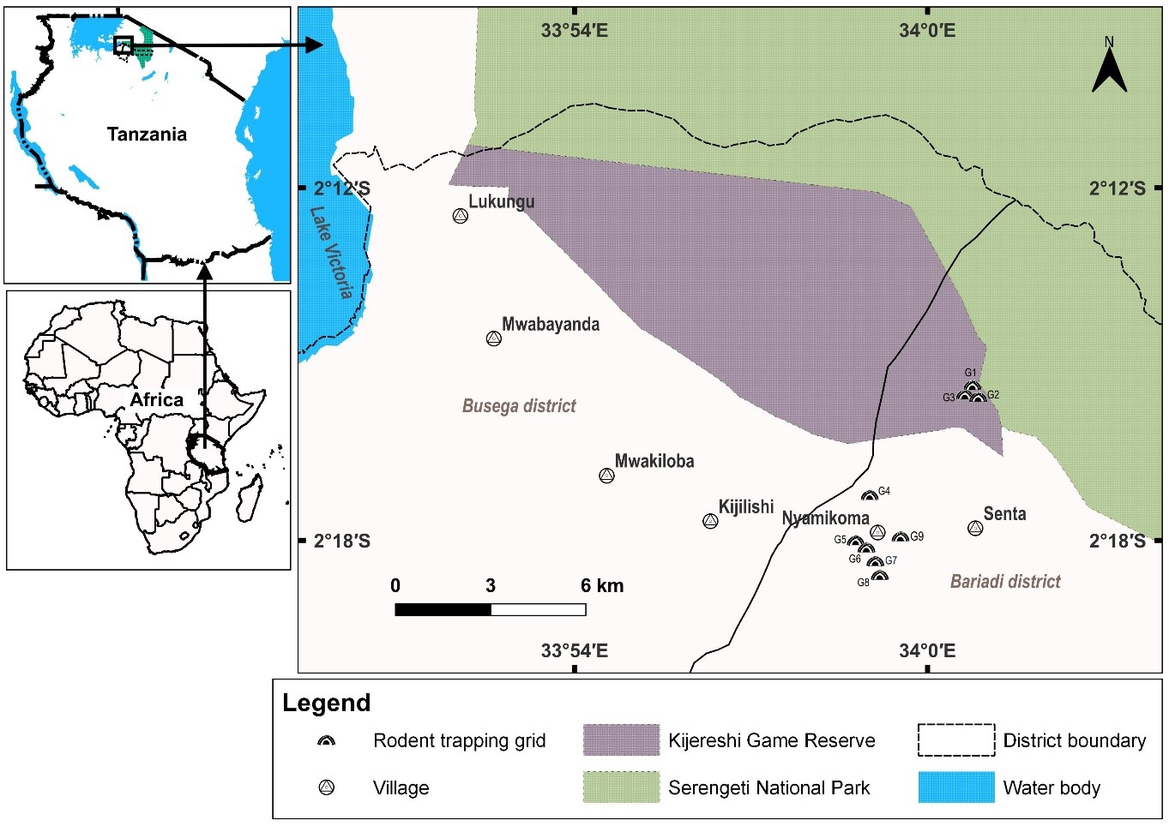

Figure 1: Location of study sites within Kijereshi GameReserve and Nyamikoma village

The grassland patches in Kijereshi Game Reserve are dominated by grasses such as Sporobolus ioclados, Chrysochloa orientalis Microchloa kunithii and Sporobolus nervosa. Also, there are forbs e.g. Commelina spp, Portulaca spp, and Indigofera hochstetteri, Justicia
matamensis, and sedges e.g. cyperacea (McSherry, 2015). Some of the trees and shrubs found in the reserve include Vachellia tortilis, Senegalia senegalensis, Solanum incunum, Balanites aegiptiaca, Ziziphus mucoranota, Vachellia seyal, Vachellia dropenorobium, Abrus precatorius, Grewia falax, Commiphora spp, Cordia monoica, Euphobia spp, Salvadora persia and Agave spp.

The fallow land fields were covered by various perennials including invasive species like Opotuntia spp, Lantana camara and Datura stromonium, and annual grasses such as Panicum maximum, Digitaria scalarum, Bidens pilosa, Cynodon dactylon, and Commellina bengelensis, which were common in disturbed soils (Rwebuga et al., 2023). The fallow lands surround cultivated fields, which, during the wet season, are commonly planted with maize crops (Rwebuga personal observation, 2020). Fragments of mixed crop gardens and small farms comprising legumes, bananas, sweet potatoes, cotton and paddy are commonly planted in the vicinity of the maize crop fields (Rwebuga et al., 2023).

2.2 Sampling Design and Trapping of Rodents
The rodents were trapped for twenty-four months using a Capture-Mark–Recapture (CMR) technique from April 2020 to March 2022. A total of nine permanent 70 × 70 m randomly set trapping grids were established as follows; three in the wooded grassland (WG) within Kijereshi Game Reserve, three in the Fallow land, and the other three in the Maize crop fields within Nyamikoma village land. Maize crop fields had ongoing maize crop cultivation throughout the study period whereas fallow fields were not cultivated at all throughout this period.

The size of the grids corresponds with the approximate size of the farmer’s field (Mulungu et al., 2013). A distance of about 300 m or so was set between CMR grids, because such distance is presumably
enough to prevent overlaps of rodents from different communities (Mulungu et al., 2013). Each grid consisted of seven parallel lines, 10 m apart, and seven trapping stations per line, which also were 10 m from each other, making a total of 49 stations per grid.

One Sherman LFA live trap (8 × 9 × 23 cm, H.B. Sherman Traps Inc., Tallahassee, FL, USA) was placed at each trapping station, and all were set for three consecutive nights at intervals of four weeks every month. Traps, baited with peanut butter mixed with bran/maize flour, were placed in the afternoon and inspected in the morning and left open during the day and night (Makundi et al., 2010). Trapping was conducted concurrently in all three habitats whereby a total of 441 traps were used at once. We treated all captured animals in compliance with the 1964 Helsinki Declaration (7th revision) and guidelines of the American Society of Mammologists (Sikes and Gannon, 2011). Also, our research study adhered to the ethical regulations of the Sokoine University of Agriculture (SUA), and all national procedures for acquiring permits from the local authority to carry out research in Tanzania (Happold, 2013).

On the first day of capture, all animals were marked by toe clipping using an established coding system (Mulungu et al., 2015), and for each capture, the trap station was recorded along with the small mammal’s sex, weight and reproductive condition (males were either scored as scrotal or non-scrotal and females as the perforate or imperforate vagina, lactating or pregnant through palpation) (Happold, 2013). All trapped rodents were identified at the species level using different techniques, including field guides (Borremans et al., 2014). Thereafter, they were released at the same location of capture.

2.2 Data Processing and Analysis

2.2.1 Population dynamics and breeding patterns
Monthly population abundance of M. natalensis was estimated by the direct enumeration method using a calendar of captures, and was expressed as the Minimum Number of Animals Known Alive (MNA)(Krebs, 1966), a measure of population size for Mark-Recapture studies of small mammals. It is calculated by summing up the number of animals caught at a particular time, as well as all other animals known to be alive because they were caught both before and during that time (Krebs, 1966) . Then abundance was expressed in terms of population density as the MA/hectare. Breeding patterns were established by determining the number of sexually/reproductively active and non-active females in different habitat types and months. Females were considered to be sexually/reproductively active when the vagina was perforated, nipples swollen on account of lactation or when they were pregnant. Correspondingly, all other females with closed vagina and non-swollen nipples were considered non-sexually active. The definition of sexual activity used in this study was adopted from (Leirs, 1995) who defined the terminology as a physiological condition, and not as a typical behaviour. We tested differences in rodent abundance between the trapping months and habitat types using non-parametric Kruskali Wallis test. Means separation test between significantly different groups was performed using pairwise.wilcox.test() function in R programme (Mulungu et al., 2016). Graph plotting was used to indicate the relationship between rainfall pattern and monthly fluctuations in population abundance (MNA/h) across different years of trapping, breeding (active) and non- breeding (non-active) female M. natalensis and the total number of female M. natalensis in different months and habitats. Further, to understand the effect of rainfall, habitats and trapping months on the density of M.natalensis, we built a negative binomial generalized linear model (GLM), implemented in the package MASS after detecting data over dispersion (Mwasapi & Rija, 2022).

During this study, only female individuals of M.natalensis were considered because males can be sexually active all the year round and one male can impregnate several females (Mulungu et al., 2013b). Further, two statistical tests were performed; Pearson correlation analysis to establish the relation between rainfall and breeding of M.natalensis, and also, we ran a negative binomial generalized linear model (GLM) to understand the influence of rainfall, habitats and their interaction on the breeding numbers of rodents per every month of trapping. Rainfall data to link the population dynamics and breeding pattern were obtained from Handajega Meteorological Station under the Tanzania National Parks Authority (TANAPA).

3.0 Results

3.1 Trend of abundance of M. natalensis across habitats and seasons
Population abundance in terms of density of Mastomys natalensis varied significantly between habitat types (Χ² = 8.922, df = 2, p-value = 0.012).It was highest in the Maize (MNA 46.24/h) than the Fallow (MNA 28.42/h) by 38.5%, and WG (MNA 15.42/h) by 66.7%. Also, there was a significant difference between seasons (W = 982.5, p-value < 0.001) and the density was higher during the dry season, MNA 40/h as compared to the wet season, MNA 16/h. In the Maize, two density peaks were observed, the first one in June 2020, and the second in May 2021(Figure 2). Nevertheless, an overall higher density of Mastomys natalensis was experienced in May and June 2020 compared to the entire 2021 and the months of 2022 (Figure 2). Apparently, short rains across the study period exhibited less influence on its density despite the heaviest downpour in November 2020 (Figure 2).

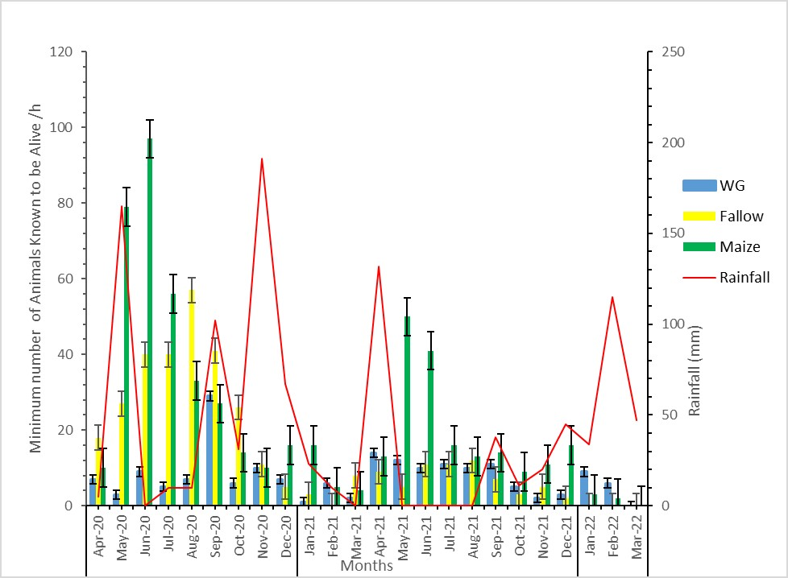

Figure 2: Density of Mastomys natalensis in different months and habitat types in relation to rainfall patterns

3.2 Effects of habitat types and trapping months on abundance of M. natalensis
Habitat types and trapping months showed varied influences on the density of M. natalensis (Table 1). Whereas Maize exhibited a significant positive influence, WG showed a negative significant effect (Table 1). Concerning the effect of the trapping months on the abundance of M.natalensis, months of May through September (all of them but May, falling in the dry season) showed a significant positive effect as contrasted to the months of January and February (all falling in a wet season) that had significant negative influence to the animal’s abundance (Table 1). Further, predicted density values of M.natalensis showed a low association with months falling in the wet season, January and February. However, the abundance increases reasonably in the last moth of the long rainy season (May 2020) and reaches peak during the early part of the dry season (in June 2020), but declines drastically in the short rainy season (October to December 2020)
(Figure 3a). Also, the predicted density values indicate varying associations with the habitat types. It seems to be associated mostly with Maize while it is least associated with the WG (Figure 3b).

Table 1: Effect of habitats and trapping months on abundance of M. natalensis basing on the density (MNA/ha) as revealed in the GLM model
Coefficients: Estimate Std. Error z value Pr(>|z|)
(Intercept) | 2.359e+00 | ±3.394e-01 | 6.950 | 3.65e-12 ***
HabitatsMaize | 6.092e-01 | ±1.692e-01 | 3.600 | 0.000 ***
HabitatsWG | -2.479e-01 | ±1.788e-01 | -1.387 | 0.000 ***
MonthsApr-21 | 3.617e-02 | ±4.568e-01 | -1.387 | 0.167
MonthsAug-20 | 9.728e-01 | ±4.381e-01 | 2.220 | 0.026 *
MonthsAug-21 | -1.783e-02 | ±4.584e-01 | -0.039 | 0.970
MonthsDec-20 | -3.323e-01 | ±4.698e-01 | -0.707 | 0.480
MonthsDec-21 | -7.089e-01 | ±4.881e-01 | -1.452 | 0.146
MonthsFeb-21 | -1.195e+00 | ±5.223e-01 | -2.288 | 0.022 *
MonthsFeb-22 | -1.455e+00 | ±5.469e-01 | -2.660 | 0.009 **
MonthsJan-21 | -7.850e-01 | ±4.926e-01 | -1.594 | 0.111
MonthsJan-22 | -1.019e+00 | ± 5.084e-01 | -2.005 | 0.045 *
MonthsJul-20 | 8.984e-01 | ±4.391e-01 | 2.046 | 0.041 *
MonthsJul-21 | 4.566e-02 | ±4.565e-01 | 0.100 | 0.920
MonthsJun-20 | 1.205e+00 | ±4.355e-01 | 2.767 | 0.006 **
MonthsJun-21 | 3.928e-01 | ±4.477e-01 | 0.877 | 0.380
MonthsMar-22 | -3.527e+01 | ±4.477e+06 | 0.000 | 10.00
MonthsMay-20 | 8.724e-01 | ±4.394e-01 | 1.985 | 0.047 *
MonthsMay-21 | 4.300e-01 | ±4.470e-01 | 0.962 | 0.336
MonthsNov-20 | -1.147e-01 | ±4.616e-01 | -0.248 | 0.804
MonthsNov-21 | -8.073e-01 | ±4.940e-01 | -1.634 | 0.102
MonthsOct-20 | 2.544e-01 | ±4.509e-01 | 0.564 | 0.573
MonthsOct-21 | -8.078e-01 | ±4.940e-01 | -1.635 | 0.102
MonthsSep-20 | 1.061e+00 | ±4.371e-01 | 2.426 | 0.015 *
MonthsSep-21 | -1.245e-01 | ±4.619e-01 | -0.270 | 0.787
Signif. codes: 0 ‘ ***’ 0.001 ‘**’ 0.01 ‘*’ 0.05 ‘.’ 0.1 ‘ ’ 1

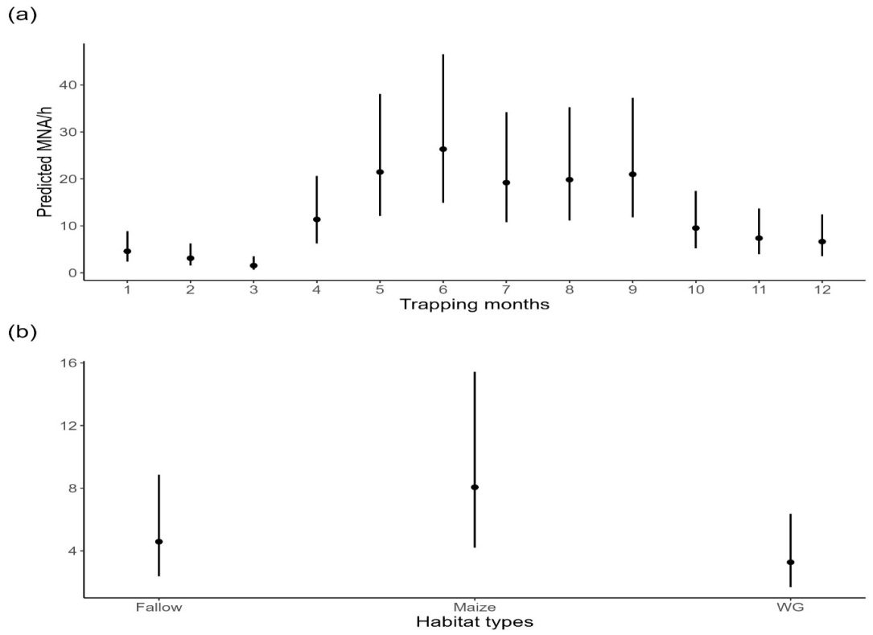

Figure 3: Upper plot (a) shows predicted values of M.natalensis densities (MNA/h) from January (1) to December (12). The lower plot (b) indicates predicted M.natalensis densities in each of the three habitat types (Fallow, Maize and WG). In all figures predicted MNA/h are for all months, both dry and wet seasons, for pooled data for January to December for all trapping years

3.3 Breeding patterns, relationship between rainfall and breeding patterns and the effect of habitat types and rainfall on the number of breeding females
Sexually active females dominated the Maize crop fields in both dry (W = 41, p-value = 0.001) and wet seasons (W = 158.5, p-value = 0.003), but dominated the WG (W= 158, p-value = 0.002) and Fallow (W = 140, p-value = 0.025) as compared to the non-sexually active only during the wet season. On the contrary, non-sexually active females were more abundant than the sexually active ones in the Fallow than the other two habitat types during the dry season (W = 46.5, p-value = 0.014). Basically, there was no statistical difference in the abundance of the sexually active females in different habitats (Χ² = 3.5198, df = 2, pvalue = 0.172 ) and during different seasons (W = 584, p-value = 0.472). However, predicted values of sexually active females showed more association with Fallow, followed by Maize and lastly by WG (Figure 4) and also, there were fluctuations of the same in relation to rainfall patterns (Figure 5). Nevertheless, their abundance reached highest peak in the Maize after the long rainy season, June 2020 while abundance of females of both statuses remained below average both in the WG and in the Fallow (Figure 5).

Furthermore, whereas, spearman’s rank correlation between numbers of breeding females and monthly rainfall revealed a weak negative non-significant correlation (r(67) = -0.09, p = 0.446), the generalized linear model test on the effect of habitat types and rainfall revealed varied effects on M.natalensis breeding pattern. Furthermore, although both Maize and WG habitats showed significant negative influences, their interactions revealed positive non-significant influences as contrasted from rainfall that had a non- significant negative influence (Table 2). Also, predicted numbers of actively breeding M.natalensis comparatively showed to be more associated with Fallow as compared to Maize and WG.

Table 2: Generalized linear model results of the effect of habitats, trapping months and rainfall on the number of breeding females of M. natalensis
Coefficients: | Estimates |  | Std.Error | zvalue |  | Pr(>|z|)
(Intercept) |  | 2.740992 | ±0.3312733 | 8.274 | < 0.001 ***
HabitatsMaize |  | -0.841417 | ±0.4746093 | -1.773 | < 0.001.
HabitatsWG |  | -0.000847 | ±0.4815767 | -2.93 | 0.003 **
Rainfall |  | -0.000847 | ±0.0047247 | -0.179 | 0.858
HabitatsMaize:Rainfall |  | 0.000791 | ±0.0067636 | 0.117 | 0.907
HabitatsWG:Rainfall |  | 0.004667 | ±0.0067876 | 0.688 | 0.492
Signif. codes: 0 ‘***’ 0.001 ‘**’ 0.01 ‘*’ 0.05 ‘.’ 0.1 ‘ ’ 1

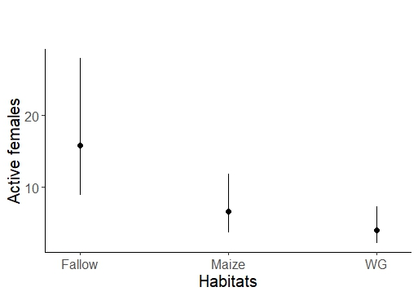

Figure 4: Predicted numbers of active breeding females in the three habitat types (Fallow, Maize and WG) for all months (both dry and wet seasons) for pooled data for January to December for all trapping years

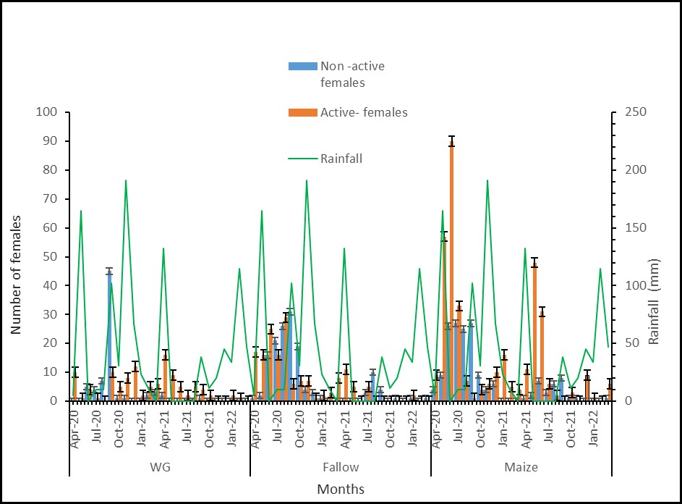

Figure 5: Fluctuations in number of breeding (active) and non- breeding (non-active) female Mastomys natalensis in different months, habitat types in relation to rainfall patterns

3.4 Trend of total females across habitats and seasons
Further, the abundance (total number) of female Mastomys natalensis varied significantly across the three habitats (Figure 6; Χ² = 6.778, df = 2, p = 0.034) without significant variation between seasons (W = 787.5, p = 0.117). According to the post-hoc test performed using a Wilcoxon test, the difference existed between WG and Fallow (p= 0.03) throughout the trapping period and their abundance was noted to peak differently in different months. For example, the population exhibited main peaks (higher population size in each habitat) and secondary
peaks (high population size in each habitat but comparatively less than the main ones) in the Maize in June 2020 and in May 2021, but peaked in the WG and Fallow later on in August/September 2020 (Figure 6).

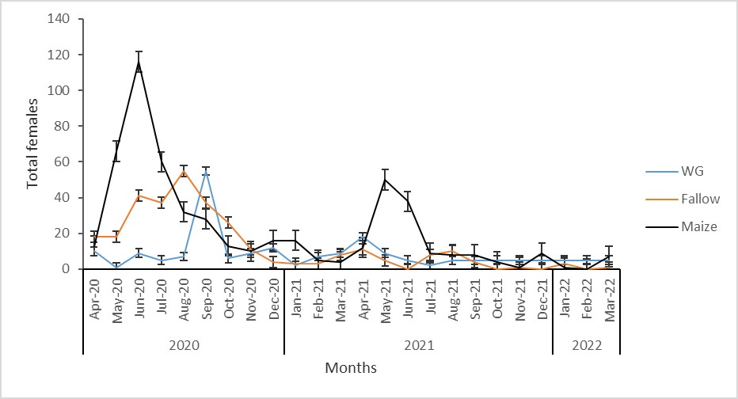

Figure 6: Fluctuation in abundance of female Mastomys natalensis in different habitat types and trapping months

4.0 Discussion
The population density of Mastomys natalensis varied between habitats and seasons. The highest density occurred in the maize crop fields, and that was attributed to the higher availability of food resources most time of the year than in the fallow land and the wooded grassland (Rwebuga et al., 2023), which could have favoured its higher proliferation. According to studies conducted in different parts of eastern and southern Africa, variation in abundance of M. natalensis due to difference in habitat quality among other factors is a common phenomenon (Agerie and Afework, 2015; Leirs, 1995; Leirs et al.,
1996b; Makundi et al., 2006; Mulungu et al., 2013a). This is because status of the resources being offered by a habitat, enables some species to flourish well compared to others (Brown 1984; Brown et al., 1996; Chimimba et al., 2004; Mulungu et al., 2013). Such habitat effect ascertains that abundance of M. natalensis may be patchy, with large numbers occurring in quality habitats while other nearby habitats may still maintain no/or less individuals (Mdangi et al., 2013). This phenomenon probably could explain the presence of least abundance of M. natalensis in the wooded grassland compared to other habitat types. For example, (Leirs, 1995) found 85% of the captured small mammals in farmland and fallow areas in Morogoro, Tanzania to be M. natalensis while in natural miombo woodland and moist grassland 50 km away, the species comprised only 27% of the trapped small mammals in a community of 17 species. On the other hand, our findings are partially different from other investigators elsewhere, for example, (Mulungu et al., 2013) recorded higher population density of the species in fallow land, which in the current study ranked second. Their results from irrigated rice fields were associated with the species nesting and commuting behaviour (Ylonen and Singleton, 2002), the consequential effect being the probable reason for its substantial numbers of individuals trapped in the fallow land before reaching their destination i.e., the rice fields (Monadjem and Perrin, 1998) .

The two density peaks of Mastomys natalensis population in the maize crop fields in June 2020 and in May 2021, and overall higher density during the dry than wet season were linked to rainfall pattern. According to Leirs (1995) , the species breeds during the long rains and generally starts one month after the usual peak rainfall (March/April), and continues to end of the dry season (September), substantiating the influence of rainfall under a bimodal rainfall pattern (Leirs, 1995; Leirs et al., 1989; Linn, 1991; Telford, 1989). Therefore, the consequent high population observed in the dry season during the present study is a
result of high breeding activity in the long wet season (Christensen, 1993; Leirs et al., 1990). Whereas, maize crop fields exhibited a significant positive influence on the abundance of M.natalensis, the wooded grassland habitat showed a high significant negative effect as this habitat floods easily because it is more bowl shaped, and stays with water for comparatively longer periods (Rwebuga et al., 2023).

Less effect of the short rainy season observed in this study aligns with results by (Brown et al., 1996) at the inner delta of the Niger River in Mali, who reported low survival rates of Mastomys huberti due to deaths resulting from flooding of burrows caused by the substantial precipitation of the short rainy season from mid-November to early March. Farmers in our study area also reported about noticing dead individuals of different rodent species during farm preparations in November (short rainy season) for the first sowing season. The flooding effect was also reflected by the generalized linear model results in this study. This phenomenon, could further be explained by the fact that trapping months of January, February and March, occasionally having long standing water, depending on previous years’ amount of rainfall, had significant negative effect on the abundance of the mammalian species. This went in line with its predicted density values that seem to be low in months of January and February, but increasing from April/May reaching peak in June, after which it falls a little in July, and then levels off to September, followed by a linear decline in the months of the short rainy season, October/November to December.

Following establishment of breeding pattern through determining the number of sexually/reproductively active and non-sexually active females in different habitats and months, sexually active females were found to dominate in the maize crop fields in both dry and wet seasons. The pattern suggests that, comparatively, breeding occurred more in the maize crop fields as compared to other habitats, although it was
continuous throughout the year in all habitats as contrasted to (Leirs et al.,1996b) who reported breeding of M.natalensis to be seasonal. However, only a small proportion of the animals were observed to be actively breeding in some months in both seasons. Also, the breeding females could not be noticed completely in the months when there were zero captures. Our findings are in line with (Mulungu et al., 2013) who observed less breeding females of M. natalensis during the months of August to October compared to other months whereby high peaks of breeding females were observed in the months of June (early dry season) and December (short rainy season).

The observed pattern corresponded to the maturity and harvesting of rice crop in their study area (Mulungu et al., 2013). Less or lack of captured individuals during the wet season was also reported by (Granjon et al., 2005) who suggested it to be linked to low survival due to flooding of the small mammals’ nests. Furthermore, low survival effect due to flooding in our study area, could also be explained by spearman’s rank correlation results between numbers of breeding females and monthly rainfall, which revealed a weak negative but non-significant correlation. Also, generalized linear model results revealed that both maize crop fields and wooded grassland habitats and rainfall had negative influences on the numbers of breeding females as contrasted to their interactions, which revealed positive but non-significant influences and hence modifying the influence of the main effects.

The continuous breeding of M.natalensis during dry season, low though could be attributed to availability of food resources as was pointed out by Skoglund (1992) that seed bank reaching up to 21, 000 seeds m² is available in the Serengeti ecosystem, which rodents can easily get access to especially during the dry season. Also, availability of after-harvest maize cobs and later access to seeds sown in the maize crop fields during the minor cropping season starting in September/October
depending on the availability of precipitation is another source of food supporting some reproduction activity.

Further, the pattern for the wooded grassland, fallow land and maize crop fields in relation to quality food availability (Rwebuga et al., 2023), which in turn is linked to rainfall pattern (Christensen, 1993; Leirs et al., 1990), probably justifies higher abundance of sexually active females in maize crop fields in both dry and wet season. But in turn, became dominant in the wooded grassland and fallow land, as compared to the non-sexually active ones, during the wet season. Generally, however, predicted numbers of active females seem to be more associated with fallow land compared to other habitat types probably due to its closeness to crop fields and the type of vegetation and cover it provides to the rodent species (Mayamba et al., 2019). Moreover, throughout the trapping period in all three habitats, the total number of females peaked during the dry season between May and October 2020. Regarding individual habitats, highest and secondary peaks were recorded in the maize crop fields in June 2020 and May 2021, respectively whereas wooded grassland and fallow land peaked in August/September 2020. The pattern is probably due to that May to October covers the period in which seeds/cereals are plentiful in each of the experimental habitat as reported in (Mulungu et al., 2013b).

5.0 Conclusions
Based on results of the study, the population density of Mastomys natalensis fluctuated across months of trapping and between habitats. Numerically, abundance of M. natalensis was higher in the Maize crop fields compared to other habitats. Despite the continuous breeding of the species in the Maize crop fields, the density was higher in the dry season compared to the first wet season (basically from October to January), a period that coincided with the short rains. Hence, population control could be more impactful during this time when populations are low to allow farmers to maximize maize crop production. Also, future studies should try to find out why M. natalensis density declines during a period expected to have sufficient supply of food resources in these areas.

Acknowledgments: We are extremely grateful to the African Centre of Excellence for Innovative rodent pest Management and Biosensor Technology Development-ACE II for sponsoring this project, the Tanzania Wildlife Management Authority for providing a research permit into Kijereshi Game Reserve and the Sokoine University of Agriculture for approving a research permit. We are also thankful to Professor Fortunatus B.S. Makonda for doing the vegetation sampling and analysis and Mr Khalidi Kibwana from SPMC for assisting with data collection in the field.

Author Contributions: Conceptualization, methodology, data curation, formal analysis and drafting and/or commenting on the manuscript: E.J.R, S.N.H, L.S.M and A.A.R. All authors have read and agreed to the submission of the manuscript.

Funding: This research was funded by The African Centre of Excellence for Innovative Rodent Pest Management and Biosensor Technology Development. The Sokoine University of Agriculture, Tanzania-ACEII-Credit No. 5799-TZ.
Conflicts of Interest: The authors declare no conflict of interest.

Institutional Review Board Statement: The study was conducted according to the guidelines of the Declaration of Helsinki, and approved by the Institutional Review Board of the Sokoine University of Agriculture for research, regulations and guidelines-2019 through research clearance approval referenced SUA/ADM/R.1/8/561/2020 and the Tanzania Wildlife Conservation Act No. 5 of 2009.
Data availability: All data used in this analysis can be obtained from the corresponding author upon request.

References
Agerie, A. and Afework, B. (2015). Population structure of rodents in Alage, Southern Ethiopia. Journal of Ecology and The Natural Environment, 7(1), 7–13. https://doi.org/10.5897/jene2014.0492
Andreassen, H. P., Sundell, J., Ecke, F., Halle, S., Haapakoski, M., Henttonen, H., Huitu, O., Jacob, J., Johnsen, K., Koskela, E., Luque-Larena, J. J., Lecomte, N., Leirs, H., Mariën, J., Neby, M., Rätti, O., Sievert, T., Singleton, G. R., van Cann, J., and Ylönen, H. (2021). Population cycles and outbreaks of small rodents: ten essential questions we still need to solve. Oecologia, 195(3), 601–622. https://doi.org/10.1007/s00442-020-04810-w
Bendik, N. F. and Dries, L. A. (2018). Density-dependent and density-independent drivers of population change in Barton Springs salamanders. Ecology and Evolution, 8(11), 5912–5923. https://doi.org/10.1002/ece3.4130
Bergstrom, B. J., Sensenig, R. L., Augustine, D. J. and Young, T. P. (2018). Searching for cover: soil enrichment and herbivore exclusion, not fire, enhance African savanna small-mammal abundance. Ecosphere, 9(11). https://doi.org/10.1002/ecs2.2519
Bjørnstad, O. N. and Grenfell, B. T. (2001). Noisy clockwork: Time series analysis of population fluctuations in animals. In Science (Vol. 293, Issue 5530). https://doi.org/10.1126/science.1062226
Borremans, B., Hughes, N. K., Reijniers, J., Sluydts, V., Katakweba, A. A. S., Mulungu, L. S., Sabuni, C. A., Makundi, R. H. and Leirs, H. (2014). Happily together forever: Temporal variation in spatial patterns and complete lack of territoriality in a promiscuous rodent. Population Ecology, 56(1), 109–118. https://doi.org/10.1007/s10144-013-0393-2
Bowman, J., Forbes, G., Dilworth, T., Bowman, J., Forbes, G. and Dilworth, T. (2000). The Spatial Scale of Variability in Small-Mammal Populations Published by : Wiley on behalf of Nordic Society Oikos Stable URL : https://www.jstor.org/stable/3683103 The spatial scale of variability in small-mammal populations. 23(3), 328–334.

Brown, J. H. (1984). On The Relationship Between Abundance And Distribution Of Species Spatial Variation in Abundance Witlzin Species. The American Naturalist, 124(2), 255–279. https://doi.org/10.1086/284267
Brown, J. H., Stevens, G. C. and Kaufman, D. M. (1996). The geographic range: Size, shape, boundaries, and internal structure. Annual Review of Ecology and Systematics, 27(May 2014), 597–623. https://doi.org/10.1146/annurev.ecolsys.27.1.597
Campbell, K. and Hofer, H. (1995). People and wildlife: spatial dynamics and zones of interaction. In: Serengeti II: Dynamics, Management, and Conservation of an Ecosystem (Eds A. R. E. Sinclair and P. Arcese). The University of Chicago Press, Chicago and London.
Cao, C., Shuai, L. Y., Xin, X. P., Liu, Z. T., Song, Y. L. and Zeng, Z. G. (2016). Effects of cattle grazing on small mammal communities in the Hulunber meadow steppe. PeerJ, 2016(8). https://doi.org/10.7717/peerj.2349
Caro, T. and Scholte, P. (2007). When protection falters. African Journal of Ecology, 45(3), 233–235. https://doi.org/10.1111/j.1365-2028.2007.00814.x
Chimimba, C. T., Aarde, R. J. Van and Fairall, N. (2004). The distribution of two medically and agriculturally important cryptic rodent species , Mastomys natalensis and M . coucha ( Rodentia : Muridae ) in South Africa. 39(October), 235–245.
Christensen, J. T. (1993). The seasonal variation in breeding and growth of Mastomys natalensis (Rodentia: Muridae): evidence for resource limitation. African Journal of Ecology, 31(1). https://doi.org/10.1111/j.1365-2028.1993.tb00513.x
Colangelo, P., Verheyen, E., Leirs, H., Tatard, C., Denys, C., Dobigny, G., Duplantier, J. M., Brouat, C., Granjon, L. and Lecompte, E. (2013). A mitochondrial phylogeographic scenario for the most widespread African rodent, Mastomys natalensis. Biological Journal of the Linnean Society, 108(4). https://doi.org/10.1111/bij.12013

Granjon, L., Cosson, J.F. O., Quesseveur, E. and Sicard, B. (2005). Population dynamics of the multimammate rat mastomys huberti in an annually flooded agricultural region of central mali. https://academic.oup.com/jmammal/article/86/5/997/2219503
Gunda, D. M., Chambi, D. and Eustace, A. (2022). Do vegetation, disturbances, and water influence large mammal distribution? Geology, Ecology, and Landscapes, 6(2), 150–158. https://doi.org/10.1080/24749508.2020.1809060
Happold, D. C. . (2013). Mammals of Africa (Volume III). Bloomsbury Publishing.
Jacob, J. and Brown, J. S. (2000). Microhabitat use, giving-up densities and temporal activity as short- and long-term anti-predator behaviors in common voles. Oikos, 91(1). https://doi.org/10.1034/j.1600-0706.2000.910112.x
Krebs, C. J. (1966). Demographic Changes in Fluctuating Populations of Microtus californicus Author ( s ): Charles J . Krebs Published by : Wiley on behalf of the Ecological Society of America Stable. Ecological Society of Ame. 36(3), 239–273. URL : https://www.jstor.org/stable/1942418 Krohne, D. T., & Burgin, A. B. (1990). The scale of demographic heterogeneity in a population of Peromyscus leucopus. Oecologia, 82(1). https://doi.org/10.1007/BF00318539
Leirs, H. (1992). Population ecology of Mastomys natalensis (Smith, 1834) – implication for rodent control in Africa.. PhD Thesis, University of Antwerp, Antwerp, Belgium. University of Antwerp, Antwerp, Belgium,.
Leirs, H. (1995). Population ecology of Mastomys natalensis (Smith 1834): implication for rodent control in East Africa.
Leirs, H., Stuyck, J., Verhagen, R. and Verheyen, W. (1990). Seasonal variation in growth of Mastomys natalensis (Rodentia: Muridae) in Morogoro, Tanzania. African Journal of Ecology, 28, 298–306.

Leirs, H., Stuyck, J., Verhagen, R. and Verheyen, W. (1990). Seasonal variation in growth of Mastomys natalensis (Rodentia: Muridae) in Morogoro, Tanzania. In African Journal of Ecology (Vol. 28, Issue 4, pp. 298–306). https://doi.org/10.1111/j.1365-2028.1990.tb01164.x
Leirs, H., Verhagen, R., & Verheyen, W. (1993). Productivity of Different Generations in a Population of Mastomys natalensis Rats in Tanzania. In Source: Oikos (Vol. 68, Issue 1). https://www.jstor.org/stable/3545308?seq=1&cid=pdf-
Leirs, H., Verhagen, R., Verheyen, W., Mwanjabe, P., & Mbise, T. (1996). Forecasting Rodent Outbreaks in Africa: An Ecological Basis for Mastomys Control in Tanzania. The Journal of Applied Ecology, 33(5), 937. https://doi.org/10.2307/2404675
Leirs, H., Verheyen, W., Michiels, M., Verhagen, R., & Stuyck, J. (1989). The relation between rainfall and the breeding season of Mastomys natalensis (Smith, 1834) in Morogoro, Tanzania. Annales de La Societe Royale Zoologique de Belgique, 119(1977), 59–64.
Linn, I. J. (1991). Influence of 6-methoxybenzoxazolinone and green vegetation on reproduction of the multimammate rat Mastomys coucha. South African Journal of Wildlife Research, 21(2), 33–37. https://doi.org/https://journals.co.za/doi/abs/10.10520/EJC116871
Makundi, R. H., Massawe, A. W. and Mulungu, L. S. (2006). Management of Selected Crop Pests in Tanzania. 224–239.
Makundi, R. H., Massawe, A. W., Mulungu, L. S. and Katakweba, A. (2010). Species diversity and population dynamics of rodents in a farm-fallow field mosaic system in Central Tanzania. African Journal of Ecology, 48(2), 313–320. https://doi.org/10.1111/j.1365-2028.2009.01109.x.

Massawe, A. W., Mulungu, L. S., Makundi, R. H., Dlamini, N., Eiseb, S. J., Kirsten, F., Mahlaba, T., Malebane, P., Maltitz, E. Von, Monadjem, A., Taylor, P., Tutjavi, V. and Belmain, S. R. (2011). Spatial and temporal population dynamics of rodents in three geographically different regions in Africa: Implication for ecologically-based rodent management. African Zoology, 46(2), 393–404. https://doi.org/10.3377/004.046.0219
Mayamba, A., Byamungu, R. M., Makundi, R. H., Kimaro, D. N., Isabirye, M., Massawe, A. W., Kifumba, D., Nakiyemba, A., Leirs, H., Mdangi, M. E., Isabirye, B. E. and Mulungu, L. S. (2019). Species composition and community structure of small pest rodents (Muridae) in cultivated and fallow fields in maize-growing areas in Mayuge district, Eastern Uganda. Ecology and Evolution, 9(13), 7849–7860. https://doi.org/10.1002/ece3.5371
McCauley, D. J., Salkeld, D. J., Young, H. S., Makundi, R., Dirzo, R., Eckerlin, R. P., Lambin, E. F., Gaffikin, L., Barry, M. and Helgen, K. M. (2015). Effects of land use on plague (Yersinia pestis) activity in rodents in Tanzania. American Journal of Tropical Medicine and Hygiene, 92(4), 776–783. https://doi.org/10.4269/ajtmh.14-0504
McSherry, M. E. (2015). "Human-Managed vs. Natural Grazing Systems: Exploring Effects of Livestock and Wildlife Grazing at Multiple Scales. https://surface.syr.edu/etd/335
Mdangi, M., Mulungu, L. S., Massawe, A. W., Eiseb, S. J., Tutjavi, V., Kirsten, F., Mahlaba, T., Malebane, P., von Maltitz, E., Monadjem, A., Dlamini, N., Makundi, R. H. and Belmain, S. R. (2013). Assessment of rodent damage to stored maize (Zea mays L.) on smallholder farms in Tanzania. International Journal of Pest Management, 59(1), 55–62. https://doi.org/10.1080/09670874.2012.744495
Monadjem, A. and Perrin, M. R. (1998). Effects of supplemental food on the habitat selected by Mastomys natalensis (Muridae: Rodentia) in a subtropical grassland in Swaziland. South African Journal of Zoology, 33(3), 172–177. https://doi.org/10.1080/02541 858.1998.11448468

Monadjem, A., Taylor, P. J., Denys, C. and Cotterill, F. P. D. (2015). Rodents of sub-saharan Africa: A biogeographic and taxonomic synthesis. In Rodents of Sub-Saharan Africa: A Biogeographic and Taxonomic Synthesis. Walter de Gruyter GmbH.
Monica, S., Flora, J. M., Joseph, O. O. and Eivin, R. (2020). Small mammal community demography and reproductive seasonality under protection, pastoralism and agriculture in the Serengeti Ecosystem, Tanzania. International Journal of Biodiversity and Conservation, 12(4), 253–269. https://doi.org/10.5897/ijbc2020.1397
Mulungu, L. S., Ngowo, V., Mdangi, M. E., Katakweba, A. S., Tesha, P., Mrosso, F. P., McHomvu, M., Massawe, A. W., Monadjem, A., Kilonzo, B. and Belmain, S. R. (2016). Survival and recruitment of the multimammate mouse, Mastomys natalensis (Smith 1834), in a rice agro-ecosystem. Mammalia, 80(2), 205–210. https://doi.org/10.1515/mammalia-2014-0150
Mulungu, L. S., Ngowo, V., Mdangi, M., Katakweba, A. S., Tesha, P., Mrosso, F. P., Mchomvu, M., Sheyo, P. M. and Kilonzo, B. S. (2013a). Population dynamics and breeding patterns of multimammate mouse, Mastomys natalensis (Smith 1834), in irrigated rice fields in Eastern Tanzania. Pest Management Science, 69(3), 371–377. https://doi.org/10.1002/ps.3346
Mulungu, L. S., Ngowo, V., Mdangi, M., Katakweba, A. S., Tesha, P., Mrosso, F. P., Mchomvu, M., Sheyo, P. M. and Kilonzo, B. S. (2013b). Population dynamics and breeding patterns of multimammate mouse, Mastomys natalensis (Smith 1834), in irrigated rice fields in Eastern Tanzania. Pest Management Science, 69(3), 371–377. https://doi.org/10.1002/ps.3346

Mulungu, L. S., Sixbert, V., Ngowo, V., Mdangi, M., Katakweba, A. S., Tesha, P., Mrosso, F. P., McHomvu, M., Kilonzo, B. S. and Belmain, S. R. (2015). Spatio-temporal patterns in the distribution of the multi-mammate mouse, Mastomys natalensis, in rice crop and fallow land habitats in Tanzania. Mammalia, 79(2), 177–184. https://doi.org/10.1515/mammalia-2014-0006
Mwasapi, B. S. and Rija, A. A. (2022). Local habitat characteristics influence abundance and community structure of rodents in a regenerating Lulanda reserved forest, southern Tanzania. Restoration Ecology, 30(1), 1–10. https://doi.org/10.1111/rec.13501
Previtali, M. A., Lima, M., Meserve, P. L., Kelt, D. A. and Gutiérrez, J. R. (2009). Population Dynamics of Two Sympatric Rodents in a Variable Environment: Rainfall, Resource Availability, and Predation (Vol. 90, Issue 7).
Ranta, E., Lindstrom, J., Linden, H., Ranta, E. S. A., T, J. A. N. L. and Lindent, H. (1995). Synchrony in Tetraonid Population Dynamics Published by : British Ecological Society Synchrony in tetraonid population dynamics. 64(6), 767–776.
Rwebuga, E. J., Mulungu, L. S., Rija, A. A., Hassan, S. N. (2023). Ecological correlates of population abundance of a pest small mammal species ( Mastomys natalensis ) inhabiting a protected area-farmland landscape in western. Tanzania Journal of Forestry and Nature Conservation, 92(1), 159–169.
Sikes, R. S., & Gannon, W. L. (2011). Guidelines of the American Society of Mammalogists for the use of wild mammals in research. Journal of Mammalogy, 92(1). https://doi.org/10.1644/10-MAMM-F-355.1
Skoglund, J. (1992). The Role of Seed Banks in Vegetation Dynamics and Restoration of Dry Tropical Ecosystems. Journal of Vegetation Science, 3(3), 357–360.

Stenseth, N. C., Leirs, H., Skonhoft, A., Davis, S. A., Pech, R. P., Harry, P., Singleton, G. R., Lima, M., Machang, R. S., Makundi, R. H., Zhang, Z., Brown, P. R., Shi, D., & Wan, X. (2003). Mice , rats , and people : the bio-economics of agricultural rodent pests In a nutshell : Front Ecol Environ.
Tarsi, K. and Tuff, T. (2012). Introduction to population demographics. In Nature Education Knowledge (Vol. 3, Issue 11, p. 3). http://www.nature.com/scitable/knowledge/library/introduction-to-population-demographics-83032908
Telford, S. R. (1989). Population Biology of the Multi-mammate Rat, Praomys (Mastomys) Natalensis at Morogoro, Tanzania, 1981-1985. University of Florida.
Thompson, R. C. A. (2013). Parasite zoonoses and wildlife: One health, spillover and human activity. International Journal for Parasitology, 43(12–13), 1079–1088. https://doi.org/10.1016/j.ijpara.2013.06.007
Umetsu, F., & Pardini, R. (2007). Small mammals in a mosaic of forest remnants and anthropogenic habitats - Evaluating matrix quality in an Atlantic forest landscape. Landscape Ecology, 22(4), 517–530. https://doi.org/10.1007/s10980-006-9041-y
Utrera, A., Duno, G., Ellis, B. A., Salas, R. A., De Manzione, N., Fulhorst, C. F., Tesh, R. B.and Mills, J. N. (2000). Small mammals in agricultural areas of the western llanos of Venezuela: Community structure, habitat associations, and relative densities. Journal of Mammalogy, 81(2), 536–548. https://doi.org/10.1644/1545-1542(2000)081<0536:SMIAAO>2.0.CO;2
Ylonen,. H.J. Jacob, Davies, M.J. and Singleton, G. R. (2002). Predation risk and habitat selection of Australian house mice Mus domesticus during an incipient plague: desperate behaviour due to food depletion. Oikos, 99, 284–289.

CHAPTER FOUR

PAPER III

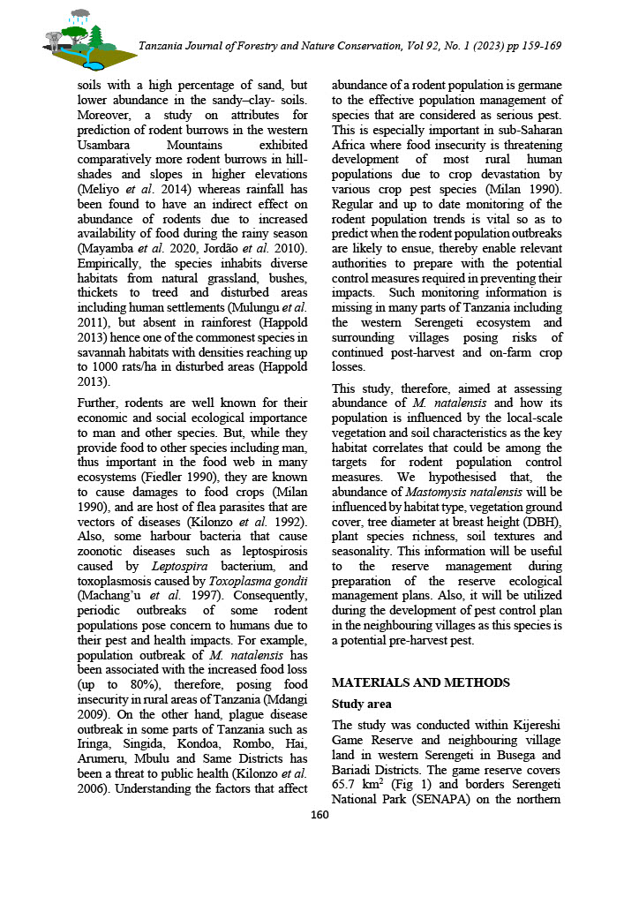

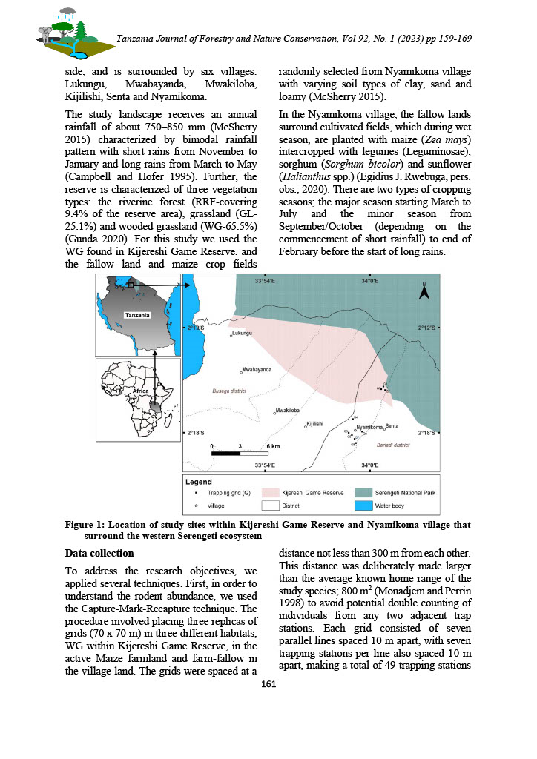

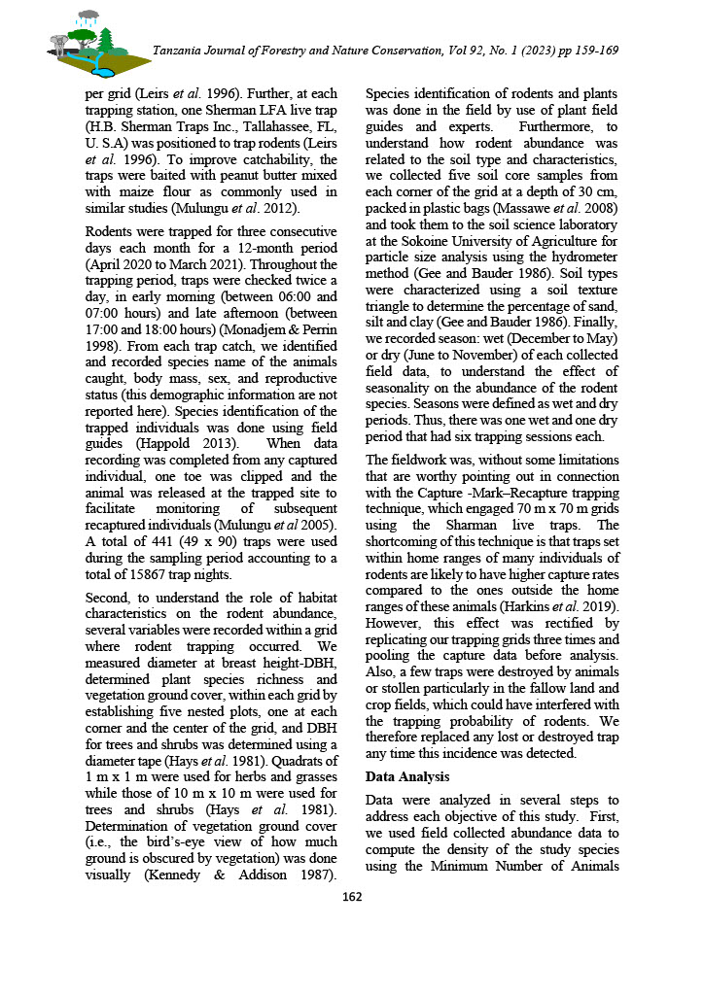

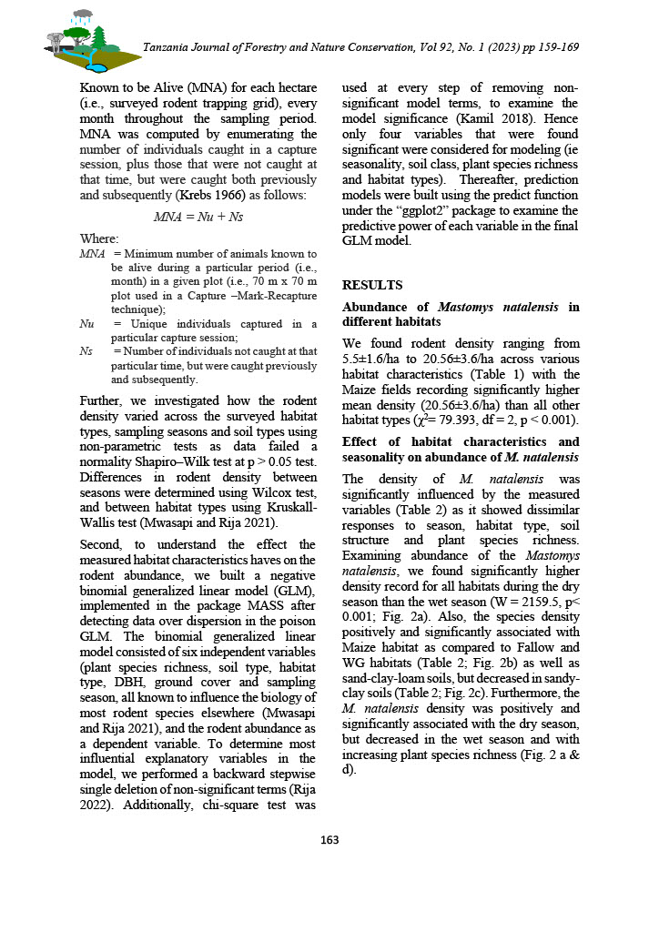

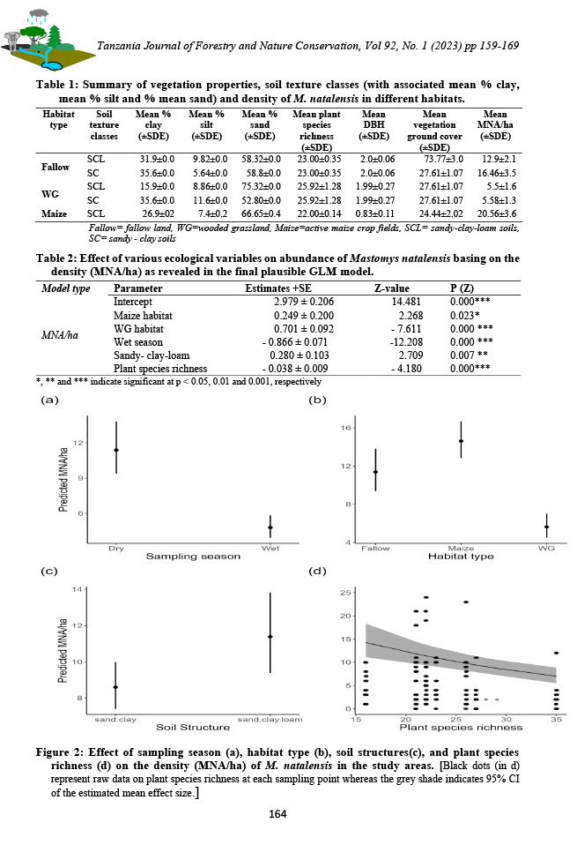

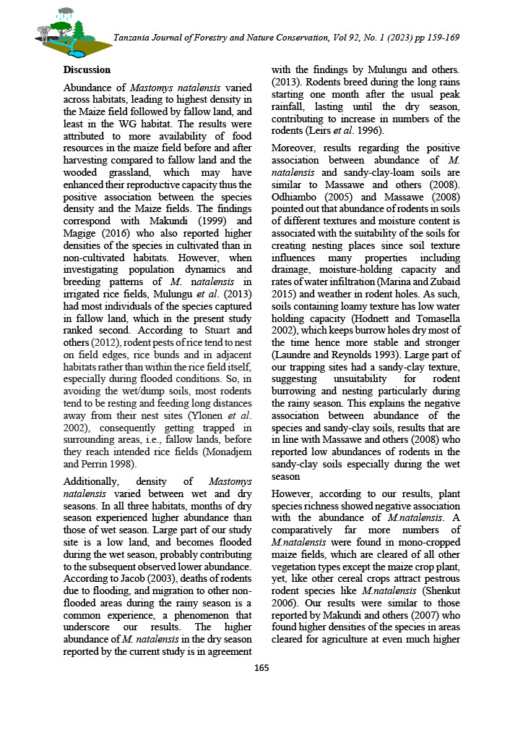

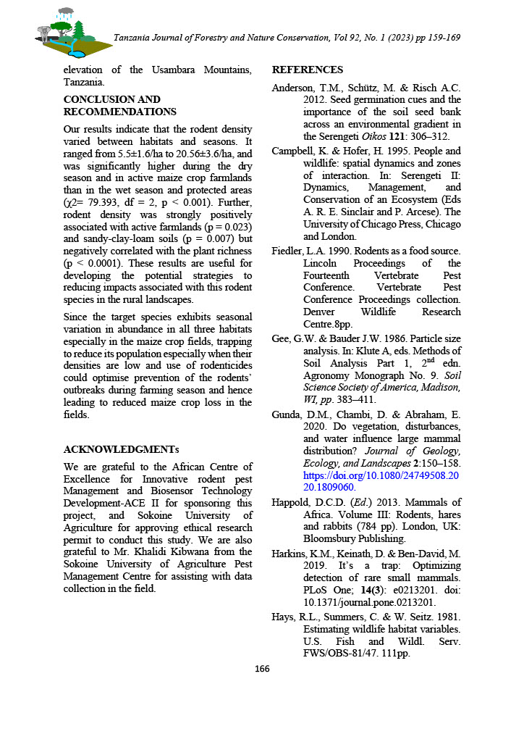
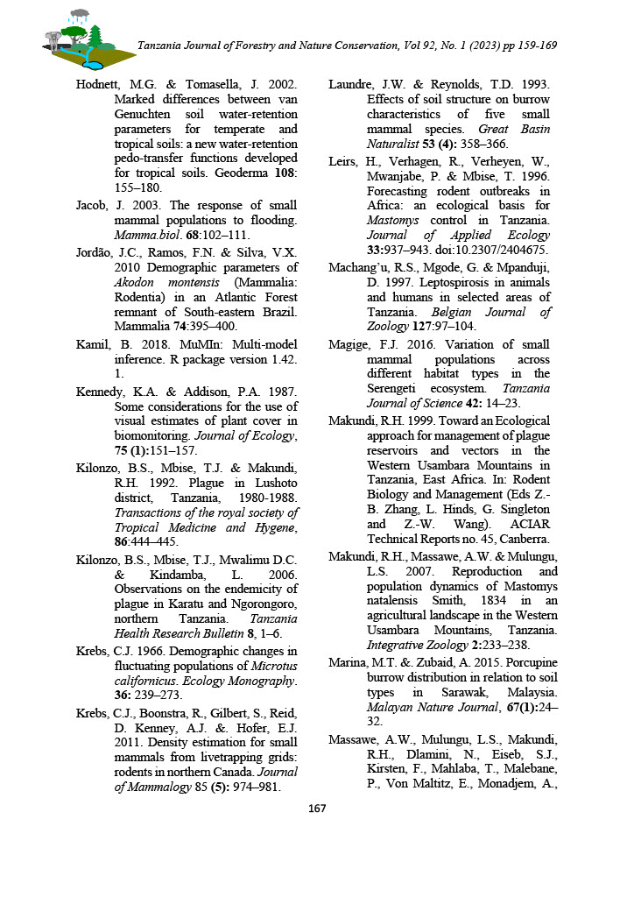

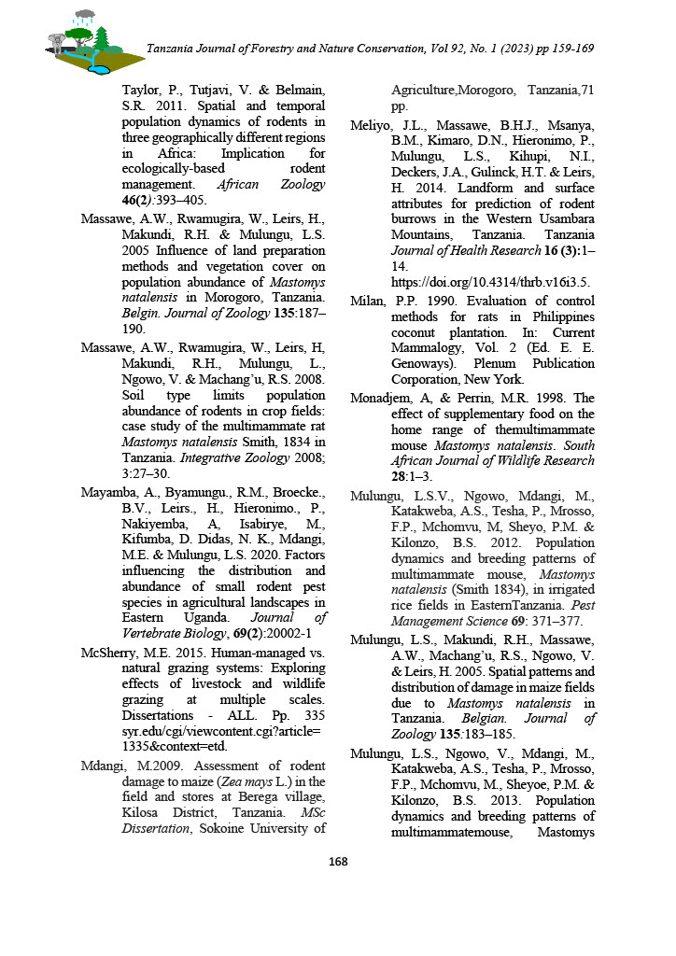

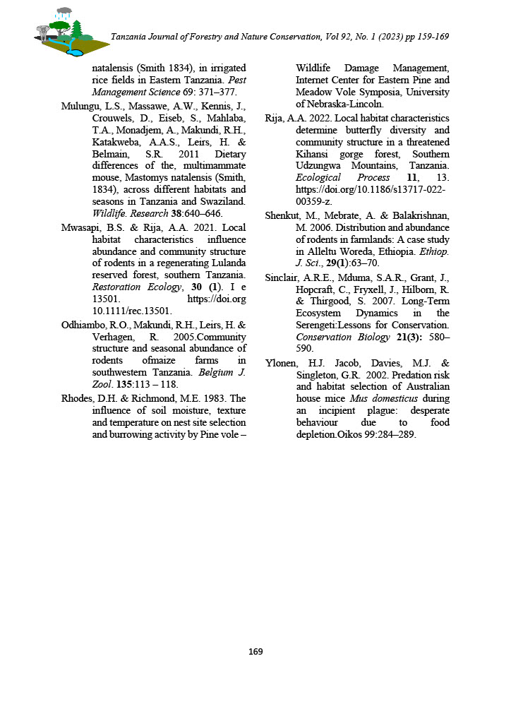

CHAPTER FIVE

PAPER IV
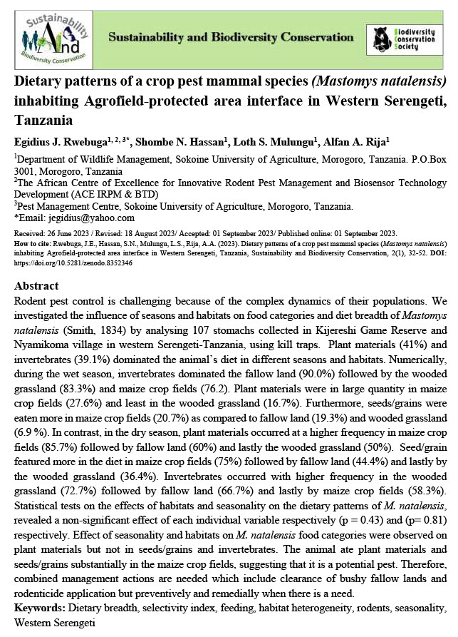

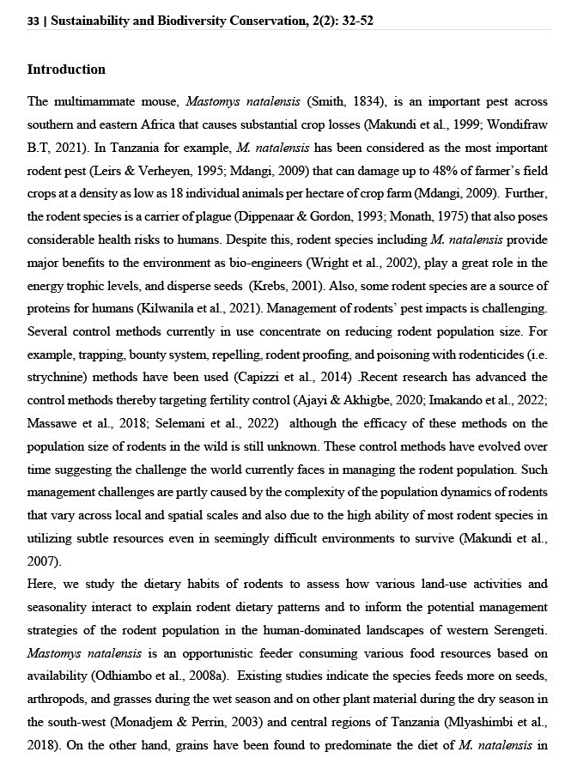

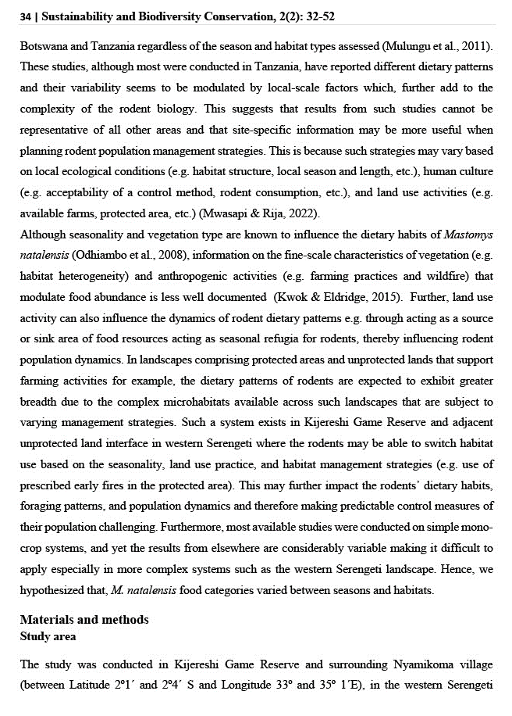
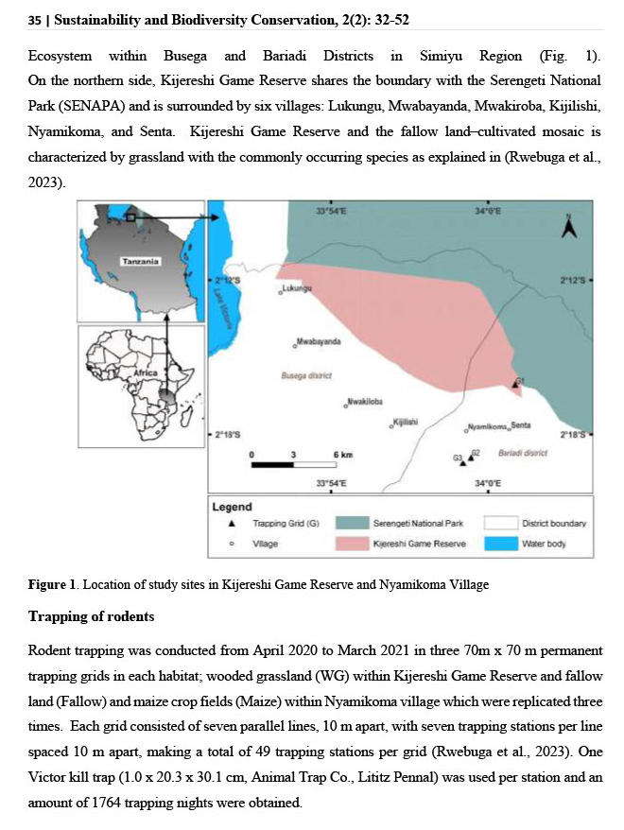

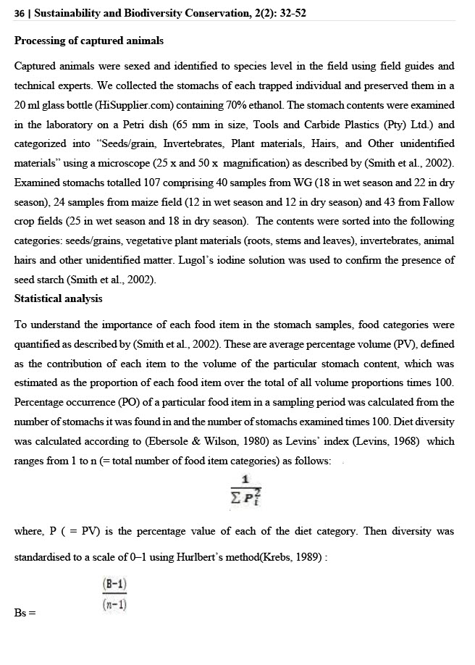

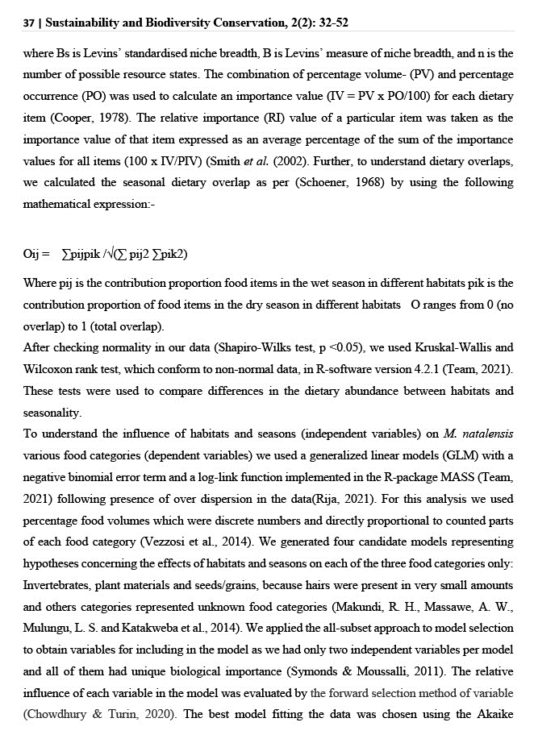

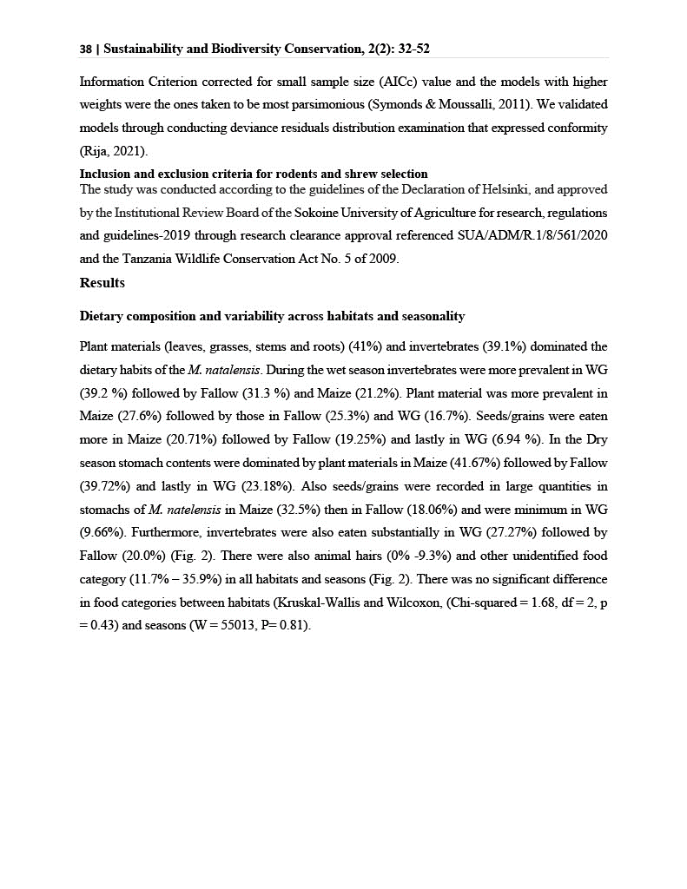

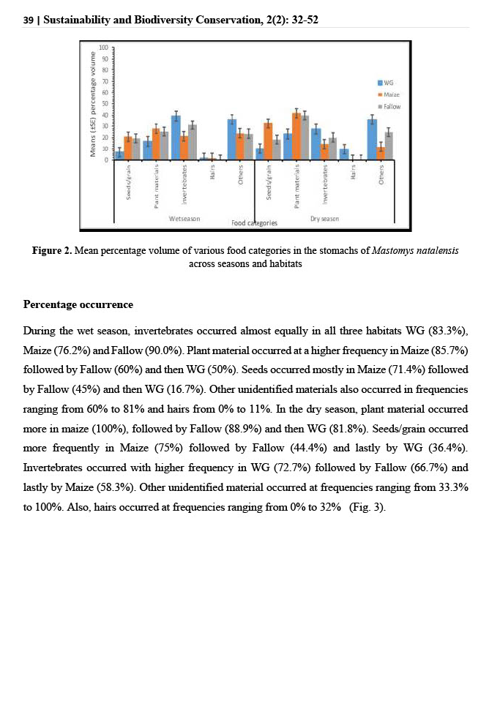
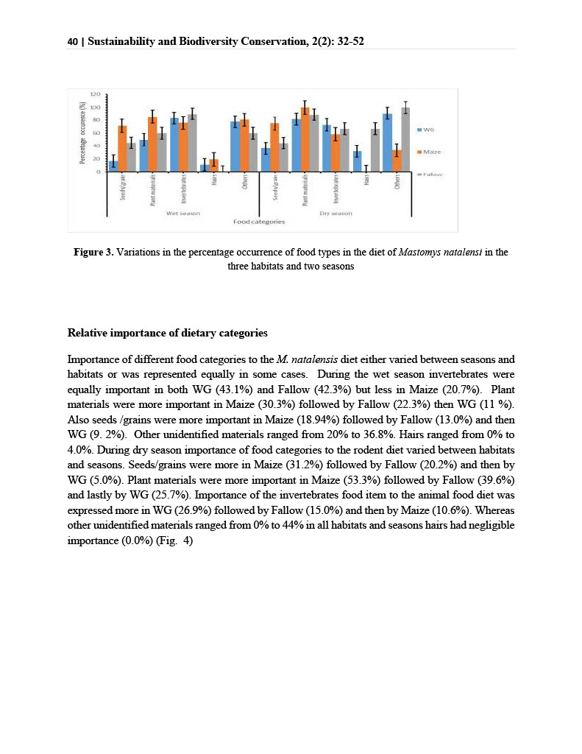
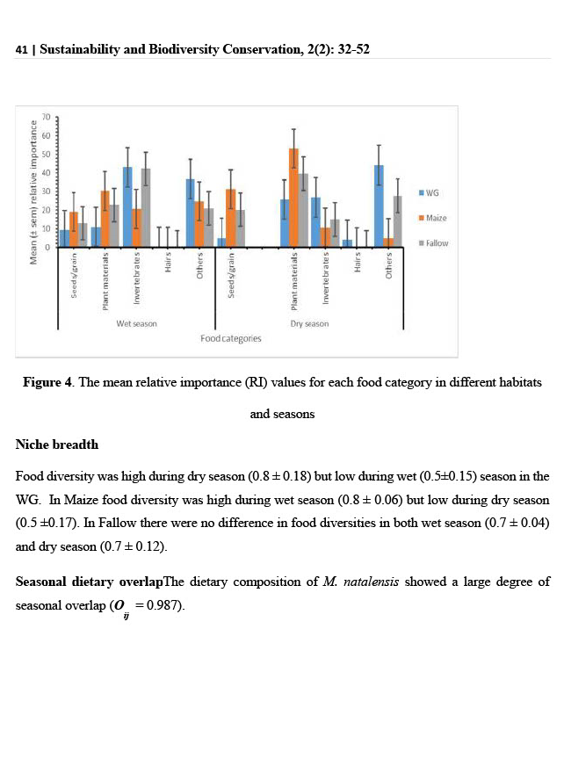

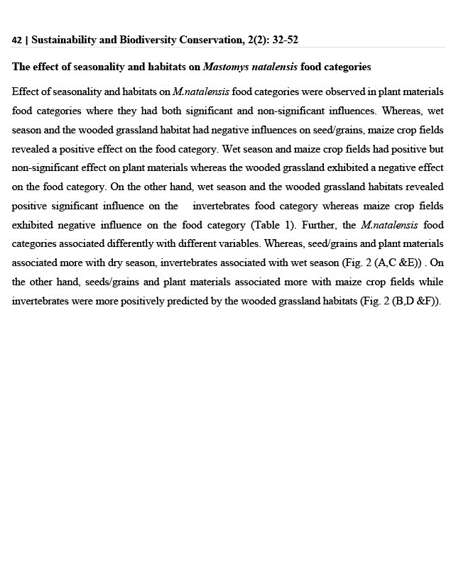

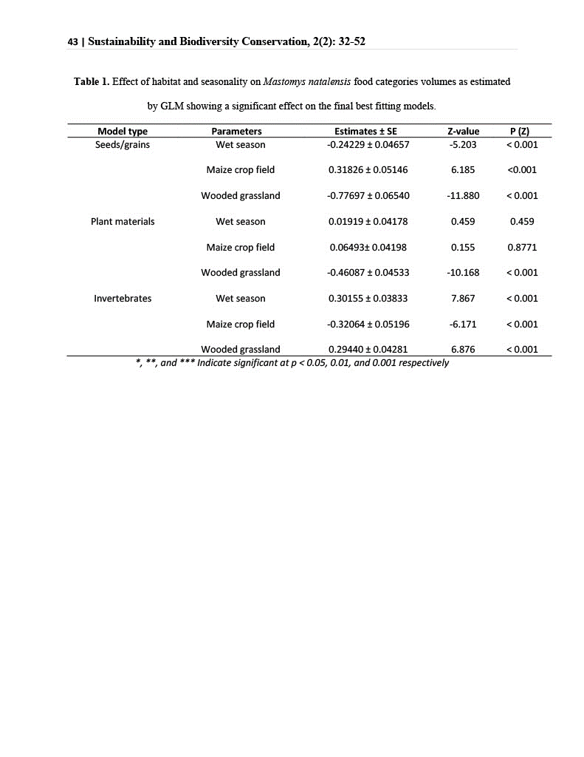

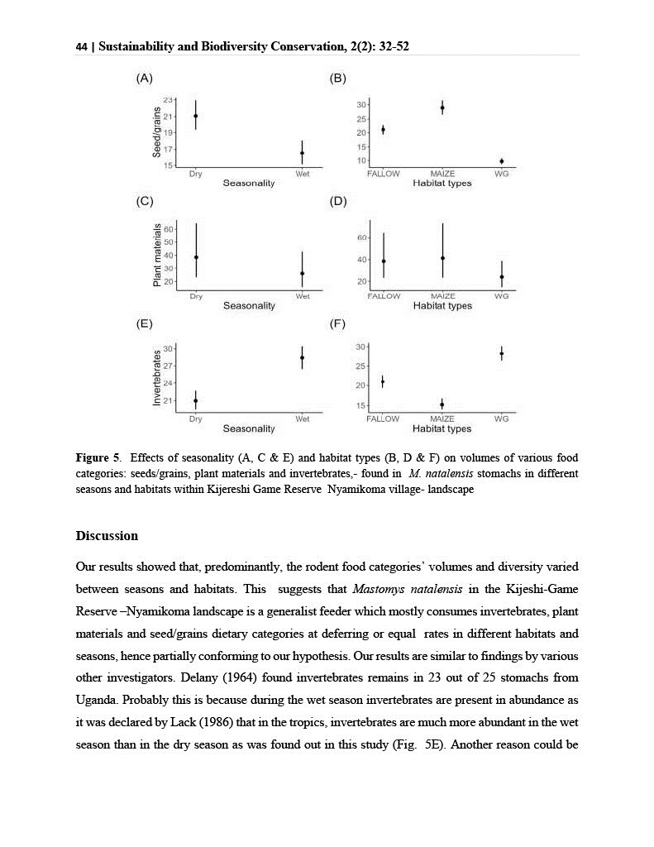

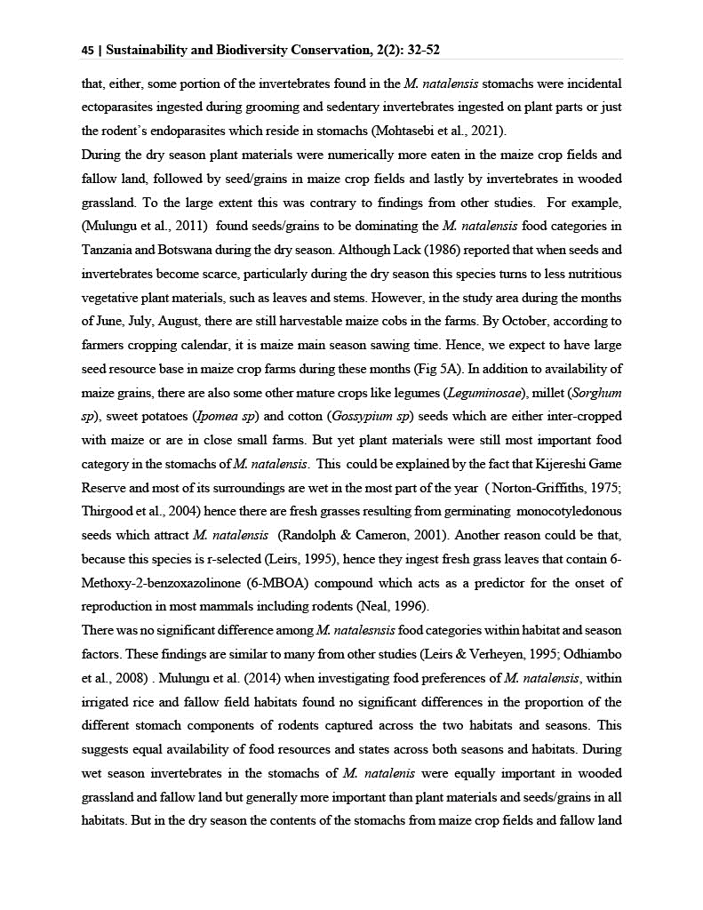

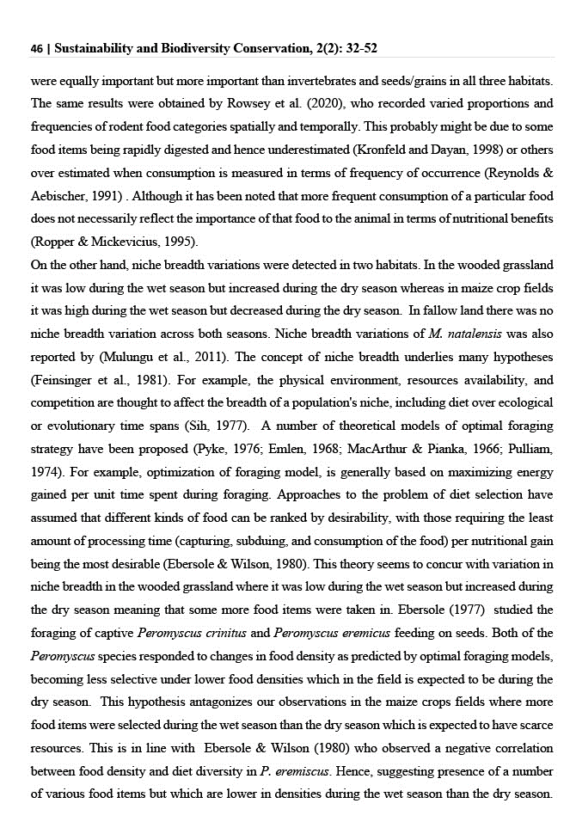

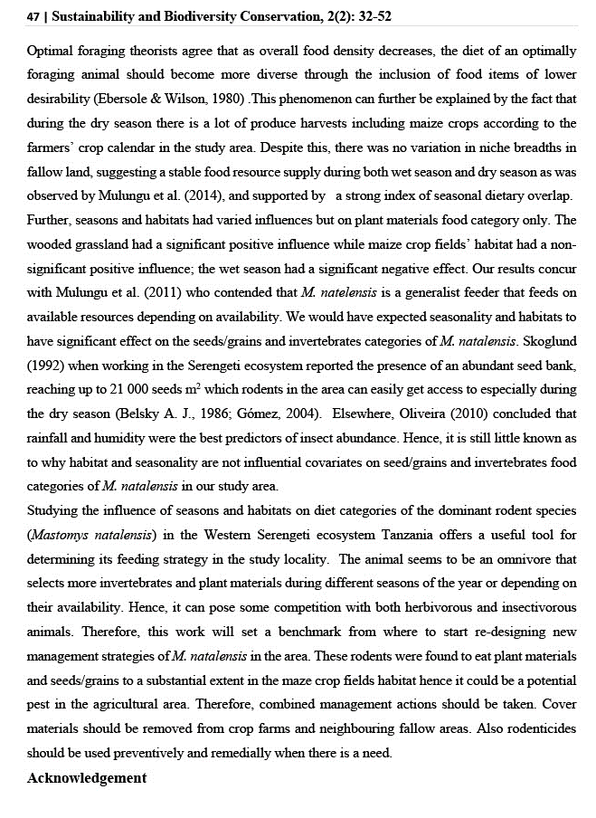

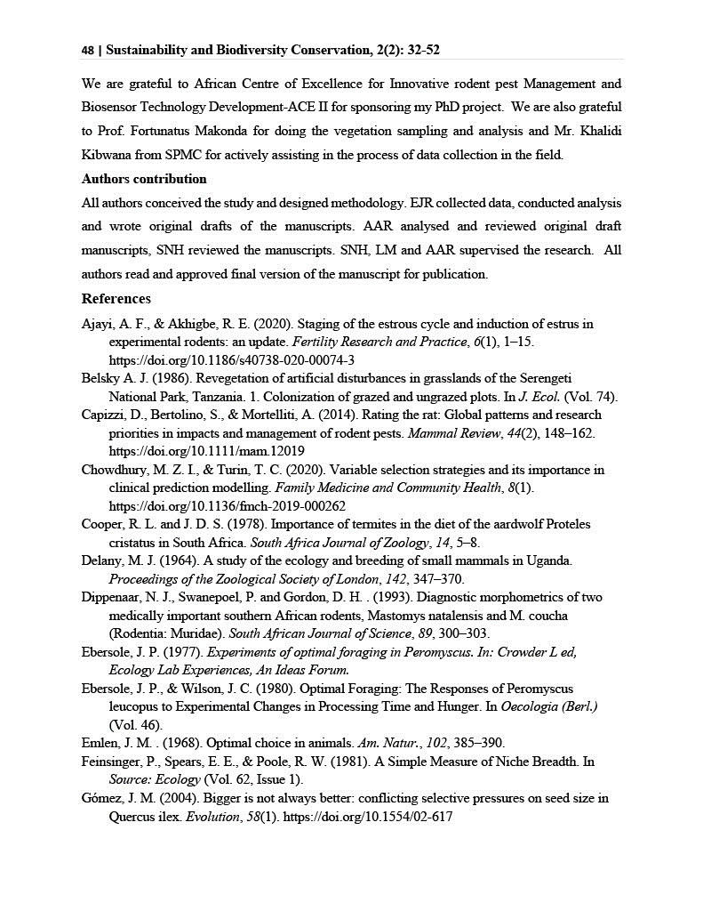

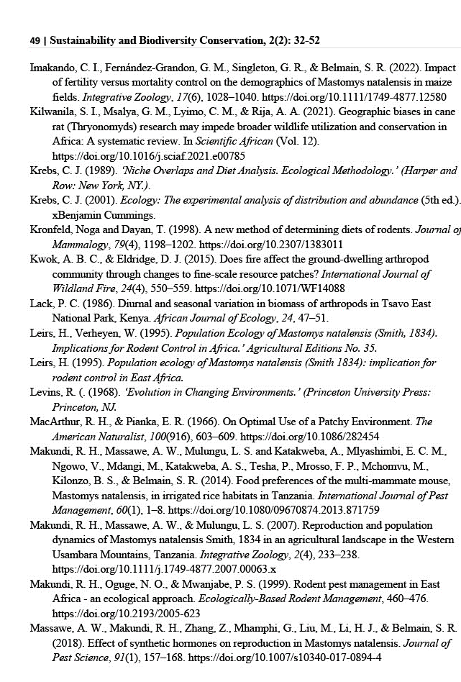

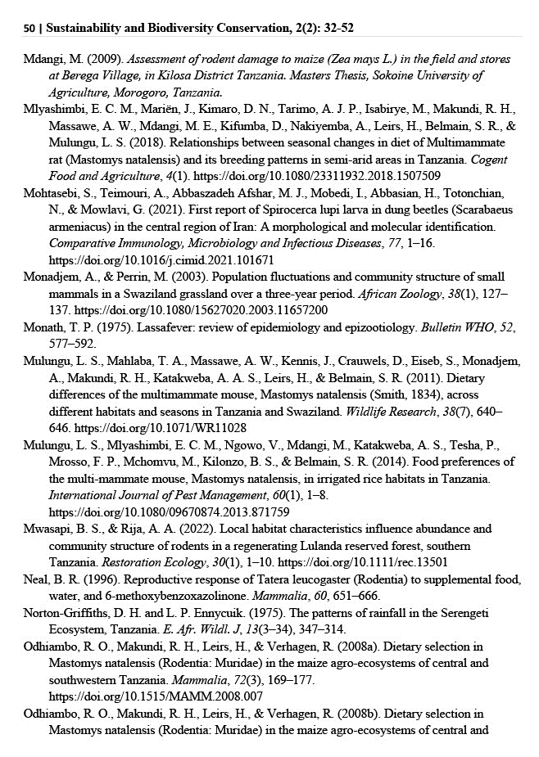

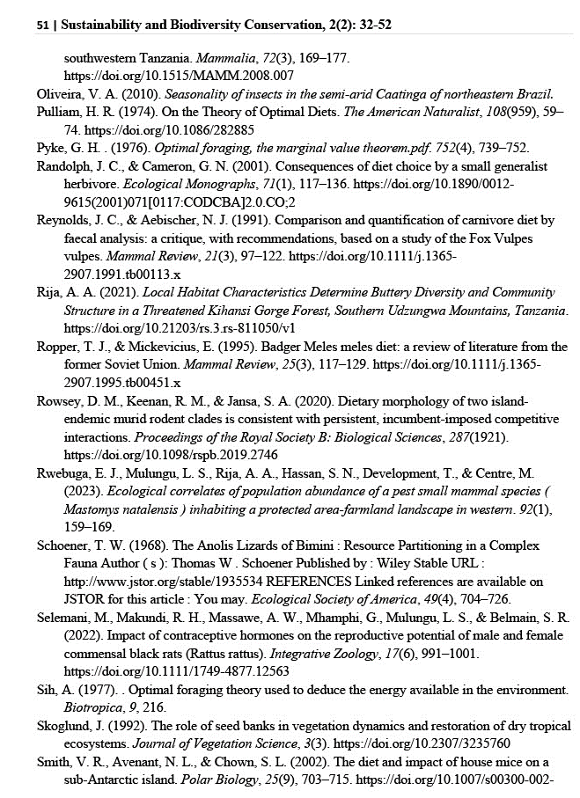

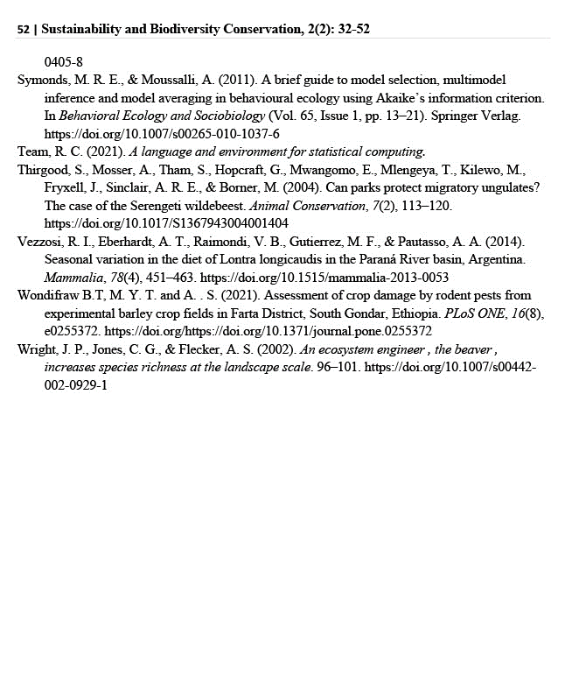

CHAPTER SIX

6.0 GENERAL DISCUSSION, CONCLUSIONS AND RECOMMENDATIONS

6.1 General Discussion
During the twelve-month period of study, eight species of rodents and one insectivore species were recorded from the wooded grassland, maize crop fields and fallow land habitat types. Hence, our study area, comparatively, seems to be a good representative of the great Serengeti ecosystem,which forms a part, in terms of species richness as it only covers less than 0.5% of the whole ecosystem size (Keesing, 2000; TAWA, 2018) and still we came up with such a number of the small mammal species. This is in line with the non-assymptotic accumulation curves in all habitats in the present study, suggesting that, more effort could have led to capture of more species. Mostly, rodent species could have been obtained in the wooded grassland, followed by fallow land and lastly in the maize crop fields.

The combined data records over the period of 48-years (from 1962 to 2010) for the great Serengeti ecosystem (GSE), which our study area forms a part, revealed about 40 species of small mammals (Kingdon et al., 2013). According to Byrom et al.(2015), the reported findings for the ecosystem were a result of studies conducted in ten different habitats, using different combined trapping techniques, and trapping for three to ten nights a month. Similarly, a study in Wisconsin, USA by Stephens and Anderson (2014) on habitat associations and assemblages of small mammalian species in natural plant communities found that Sherman live traps and pitfall traps combined captured significantly more species than either trap type used independently. Therefore, the small number of rodent species reported by the present sudy was probably due to use of a single trapping technique (i.e.
Capture-Mark-Release), whereby only one trap was used per trap station in each of the three habitats types for only three trapping nights a month. Our results matches well with results of another study elsewhere in Tanzania, where a single type of live capture traps was employed, hence only four to nine species of small mammals obtained (Makundi et al., 2010)..

Basically, our study area is a system that contains many rare species (Kingdon et al., 2013), so this could also contribute to less number of species recorded during the current study. Apparently, four of the nine species encountered were very rarely caught between one or two habitat types. These were: Saccostomus compestris, Acomys wilson, Mus minotoides and Rattus rattus. Same species were reported to be rare in the previous long-term studies, suggesting their patchy and localized distribution (Kingdon et al., 2013)

Spatial variations in the small mammal species composition was observed during the study with Mastomys natalesis having highest species composition in maize crop fields, followed by fallow land and lastly by the wooded grassland habitat type. These results are similar to findings by Kessy et al. (2023) who reported dominance of M.natalensis in various habitat types and seasons. This is, probably, conforming to the hypothesis that multimammate mice are able to survive in a wide range of environmental conditions, and are often the most numerous mice in savanna habitats and agricultural fields (Kingdon et al., 2013).

Species richness also varied spatially with highest richness occurring in the wooded grassland, but lowest in maize crop fields. Generally, richness was higher in months that fall in the rainy season, suggesting rodents’ response to the availability of food and vegetation cover as it was reported in the previous studies (Makundi et al., 2010) . On the other hand, drier months had reduced small mammal richness, similar to findings that were reported in Ethiopia by Cao et al. (2016), probably because of decreased cover and limited heterogeneity in available food
items (Attuquayefio et al., 2013). Further, the small mammal species diversity was spatially highest in fallow land and lowest in maize crop fields while temporally, diversity was higher in the wooded grassland and fallow land in the wet season, but higher in the maize crop fields during the dry season. The results are in agreement with Chidodo et al. (2020), who reported that habitat characteristics influence the diversity of rodents. Some habitats may offer more vegetation as a source of food, and shelter for breeding as well as protection of the rodents from possible predation (Shilereyo et al., 2020).

Since M. natalesis was a dominant species, several ecological aspects about it were investigated. It was found out that age structure of the species varied among adults, subadults and juveniles. In that case, there was a statistical difference in the numbers of adults, subadults and juveniles of M. natalensis between different habitat types similar to results reported by Shilereyo et al.( 2020). In the month of September, there were more adults, subadults and juveniles in the wooded grassland habitat types than in other months as was reported by Attuquayefio et al. (2013). This probably is because it is a peak of breeding for most individuals and is far more pronounced in the wooded grassland than in other habitats as the compensation for deaths of rodent individuals that had died during the rainy season. Most part of our study area fall in a low land, which comparatively floods easily, leading to more deaths of rodents as was observed by Jacob (2003). In maize crop fields there were more numbers of adults during the months of May 2020, June 2020 and July 2020. Similar results were observed by Attuquayefio et al. (2013). This suggests that higher numbers of adults are often caught more than juveniles and subadults as age tends to affect trappability depending on the rodent’s prior experience and social rank (Golley et al., 2009). Normally, juveniles do not move far from their nests, hence decreasing their probability of encountering traps (Golley et al., 2009).

The sex ratio of M.natalensis was found biased towards males in the wooded grassland habitat types for seven months: April 2020, June 2020, September 2020, October 2020, December 2020, January 2021 and March 2021. The same phenomenon was found in fallow land for three months: April 2020, July 2020 and December 2020 whereas in the maize crop fields, the bias was for five months: April 2020, May 2020, September 2020, January 2021 and March 2021. However, the sex ratio bias of M. natalensis shifted towards females for four months in each habitat type. In the wooded grassland, it was in May 2020, August 2020, November 2020 and February 2021 whereas in fallow land it was in May 2020, June 2020, August 2020 and October 2020; and June 2020, July 2020, August 2020 and November 2020 in the maze crop fields. The months were distributed into different seasons. April 2020, May 2020, December 2020, January 2021, February 2021, March 2021 and November 2020 fall in the wet season while June 2020, July 2020, August 2020, September 2020 and October 2020 fall in the dry season (Norton-Griffiths et al., 1975; Ritchie, 2008). These results are in line with findings by other investigators. For example, Mlyashimbi et al. (2019) reported more males of M. natalensis compared to females during the dry season and attributed this to factors like the search for food and mates or individuals which were just on transit as males of this species are known for exhibiting larger home ranges. On the other hand, Wolf and Batli (2002) reported differential capture between male and female sexes of rodent species simply because of varying conditions of traps used (i.e. clean or dirty). Further, Namukonde (2017) and Babale et al. (2018) observed differences in the capture of female and male rodents resulting from environmental factors such as fire and vegetation types that determined the presence or absence of a rodent of a given sex in a certain locality and time.

Generally speaking, abundance of the rodent species was found to vary between habitat types and seasons. The highest density occurred in the maize crop fields, and that probably attributed to the higher availability
of food resources most time of the year than in the fallow land and the wooded grassland (Rwebuga et al., 2023), which could have favoured its higher proliferation. According to studies conducted in different parts of eastern and southern Africa, variation in abundance of M. natalensis due to difference in habitat quality among other factors is a common phenomenon (Agerie and Afework, 2015; Leirs, 1995; Leirs et al., 1996; Makundi et al., 2006 & Mulungu et al., 2013). This is because status of the resources being offered by a habitat, enables some species to flourish well compared to others (Chimimba et al., 2004). Such habitat effect ascertains that abundance of M. natalensis may be patchy, with large numbers occurring in quality habitats while other nearby habitats may still maintain no/or less individuals (Mdangi et al., 2013). This phenomenon probably could explain the presence of least abundance of M. natalensis in the wooded grassland compared to other habitat types. For example, Leirs (1995) found 85% of the captured small mammals in farmland and fallow areas in Morogoro, Tanzania to be M. natalensis while in natural miombo woodland and moist grassland 50 km away, the species comprised only 27% of the trapped small mammals in a community of 17 species. On the other hand, our findings are partially different from other investigators elsewhere, for example, Mulungu (2013) recorded higher population density of the species in fallow land, which in the current study ranked second. Their results from irrigated rice fields were associated with the species nesting and commuting behaviour and hence the consequential effect being the probable reason for its substantial number of individuals trapped in the fallow land before reaching their destination i.e., the rice fields (Monadjem & Perrin, 1998).

However, density of the rodent fluctuated spatially and temporally. There were two density peaks of M. natalensis density in the maize crop fields in June 2020 and in May 2021, and overall higher density during the dry than wet season, which seem to have been linked to rainfall pattern. According to Leirs (1995), the species breeds during the long
rains and generally starts one month after the usual peak rainfall (March/April), and continues to end of the dry season (September), substantiating the influence of rainfall under a bimodal rainfall pattern (Leirs et al., 1989; Leirs, 1995; Linn, 1991; Telford, 1989). Therefore, the consequent high population observed in the dry season during the present study is a result of high breeding activity in the long wet season (Christensen, 1993; Leirs et al., 1990). Whereas maize crop fields exhibited a significant positive influence on the abundance of M.natalensis, the wooded grassland habitat showed a high significant negative effect as this habitat floods easily because it is more bowl shaped, and stays with water for comparatively longer periods (Rwebuga et al., 2023). Also, farmers in our study area reported about noticing dead individuals of different rodent species during farm preparations in November (short rainy season) for the first sowing season. The flooding effect was also reflected by the generalized linear model results in this study. This phenomenon could further be explained by the fact that trapping months of January, February and March, occasionally having long standing water, depending on previous years’ amount of rainfall, had significant negative effect on the abundance of the mammalian species. This went in line with its predicted density values that seem to be low in months of January and February, but increasing from April/May reaching peak in June, after which it falls a little in July, and then levels off to September, followed by a linear decline in the months of the short rainy season, October/November to December.

In addition to this, sexually active females were found to dominate in the maize crop fields in both dry and wet seasons. The pattern suggests that, comparatively, breeding occurred more in the maize crop fields as compared to other habitat types, although it was continuous throughout the year in all habitat types as contrasted to Leirs et al. (1996) who reported breeding of M.natalensis to be seasonal. However, only a small proportion of the animals were observed to be actively breeding in some months in both seasons. Also, the breeding females could not be
noticed completely in some months including the ones which had zero captures. These findings are in line with Mulungu et al. (2013) who observed less breeding females of M. natalensis during the months of August to October compared to other months whereby high peaks of breeding females were observed in the months of June (early dry season) and December (short rainy season).

The observed pattern corresponded to the maturity and harvesting of rice crop in their study area (Mulungu et al., 2013). Less or lack of captured individuals during the wet season was also reported by Granjon et al. (2005) who suggested it to be linked to low survival due to flooding of the small mammals’ nests. Furthermore, low survival effect due to flooding in our study area, could also be explained by spearman’s rank correlation results between numbers of breeding females and monthly rainfall, which revealed a weak negative and non-significant correlation. Also, generalized linear model results revealed that both maize crop fields and wooded grassland habitat types and rainfall had negative influences on the numbers of breeding females as contrasted to their interactions, which revealed positive, but non-significant influences.

The continuous breeding of M.natalensis during dry season, could be attributed to availability of food resources as was pointed out by Skoglund (1992), that seed bank reaching up to 21, 000 seeds m⁻² is available in the Serengeti ecosystem, which rodents can easily get access to especially during the dry season. Also, availability of after-harvest maize cobs and later on access to seeds sown in the maize crop fields during the minor cropping season starting in September/October depending on the availability of precipitation is another source of food supporting some reproduction activity.

Further, the pattern for the wooded grassland, fallow land and maize crop fields in relation to quality food availability (Rwebuga et al., 2023),
which in turn is linked to rainfall pattern (Christensen, 1993 ; Leirs et al., 1990), probably justifies higher abundance of sexually active females in maize crop fields in both dry and wet seasons. Generally, however, predicted numbers of active females seemed to be more associated with fallow land compared to other habitat types, probably due to its closeness to crop fields and the type of vegetation and cover it provides to the rodent species (Mayamba et al., 2019 ; Mulungu et al., 2013). Moreover, throughout the trapping period in all three habitats, the total number of females peaked during the dry season between May and October 2020. Regarding individual habitats, highest and secondary peaks were recorded in the maize crop fields in June 2020 and May 2021, respectively whereas wooded grassland and fallow land peaked in August/September 2020. The pattern is probably due to that May to October covers the period in which seeds/cereals are plentiful in each of the experimental habitat as reported in Mulungu et al. (2013).

In order to gain more knowledge on factors influencing M.natalensis population size, various ecological correlates on its abundance were studied. The findings revealed a positive association between abundance of M. natalensis and sandy-clay-loam soils, similar to Massawe et al. (2008). In another study, Odhiambo et al. (2005) and Massawe et al. (2008) had associated abundance of rodents in soils of different textures and moisture content with the suitability of the soils for creating nesting places. Their view was based on the understanding that soil texture influences properties such as drainage, moisture-holding capacity and rates of water infiltration and weather in rodent holes (Marina and Zubaid, 2015). As such, soils containing loamy texture have low water holding capacity (Hodnett and Tomasella, 2002), which keeps burrow holes dry most of the time hence more stable and stronger (Laundre and Reynolds, 1993). In this study, large part of trapping sites had a sandy-clay texture, suggesting unsuitability for rodent burrowing and nesting particularly during the rainy season. This explains the negative association that was noticed between
abundance of the species and sandy-clay soils, results that are in line with Massawe et al (2008), who reported low abundances of rodents in the sandy-clay soils especially during the wet season. Also, it was found out that, plant species richness had negative association with the abundance of M.natalensis. A comparatively far more numbers of M.natalensis were found in mono-cropped maize fields, which are cleared of all other vegetation types except the maize crop plant, yet, like other cereal crops attract pestiferous rodent species like M.natalensis (Shenkut, 2006). Our results were similar to those reported by Makundi et al. (2007) who found higher densities of the species in areas cleared for agriculture at even much higher elevation of the Usambara Mountains, Tanzania.

Since it has been reported by many scholars that M. natalensis dominates over other species where it occurs (Kingdon, 2013), and also that M. natalensis is highly attracted to agricultural fields (Rwebuga et al., 2023), an investigation on it dietary patterns was conducted. Findings indicated that the rodent species is a generalist feeder, which mostly consumes invertebrates, plant materials and seed/grains dietary categories at equal or deferring rates in different habitats and seasons. Whereas the small mammal species food diversity varied between habitats and seasons, the dietary composition seasonal overlap showed a higher index value. On the other hand, the influence of habitat and on food categories was observed on the vegetative plant material food category, but not on seeds/grains and invertebrates’ categories. These results are similar to findings by various other investigators. For example, Delany (1964) found that invertebrate remains in 23 out of 25 stomachs from Uganda. Probably, this is because during the wet season invertebrates are present in higher abundance as it was declared by Lack (1986) that in the tropics, invertebrates are much more abundant in the wet season than in the dry season. Or probably, some portion of the invertebrates found in the M.natalensis stomachs
were either incidental ectoparasites ingested during grooming and sedentary invertebrates ingested on plant parts (Wolf'f' & Hurlbutt, 1982) or just the rodent’s endoparasites (Mohtasebi et al., 2021).

During the dry season, vegetative plant materials were numerically more eaten in the maize crop fields and fallow land, followed by seed/grains in maize crop fields and lastly by invertebrates in wooded grassland. To the large extent, this was contrary to findings from other studies. For example, Mulungu et al. (2011) found seeds/grains to be dominating the M. natalensis food categories in Tanzania and Botswana during the dry season. Although Lack (1986) reported that when seeds and invertebrates become scarce, particularly during the dry season, this species turns to less nutritious vegetative plant materials, such as leaves and stems. However, in the study area during the months of June, July, August, there are still harvestable maize cobs in the farms. According to their cropping calendar, it is maize harvesting time. Hence, that was expected to be large seed resource base in maize crop farms during these months. In addition to availability of maize grains, there are also some other matured food sorces like legumes (Leguminosae), millet (Sorghum sp) sweet potatoes (Ipomea sp) and cotton (Gossypium sp) seeds, which are either intercropped with maize or are in close small farms. But yet vegetative plant materials were still most important food category in the stomachs of M. natalensis. This could be explained by the fact that Kijereshi Game Reserve and most of its surroundings are wet in the most part of the year (Thirgood et al., 2004;Norton-Griffiths et al., 1975) hence fresh grasses available due to some germinating monocotyledonous seeds, which attract M. natalensis (Randolph,1991). Or probably because this species is r-selected (Leirs, 1995) and it normally ingests fresh grass leaves that contain 6-Methoxy-2-benzoxazolinone (6-MBOA), compound which acts as a predictor for the onset of reproduction in most mammals including rodents (Neal, 1996).

No significant difference in rodent food categories both between habitats and seasons was detected. These findings are similar to other studies e.g., Leirs and Verheyen (1995) and Odhiambo et al. (2008). Mulungu et al. (2014) when investigating food preferences of M. natalensis, within irrigated rice and fallow field habitats found no significant differences in the proportion of the different stomach components of rodents captured across the two habitats and seasons. Probably this could be due to equal availability of food resources and states across both seasons and habitats.

During the wet season, invertebrates in the stomachs of M.natalensis were relatively equally important in wooded grassland and fallow land, but generally more important than plant materials and seeds/grains in all habitats. But in the dry season, the contents of the stomachs from maize crop fields and fallow land were relatively equally important, but more important than invertebrates and seeds/grains in all three habitats. The same results were obtained by Thomas et al. (2022), who recorded varied proportions and frequencies of rodent food categories in different habitat types and seasons This probably might be due to some food items being rapidly digested and hence underestimated (Kronfield & Dayan, 1998) or that, resuts were overestimated in previous researches due to measuring consumption in terms of frequency of occurrence (Reynold & Abischer, 1991).

Although more frequent consumption of a particular food does not necessarily reflect the importance of that food to the animal in terms of nutritional benefits (Roper and Mickeuicius, 1995), niche breadth variations were detected in two habitat types. In the wooded grassland the niche breadth was low during the wet season, but became high during the dry season. On the contrary, in the maize crop fields, the niche breadth was high during the wet season, but decreased during the dry season whereas, in the fallow land there was no niche breadth variation across both seasons. Niche breadth variations of M.natalensis
was also reported by Mulungu et al. (2011). The concept of niche breadth underlies many hypotheses (Feinsinger et al., 1981). For example, the physical environment, resources availability, and competition are thought to affect the breadth of a population's niche, including diet over ecological or evolutionary time spans (Sih, 1977). A number of theoretical models of optimal foraging strategy have been proposed (Emlen, 1968; MacArthur & Pianka, 1966). For example, optimization of foraging model is generally based on maximizing energy gained per unit time spent during foraging. Approaches to the problem of diet selection have assumed that different kinds of food can be ranked desirability, with those requiring the least amount of processing time (capturing, subduing, and consumption of the food) per nutritional gain being the most desirable (Ebersole & Wilson, 1980). This theory seems to concur with variation in niche breadth in the wooded grassland where it was low during the wet season, but increased during the dry season, meaning that some more food items were taken in also. Ebersole (1977) studied the foraging of captive Peromyscus crinitus and Peromyscus eremicus feeding on seeds. Both Peromyscus species responded to changes in food density as predicted by optimal foraging models, becoming less selective under lower food densities, which in the field is expected to happen during the dry season. However, this hypothesis is contrary to what has happened in maize crops fields, where more food items were selected during the wet season when there is a lot of food resources, but less selected during the dry season when the resources are scarce. This pattern could be explained by the fact that Ebersole and Wilson (1980) observed a negative correlation between food density and diet diversity in P. eremiscus. Ebersole and Wilson (1980) ascertains that addition of food items of lower rank to the optimal diet is expected under conditions of relatively low overall food density, when the absolute reduction in average per item search time that results from the addition of a new food type is likely to exceed the absolute gain in per item processing time. Therefore, it could be that a number of various food items were there, but in lower densities during
the wet season as compared to the dry season. Optimal foraging theorists agree that as overall food density decreases, the diet of an optimally foraging animal should become more diverse through the inclusion of food items of lower desirability (Ebersole & Wilson, 1980). This phenomenon can further be explained by the fact that during the dry season there is a lot of produce harvest including maize crops, according to the farmers’ crop calendar in the study area. However, there was no variation in niche breadths in fallow land, may be this suggests a stable food resource supply during both wet season and dry season as was observed by Mulungu (2014). This discourse is being supported by the results of seasonal dietary overlap, which indicated a strong index value.

6.2 General Conclusions
Spatial variations in the small mammal species richness and diversity were observed in the current study with fallow land displaying higher species richness and diversity as compared to wooded grassland and maize crop fields, hence suggesting that, currently, the disturbed areas surrounding the Kijeshi Game Reserve is more suitable habitats for conservation of the rodents’ gene pool. Probably this is due to the fact the Game Reserve is still recovoring from human disturbance in the recent past. Hence, much effort is still needed within the protected Kijereshi Game Reserve that is intended to propagate and sustain higher species richness and diversity than the surrounding areas, through increasing higher habitat heterogeneity and suitability. These findings suggest also that within the protected area there are still some on-going human activities such as cattle grazing, fire wood and tree log collection which exert deleterious effects on some small-mammal species by reducing the suitability of their habitats, species richness and diversity. Therefore, such harmful human activities that have negative impacts on small mammal communities in the area need to be minimized.

On the other hand, however, the current study showed that age structure of M. natalensis varied significantly in numbers of adults, subadults and juveniles between different habitat types and seasons. In the month of September, there were more adults, subadults and juveniles in the wooded grassland habitat than in other months suggesting that this is a peak of reproduction of this rodent species in this area. On the other hand, observation of the sex ratio of M.natalensis revealed a bias towards males in some months of the year before it shifted to the months of June, July, August, September, October and November probably suggesting that these are months when females are searching for food with needed quality for their pregnancies

We also noted that, the population density of Mastomys natalensis fluctuated across months of trapping and habitats whereby, numerically, the M. natalensis abundance was higher in maize crop fields as compared to other habitat types. Generally, there was a significant difference in the rodent population density across habitats and between seasons although drop in densities was similar in all habitats. Densities dropped from higher ones during the dry season to lower ones during the wet season between November and February, although during this time there is much food available for rodents, probably these months are ideal for control of the rodent species because now their populations are low. Also, it could be a proper period for maximizing maize crop production. Further, our results showed that rodent density was strongly positively associated with active farmlands and sandy-clay-loam soils but negatively correlated with the plant richness but negatively associated with farms dominated by sandy-clay soils. Hence, proper classicification of soil types can give proper information on avoiding effects of the rodent pests, during selection of specific farming areas depending on the type of crop being considered. Further more, investigation of food categories of Mastomys natalensis in the Kijeshi-Game Reserve –Nyamikoma landscape revealed that, the rodent
species is a generalist feeder which mostly consumes invertebrates, plant materials and seed/grains dietary categories at equal or deferring rates in different habitats and seasons. However, its food diversities varied between habitats and seasons and the dietary composition seasonal overlap showed a higher index value. Hence, this information is an evidence that the rodent species can eat a number of food crops as a result causing varying economic loss to farmers.

6.3 General Recommendations
Rodents are well known for their economic and social ecological importance to man and other species. But, while they provide food to other species including man, thus important in the food web in many ecosystems, they are known to cause damages to food crops. For example, periodic outbreaks of Mastomys spp. populations pose concern to humans due to their pest impacts, especially in sub-Saharan Africa, where food insecurity is threatening development of most rural human populations due to crop devastation by various crop pest species. Further, these rodent species harbour pathogens that cause zoonotic diseases, but also may carry internal/external parasites that could serve as vectors of diseases. Hence, strategies that will ensure safeguarding of human health, conservation of non-harmful rodent species and specifically, managing Mastomys spp, are needed in place. In this particular study, Mastomys natalensis was found to dominate spatially and temporally whereas the rare species were Acomys wilsoni, Mus minutoides and Rattus rattus, hence, the following recommendations are put forward:

i) More studies on rodent transmitted zoonotic diseases are still needed in villages and within the protected area in order to ensure good health status to the wildlife personnel, tourists and all the people engaged in the tourism industry within all protected areas in Tanzania:

ii) Further, rodent community ecology studies are needed in much bigger areas whereby mixed- trap techniques should be considered to improve capture success and richness. This information is very important in enabling ecologists, wildlife managers, agricultural extension officers and health personnel to be able to differentiate between pernicious and useful rodents;

iii) Management options of the pest rodent species should either be timed when rodent species populations are low specifically in the second rainy season (November - February) to counteract potential population build up in subsequent season, which may result into substantial crop damages. Alternatively, routine management practices should be executed year around following cultural and/or contemporary guidelines;

iv) Proper training to farmers is needed before adopting certain pre-harvest and post-harvest rodent pest management options as they seem to be involving concepts that can be a challenge to farmers. In certain cases, management options may depend on crop type and stage of development. Effectiveness of given rodent control/management strategies engaged will require further evaluation in terms of economic applicability. The commonly used management options in Tanzania can broadly be grouped into two major groups as follows:

1) The non-lethal or preventive approaches, which involve habitat manipulation or cultural practices, exclusion/fencing and use of repellents. The environmental sanitation is done by farmers through slash and burning fields before sowing and harvesting as a way of displacing rodent population. However, sanitation is not significantly effective as most farmers practice it on small plots that are interspersed with patches of fallow and permanent grassland.

2) The lethal approach, which involves killing of rodent using a number of techniques including trapping, chemical, toxicants and biological control (i.e. using predators). The major methods of achieving satisfactory mortalities are physical killing by trapping and rodenticides. However, killing with rodenticides during rainfall is compromised by water due to dissolving effect of the poison, hence loss of effectiveness and increased chances of poisoning non-targeted organisms. Also, in many cases, small scale farmers cannot afford to meet costs of rodenticides.

v) Long-term monitoring on rodent population ecology is important for giving an insight on the influence of climate change on rodent ecology in many areas of Tanzania.

vi) M. natalensis food categories were determined using microscope (25 x and 50 x magnification) as described by Smith et al. (2002) and this technique has certain limitations that some food items could not be identified. Hence, use of molecular methods in diet analysis would provide far more information needed for identification of specific species of food items eaten. Identification of species eaten is important as some other eaten organisms are a threat/competitor of grown crops. For example, rodents of the genus Chrotomys are known to eat the two species of the golden apple snails, Pomacea canaliculata and Pomacea maculate, which are highly invasive and cause damage to rice crops.

vii) Studies on community ecology of rodent species in other types of crops likes rice, cotton and potatoes are still required in our study area.

viii) Also, future studies should try to find out why M. natalensis densities are declining during the months when food resource is plenty?.

x) Infertilization of field rodent pest may also be engaged in controlling field rodent pests. Previous studies have demonstrated that low concentrations of the synthetic steroid hormones quinestrol (E, estrogen) and levonorgestrol (P, progesterone) delivered in combination (i.e. EP-1) can generate long-term (several weeks to months) contraceptive effects in many wild rodent species including multi-mammate rats (Mastomys natalensis) and black rat (Rattus rattus). Fertility control has an advantage, in that, it reduces reproductive output instead of culling, which creates vacant habitat that can be quickly re-colonised by new emigrant individuals. Hence, infertile individuals remain and reduce immigration of the fertile animals. However, fertility control approaches ideally require that the field application of an agent temporarily or permanently inhibits reproductive activity within a breeding season, primarily targets females, and is humane, environmentally safe, and cost effective.

REFERENCES
Agerie, A. and Afework, B. (2015). Population structure of rodents in Alage, Southern Ethiopia. Journal of Ecology and The Natural Environment, 7(1), 7–13. https://doi.org/10.5897/jene2014.0492
Attuquayefio, D. K., Garshong, R. and Attuquayefio, D. (2013). Aspects of the Ecology of Rodents in the Owabi Wildlife Sanctuary, Ghana: Sex-ratio, Age Structure and Reproductive Characteristics. In Article in Asian Journal of Applied Sciences. https://www.researchgate.net/publication/318661594
Babale, A., Joshua, A., Elena, M. and Pierre-Michel, F. (2018). Forest disturbance and seasonal food availability influence a conditional seed dispersal mutualism. Biotropica., 50(750–757). https://doi.org/https://doi.org /10.1111/btp.12570?.
Batli, M. W. A. G. (2002). Relationship Of Previous Trap Occupancy To Capture Of White-Footed Mice ( Peromyscus Leucopus ). 83(July), 728–733.
Byrom, A. E., Nkwabi, A. J. K., Metzger, K., Mduma, S. A. R., Forrester, G. J., Ruscoe, W. A., Reed, D. N., Bukombe, J., McHetto, J. and Sinclair, A. R. E. (2015). Anthropogenic stressors influence small mammal communities in tropical East African savanna at multiple spatial scales. Wildlife Research, 42(2), 119–131. https://doi.org/10.1071/WR14223
Cao, C., Shuai, L. Y., Xin, X. P., Liu, Z. T., Song, Y. L. and Zeng, Z. G. (2016). Effects of cattle grazing on small mammal communities in the Hulunber meadow steppe. PeerJ, 2016(8). https://doi.org/10.7717/peerj.2349
Chidodo, S., Kilawe, C.J., Mnyone, L.L., Broecke, B.V. and Mulungu, L. S. (2020). Factors affecting the composition of rodent assemblages in the North Uluguru Mountains. Journal of Vertebrate Biology, 69, 1–10. https://doi.org/https://doi.org/10.25225/jvb.20047
Chimimba, C. T., Aarde, R. J. Van and Fairall, N. (2004). The distribution of two medically and agriculturally important cryptic rodent species , Mastomys natalensis and M . coucha ( Rodentia : Muridae ) in South Africa. 39(October), 235–245.

Christensen, J. T. (1993). The seasonal variation in breeding and growth of Mastomys natalensis (Rodentia: Muridae): evidence for resource limitation. African Journal of Ecology, 31(1). https://doi.org/10.1111/j.1365-2028.1993.tb00513.x
Delany, M. J. (1964). A study of the ecology and breeding of small mammals in Uganda. Proceedings of the Zoological Society of London, 142, 347–370.
Ebersole, J. P. (1977). Experiments of optimal foraging in Peromyscus. In: Crowder L ed, Ecology Lab Experiences, An Ideas Forum.
Ebersole, J. P. and Wilson, J. C. (1980). Optimal Foraging: The Responses of Peromyscus leucopus to Experimental Changes in Processing Time and Hunger. In Oecologia (Berl.) (Vol. 46).
Emlen, J. M. . (1968). Optimal choice in animals. Am. Natur., 102, 385–390.
Feinsinger, P., Spears, E. E. and Poole, R. W. (1981). A Simple Measure of Niche Breadth. In Source: Ecology (Vol. 62, Issue 1).
Ford, A. (2005). An Evaluation of Wildlife Monitoring and Anti-Poaching Activities. September.
Golley, F.B., Petrusewicz, K., Ryszkowski, L. (2009). Small Mammals: Their Productivity and Population Dynamics (2nd ed). . Cambridge University Press.
Granjon, L., Cosson, J.-F. O., Quesseveur, E. and Sicard, B. (2005). Population dynamics of the multimammate rat mastomys huberti in an annually flooded agricultural region of central mali. https://academic.oup.com/jmammal/article/86/5/997/2219503
Hodnett, M. G. and J. T. (2002). Marked differences between van Genuchten soil water-retention parameters for temperate and tropical soils: a new water-retention pedo-transfer functions developed for tropical soils. Geoderma, 108, 155–180.
Jacob, J. (2003). The response of small mammal populations to flooding. Mamma. Biol., 68, 102–111. https://doi.org/https://doi.org/10.1078/1616-5047-00068.

Jerry Wolff and Bethia Hurlbutt. (1982). American Society of Mammalogists Day Refuges of Peromyscus leucopus and Peromyscus maniculatus. Journal of Mammalogy, 63(4), 666–668.
Keesing, F. (2000). Cryptic Consumers and the Ecology of an African Savanna. BioScience, 50(3), 205. https://doi.org/10.1641/0006-3568(2000)050[0205:ccateo]2.3.co;2
Kessy, S. T., Makundi, R. H., Sabuni, C., Massawe, A. W. and Rija, A. A. (2023). Rodent abundance, diversity and community structure in a bubonic plague endemic area, northern Tanzania. Mammalia, 87(5), 488–498. https://doi.org/10.1515/mammalia-2023-0012
Kingdon, J., Happold, D., Hoffmann, M., Butynski, T., Happold, M. and Kalina, J. (eds). (2013). Mammals of Africa. Volume III: Rodents, Hares and Rabbits. Bloomsbury Publishing, London.
Kronfeld, Noga and Dayan, T. (1998). A new method of determining diets of rodents. Journal of Mammalogy, 79(4), 1198–1202. https://doi.org/10.2307/1383011
Lack, P. C. (1986). Diurnal and seasonal variation in biomass of arthropods in Tsavo East National Park, Kenya. African Journal of Ecology, 24, 47–51.
Laundre, J.W. and Reynolds, T.D. (1993). Effects of soil structure on burrow characteristics of five small mammal species. Great Basin Naturalist. 53(4), 358–366.
Leirs, H., Verheyen, W. (1995). Population Ecology of Mastomys natalensis (Smith, 1834). Implications for Rodent Control in Africa.’ Agricultural Editions No. 35.
Leirs, H., Stuyck, J., Verhagen, R. and Verheyen, W. (1990). Seasonal variation in growth of Mastomys natalensis (Rodentia: Muridae) in Morogoro, Tanzania. In J. Ecol (Vol. 28).
Leirs, H., Stuyck, J., Verhagen, R. and Verheyen, W. (1990). Seasonal variation in growth of Mastomys natalensis (Rodentia: Muridae) in Morogoro, Tanzania. In African Journal of Ecology (Vol. 28, Issue 4, pp. 298–306). https://doi.org/10.1111/j.1365-2028.1990.tb01164.x

Leirs, H., Verhagen, R., Verheyen, W., Mwanjabe, P. and Mbise, T. (1996). Forecasting Rodent Outbreaks in Africa: An Ecological Basis for Mastomys Control in Tanzania. In Source: Journal of Applied Ecology (Vol. 33, Issue 5).
Leirs, H., Verheyen, W., Michiels, M., Verhagen, R. and Stuyck, J. (1989). The relation between rainfall and the breeding season of Mastomys natalensis (Smith, 1834) in Morogoro, Tanzania. Annales - Societe Royale Zoologique de Belgique, 119(1), 59–64.
Leirs, H., Verheyen, W. and Verhagen, R. (1996). Spatial patterns in Mastomys natalensis in Tanzania (Rodentia, Muridae). Mammalia, 60(4), 545–555. https://doi.org/10.1515/mamm.1996.60.4.545
Linn, I. J. (1991). Influence of 6-methoxybenzoxazolinone and green vegetation on reproduction of the multimammate rat Mastomys coucha. South African Journal of Wildlife Research, 21(2), 33–37. https://doi.org/https://journals.co.za/doi/abs/10.10520/EJC116871
MacArthur, R. H. and Pianka, E. R. (1966). On Optimal Use of a Patchy Environment. The American Naturalist, 100(916), 603–609. https://doi.org/10.1086/282454
Makundi, R. H., Massawe, A. W., & Mulungu, L. S. (2006). Management of Selected Crop Pests in Tanzania. 224–239.
Makundi, R. H., Massawe, A. W. and Mulungu, L. S. (2007). Reproduction and population dynamics of Mastomys natalensis Smith, 1834 in an agricultural landscape in the Western Usambara Mountains, Tanzania . Integrative Zoology, 2(4), 233–238. https://doi.org/10.1111/j.1749-4877.2007.00063.x
Makundi, R. H., Massawe, A. W., Mulungu, L. S. and Katakweba, A. (2010). Species diversity and population dynamics of rodents in a farm-fallow field mosaic system in Central Tanzania. African Journal of Ecology, 48(2), 313–320. https://doi.org/10.1111/j.1365-2028.2009.01109.x
Marina, M. T. and A. Z. (2015). Porcupine burrow distribution in relation to soil types in Sarawak, Malaysia. Malayan Nature Journal, 67(1), 24–32.

Massawe, A. W., Mrosso, F. P., Makundi, R. H. and Mulungu, L. S. (2008). Breeding patterns of Arvicanthis neumanni in central Tanzania. African Journal of Ecology, 46(3), 320–324. https://doi.org/10.1111/j.1365-2028.2007.00837.x
Mayamba, A., Byamungu, R. M., Makundi, R. H., Kimaro, D. N., Isabirye, M., Massawe, A. W., Kifumba, D., Nakiyemba, A., Leirs, H., Mdangi, M. E., Isabirye, B. E. and Mulungu, L. S. (2019). Species composition and community structure of small pest rodents (Muridae) in cultivated and fallow fields in maize-growing areas in Mayuge district, Eastern Uganda. Ecology and Evolution, 9(13), 7849–7860. https://doi.org/10.1002/ece3.5371
Mdangi, M., Mulungu, L. S., Massawe, A. W., Eiseb, S. J., Tutjavi, V., Kirsten, F., Mahlaba, T., Malebane, P., von Maltitz, E., Monadjem, A., Dlamini, N., Makundi, R. H. and Belmain, S. R. (2013). Assessment of rodent damage to stored maize (Zea mays L.) on smallholder farms in Tanzania. International Journal of Pest Management, 59(1), 55–62. https://doi.org/10.1080/09670874.2012.744495
Mlyashimbi, E. C. M., Vanden Broecke, B., Mariën, J., Kimaro, D. N., Tarimo, A. J. P., Machang’u, R. S., Isabirye, M., Makundi, R. H., Massawe, A. W., Hieronimo, P., Kifumba, D., Leirs, H., Mdangi, M. E., Belmain, S. R. and Mulungu, L. S. (2019). Soil type influences population dynamics and survival of the Multimammate rat (Mastomys natalensis) in semi-arid areas in Tanzania. Crop Protection, 124. https://doi.org/10.1016/j.cropro.2019.05.023
Mohtasebi, S., Teimouri, A., Abbaszadeh Afshar, M. J., Mobedi, I., Abbasian, H., Totonchian, N. and Mowlavi, G. (2021). First report of Spirocerca lupi larva in dung beetles (Scarabaeus armeniacus) in the central region of Iran: A morphological and molecular identification. Comparative Immunology, Microbiology and Infectious Diseases, 77, 1–16. https://doi.org/10.1016/j.cimid.2021.101671

Monadjem, A. and Perrin, M. R. (1998). Effects of supplemental food on the habitat selected by Mastomys natalensis (Muridae: Rodentia) in a subtropical grassland in Swaziland. South African Journal of Zoology, 33(3), 172–177. https://doi.org/10.1080/02541858.1998.11448468
Mulungu. (2013). Population dynamics and breeding patterns of multimammate mouse, Mastomys natalensis (Smith 1834), in irrigated rice fields in Eastern Tanzania. Pest Management Science, 69(3), 371–377. https://doi.org/10.1002/ps.3346
Mulungu, L. S., Lagwen, P. P., Mdangi, M. E., Kilonzo, B. S. and Belmain, S. R. (2014). Impact of spatio-temporal simulations of rat damage on yield of rice (Oryza sativa L.) and implications for rodent pest management. International Journal of Pest Management, 60(4), 269–274. https://doi.org/10.1080/0967 0874.2014.967326
Mulungu, L. S., Mahlaba, T. A., Massawe, A. W., Kennis, J., Crauwels, D., Eiseb, S., Monadjem, A., Makundi, R. H., Katakweba, A. A. S., Leirs, H. and Belmain, S. R. (2011). Dietary differences of the multimammate mouse, Mastomys natalensis (Smith, 1834), across different habitats and seasons in Tanzania and Swaziland. Wildlife Research, 38(7), 640–646. https://doi.org/10.1071/WR11028.
Mulungu, L. S., Massawe, A. W., Kennis, J., Crauwels, D., Eiseb, S., Mahlaba, T. A., Monadjem, A., Makundi, R. H., Katakweba, A. A. S., Leirs, H. and Belmain, S. R. (2011). Differences in Diet between Two Rodent Species, Mastomys natalensis and Gerbilliscus vicinus , in Fallow Land Habitats in Central Tanzania †. African Zoology, 46(2), 387–392. https://doi.org/10.3377 /004.046.0218.
Mulungu, L. S., Mlyashimbi, E. C. M., Ngowo, V., Mdangi, M., Katakweba, A. S., Tesha, P., Mrosso, F. P., Mchomvu, M., Kilonzo, B. S. and Belmain, S. R. (2014). Food preferences of the multi-mammate mouse, Mastomys natalensis, in irrigated rice habitats in Tanzania. International Journal of Pest Management, 60(1), 1–8. https://doi.org/10.1080/09670874.2013.871759.

Mulungu, L. S., Ngowo, V., Mdangi, M., Katakweba, A. S., Tesha, P., Mrosso, F. P., Mchomvu, M., Sheyo, P. M. and Kilonzo, B. S. (2013a). Population dynamics and breeding patterns of multimammate mouse, Mastomys natalensis (Smith 1834), in irrigated rice fields in Eastern Tanzania. Pest Management Science, 69(3), 371–377. https://doi.org/10.1002/ps.3346
Mulungu, L. S., Ngowo, V., Mdangi, M., Katakweba, A. S., Tesha, P., Mrosso, F. P., Mchomvu, M., Sheyo, P. M. and Kilonzo, B. S. (2013b). Population dynamics and breeding patterns of multimammate mouse, Mastomys natalensis (Smith 1834), in irrigated rice fields in Eastern Tanzania. Pest Management Science, 69(3), 371–377. https://doi.org/10.1002/ps.3346
Namukonde, K.J. and Daniel, U. G. (2017). Differential effects of fire on small mammal communities in Busanga plain, Zambia. Trop. Conserv. Sci., 10, 1–13.
Neal, B. R. (1996). Reproductive response of Tatera leucogaster (Rodentia) to supplemental food, water, and 6-methoxybenzoxazolinone. Mammalia, 60, 651–666.
Norton-Griffiths. M ; Herlocker. D and Pennycuick . L. (1975). The patterns of rainfall in the Serengeti ecosystem, Tanzania. African Journal of Ecology., 13, 347–374. https://doi.org/https://doi.org /10.1111/j.1365-2028.1975.tb00144.x.
Notes and Records. (n.d.).
Odhiambo, R., Makundi, R., Leirs, H. and Verhagen, R. (2005). Community structure and seasonal abundance of rodents of maize farms in southwestern Tanzania. Belgian Journal of Zoology, 135(SUPPL.1), 113–118.
Odhiambo, R. O., Makundi, R. H., Leirs, H. and Verhagen, R. (2008). Dietary selection in Mastomys natalensis (Rodentia: Muridae) in the maize agro-ecosystems of central and southwestern Tanzania. Mammalia, 72(3), 169–177. https://doi.org/10.1515/MAMM.2008.007

Ofori, B.Y., Attuquayefio, D.K. and Gbogbo, F. (2013). Terrestrial small mammal community structure in an anthropogenically-altered moist semi-deciduous forest zone in Ghana. Int. J. Dev. Sust, 2, 1156–1168. https://doi.org/ID: IJDS13011801
Randolph J.C., G. . C. and J. A. W. (1991). Dietary Choice of a generalist grassland herbivore, Sigmoid hispidus . Journal of Mammology, 72(2), 300–313.
Reynolds, J. C. and Aebischer, N. J. (1991). Comparison and quantification of carnivore diet by faecal analysis: a critique, with recommendations, based on a study of the Fox Vulpes vulpes. Mammal Review, 21(3), 97–122. https://doi.org/10.1111/j.1365-2907.1991.tb00113.x
Ritchie, M. (2008). Global Environmental Changes and Their Impact on the Serengeti. In: Seregeti III: Human Impacts on Ecosystem Dynamics. https://doi.org/DOI- 10.7208/chicago/9780226760353.003.0006
Rwebuga, E. J., Mulungu, L. S., Rija, A. A., Hassan, S. N., Development, T. and Centre, M. (2023). Ecological correlates of population abundance of a pest small mammal species ( Mastomys natalensis ) inhabiting a protected area-farmland landscape in western Serengeti. 92(1), 159–169.
Shenkut, M., A. M. and M. B. (2006). Distribution and abundance of rodents in farmlands: A case study in Alleltu Woreda, Ethiopia. Ethiop. J. Sci., 29(1), 63–70.
Shilereyo, M., Flora, J. M., Joseph, O. O. and Eivin, R. (2020). Small mammal community demography and reproductive seasonality under protection, pastoralism and agriculture in the Serengeti Ecosystem, Tanzania. International Journal of Biodiversity and Conservation, 12(4), 253–269. https://doi.org/10.5897/ijbc2020.1397
Sih, A. (1977). Optimal foraging theory used to deduce the energy available in the environment. Biotropica, 9, 216.

Skoglund, J. (1992). The role of seed banks in vegetation dynamics and restoration of dry tropical ecosystems. Journal of Vegetation Science, 3(3). https://doi.org/10.2307/3235760
Stephens, R. B. and Anderson, E. M. (2014). Habitat associations and assemblages of small mammals in natural plant communities of Wisconsin. Journal of Mammalogy, 95(2), 404–420. https://doi.org/10.1644/13-MAMM-A-025
Roper, T. J. and Mickevicius, E. (1995). Badger Meles meles diet: a review of literature from the former Soviet Union. Mommol Rev., 25(3), 117–129. https://doi.org/10.1111/j.1365-2907.1995.tb00451.x
TAWA. (2018). Tanzania Wildlife Management Authority-TAWA- Kijereshi Game Reserve.
Telford, S. R. (1989). Population Biology of the Multi-mammate Rat, Praomys (Mastomys) Natalensis at Morogoro, Tanzania, 1981-1985. University of Florida.
Thirgood, S., Mosser, A., Tham, S., Hopcraft, G., Mwangomo, E., Mlengeya, T., Kilewo, M., Fryxell, J., Sinclair, A. R. E. and Borner, M. (2004). Can parks protect migratory ungulates? The case of the Serengeti wildebeest. Animal Conservation, 7(2), 113–120. https://doi.org/10.1017/S1367943004001404
Thomas, S. M., Soka, G. E., Mulungu, L. S. and Makonda, F. B. S. (2022). Spatial-Temporal Variations in Dietary Consumption of Two Dominant Rodent Species (Rhabdomys dilectus and Lophuromys acquilus) on Mount Kilimanjaro, Tanzania. Diversity, 14(8). https://doi.org/10.3390/d14080659



Kuhusu Tasnifu Hii

Panya ni muhimu kiikolojia kwani ni chakula kwa wanyama wengine na pia binadamu. Hata hivyo, takribani asilimia 17 miongoni mwao husambaza maradhi na kula mazao. Aghalabu, udhibiti wao umekuwa mgumu duniani kote, kufuatia maarifa finyu juu ya biolojia, tabia na ikolojia yao na pia kutokuwapo na uwezekano wa mkakati mmoja kukidhi matarajio ya kila mahali. Hivyo, tafiti mbili juu ya ikolojia ya panya zimefanyika ndani ya Pori la Akiba Kijereshi na kijiji cha Nyamikoma jirani na Pori, Kaskazini Magharibi mwa Serengeti, ili kupata taarifa muhimu zitakazo saidia kuandaa mikakati ya kuhifadhi na kudhibiti panya. Malengo ya tafiti ya kwanza, katika mazingira na majira tofauti, yalikuwa ni (i) kubaini mpangilio wa spishi za panya, umri na jinsia zao (ii) kubaini mabadiliko katika idadi na uzalianaji wa panya na (iii) kubaini athari za kimazingira katika idadi ya panya. Lengo la tafiti ya pili ni kung’amua mfumo wa ulaji na aina za vyakula vya panya. Matokeo ya tafiti hizi yameonesha kuwa bioanuwai (diversity) ya panya ni kubwa zaidi nje ya pori kuliko ndani, hivyo hatua zaidi za kiuhifadhi zinapedendekezwa ndani ya Pori la Akiba Kijereshi na pia udhibiti wa panya katika maeneo ya mashamba ufanywe kati ya Novemba na January wakati idadi ya panya ni ndogo ambacho pia ni kipindi muafaka cha kuwekeza zaidi katika kilimo cha mahindi kwani hatari ya kushambuliwa na panya ni ndogo. Pia tafiti zaidi zifanyike juu ya panya aina ya Mastomys natalensis ili kubaini kama anasambaza vimelea vya maradhi na pia kiasi cha hasara anachosababisha katika kilimo kwani ameonekana kwa idadi kubwa zaidi kulinganisha na aina zingine za panya.

