A Prospective Method for Overcoming Challenges of Rehabilitating Degraded Semi-Arid Rangelands of Tanzania. A Case of Gairo District

David D. Maleko D, Anthony Z. Sangeda and Ephraim J. Mtengeti

Sokoine University of Agriculture, Department of Animal, Aquaculture and Range Sciences, P .O. Box 3004, Morogoro, Tanzania. Correspondence: sangedaaz@gmail.com

Background
Most semi-arid rangelands of Tanzania are highly degraded due to high land use pressures including shifting cultivation and overgrazing. The presence of large patches of bare ground, pronounced soil erosion features such as rills and gullies and high encroachment of both invasive plant species and dense thorny bushes, as well as damaged surface water resources are amongst easily noticeable signs of rangeland degradation (Figure 1).
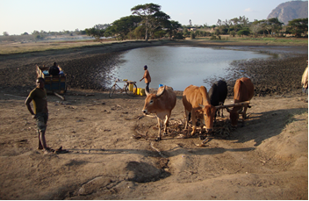
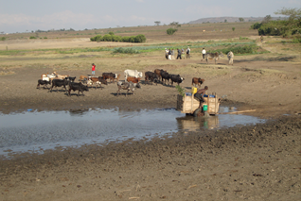
Figure 1: Retreating Malimbika Dam in Gairo District due to high siltation rates resulting from poor rangeland management thereby threatening its existence (July, 2012).

For decades bush clearing, water spreading and reseeding using improved pasture seeds (grass and legumes) have been amongst the proposed rangeland improvement practices to reduce the scarcity of feed during the dry season in communal semi-arid grazing lands. However, these technologies have not been adopted by a wider part of agro-pastoralists in the country. The low adoption rate is attributed to a number of barriers including culture, land tenure, methods used to transfer proven technology and practices, contradictory agricultural policies and unavailability of pasture seeds. In other words, the problem may not be the absence of the relevant technologies for the rehabilitation of these degraded semi-arid rangelands, but rather processes that are used to foster adoption and wise use of these technologies by the wider part of the targeted communities. For harnessing sustainable technology transfer, uptake and use towards sustainable range rehabilitation and management right approaches need to be enhanced, as well as innovated accordingly.
Description of the Experience
An overview of the project where the experience emanated
Experiences on challenges for rehabilitating degraded semi-arid rangelands using the traditional agricultural extension methods were gathered through working with agro-pastoral communities of Gairo District. The activities were undertaken as part of three years (2012 -2015) programme on Climate Change Impacts, Adaptation and Mitigation (CCIAM) under the project titled “Rangeland management strategies for adaptation and mitigating climatic change in agro-pastoral communities in Gairo District, Tanzania.” The project aimed at testing innovative strategies for rehabilitating degraded semi-arid rangelands of Gairo District. In particular, the strategies focused on enhancing forage and water resources availability for improving range productivity.

The idea of the project arose from the negative effects of climate change to the pastoral and agro-pastoral communities in the area. The precarious effects of climate change in the area include erratic rainfall, prolonged and frequent droughts resulting to decline in crop yields and frequent crop failures. Moreover, increasing human population coupled with increased number of livestock has been causing more pressure to the grazing lands through agricultural expansion and overgrazing to meet food demands. In addition, this has increased incidences of pastoral encroachments into forest reserves and catchment areas with eventual degradation of these resources. The agro-pastoral and pastoral communities were noticed to migrate to natural forest and woodlands during the dry the season in search of water and pasture. The project aimed at reducing these practices that are known to have negative consequences to both current and future generations through aggravating conflicts between herders and other land users, increasing forest loss, soil degradation and accelerating greenhouses gases emission.

Resistance from local communities in one of the project villages
The project kick-started in July 2012 with a stakeholders’ inception workshop, which involved participants from Gairo District Council, Ward councilors, Researchers, Village leaders, and Leaders of village environmental/forest/livestock keepers committees from the prospective project villages. At the inception workshop project villages were selected based on preset criteria that included a village having at least 50% of the households keeping livestock and having land(s) reserved for grazing. Three villages namely Mkalama, Kinyolisi and Leshata were selected for project implementation (Figure 2).

The inception workshop was followed by an inventory of socio-economic and range resources in the 3 project villages. During this activity the project team started to notice resistances from some community members at Mkalama village. Amongst the three (3) project villages the grazing land for Mkalama village was the smallest and highly degraded, and with broadly distributed soil bare patches. In addition, soil erosion features including rills and gullies were very prominent at Mkalama grazing fields (Figure 3), this was thought to be caused by poor vegetation cover.
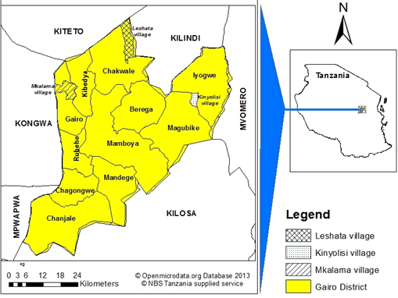
Figure 2: A map of Gairo District showing the three project villages

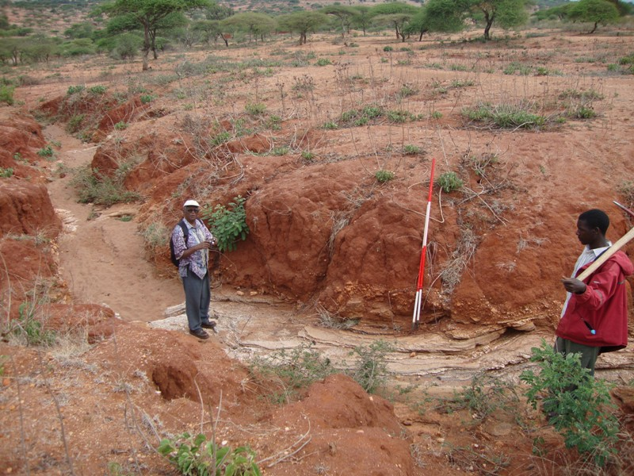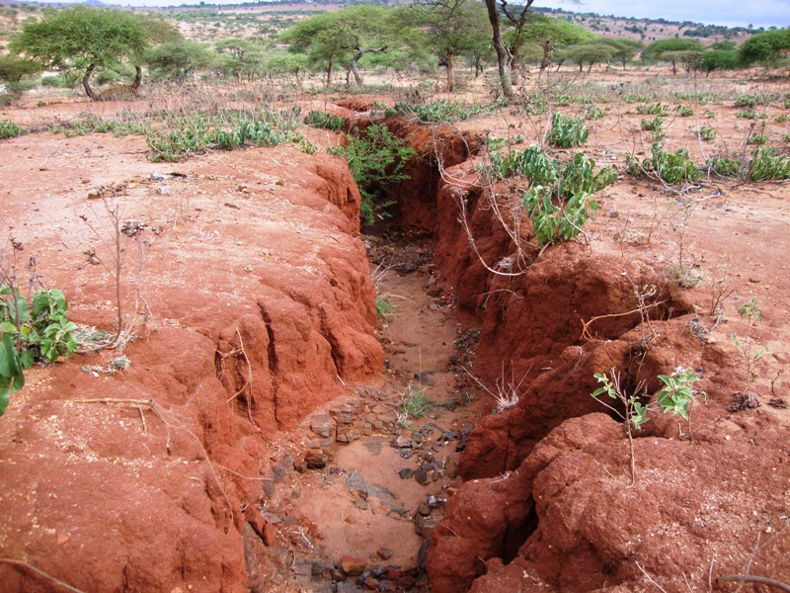
Figure 3: Both photos show degraded rangelands at Mkalama village, Gairo District.

It was further learnt that most of the livestock mainly cattle that are owned by the Mkalama inhabitants were being grazed in neighboring villages. It was also noticed that Mkalama village residents were very sensitive to land issues and that was attributed to its close proximity to Gairo Township. In which, during household surveys it was observed that some community members had fear of being dispossessed of their land without their consent for further township development.
Nonetheless, during the household surveys the researchers faced resistances from some community members claiming that the village government intended to sell part of their grazing land to Sokoine University of Agriculture. Following clarifications from the researchers and village leaders the exercise was successfully completed.
Soon after household surveys the project conducted a range inventory survey aiming at understanding the condition or health of the rangelands. This was done by measuring and assessing various vegetation and soil properties. Again, resistance arose from some residents of Mkalama village who did not want researchers to work in their grazing fields. This resistance was not observed in the other two project villages. To mitigate the resistance from villagers in Mkalama, researchers and village government officials organized a meeting with the community members where the aims of the project were further clarified. . The meeting also offered a room for the different conflicting parties with regard to use and management of Mkalama village grazing lands to discuss their differences whilst researchers facilitated towards common vision. The shared vision was a common agreement that Mkalama rangelands are degraded and joint efforts are needed towards their rehabilitation.

Establishment of Range Rehabilitation Demonstration Sites and Facilitation of Training of Trainers (ToT) within the Project Villages
After completing the range resources inventory, which was done in close collaboration with the community members, the research team established demonstrations plots for range improvement practices. The criteria for locating sites for establishing the demonstration sites included an area that is easily accessible and it is within the vicinity of most community members. In addition, the demonstration sites were supposed to be located to an area where the soil, vegetation and topographical conditions are representable of the respective village grazing areas. The demonstration plots were also designed to serve as experimental areas for testing various rangeland rehabilitation strategies. The plots were established by demarcating an area of approximately 0.5 ha within the grazed field of each village. The demarcated area was then fenced using locally available materials, mainly branches of thorny bushes and trees. The fence was deemed important to ensure that the demonstration plots are free from grazing and other human disturbances.

Within the demonstration plots, sub-plots were demarcated, within which various rain water harvesting and spreading techniques were designed, which included pitting and contour furrows. Also, bush control, weeding, reseeding using a forage grass (Cenchrus ciliaris) and a legume (Stylosanthes scabra) were conducted in the demonstration plots during the wet season – March, 2013. The community members, village leaders and livestock field officers for each project village were actively involved in all activities including site selection, land preparations and sowing (Figure 4 (i) and (ii)) Moreover, the researchers provided an explanation for each practice that was introduced.

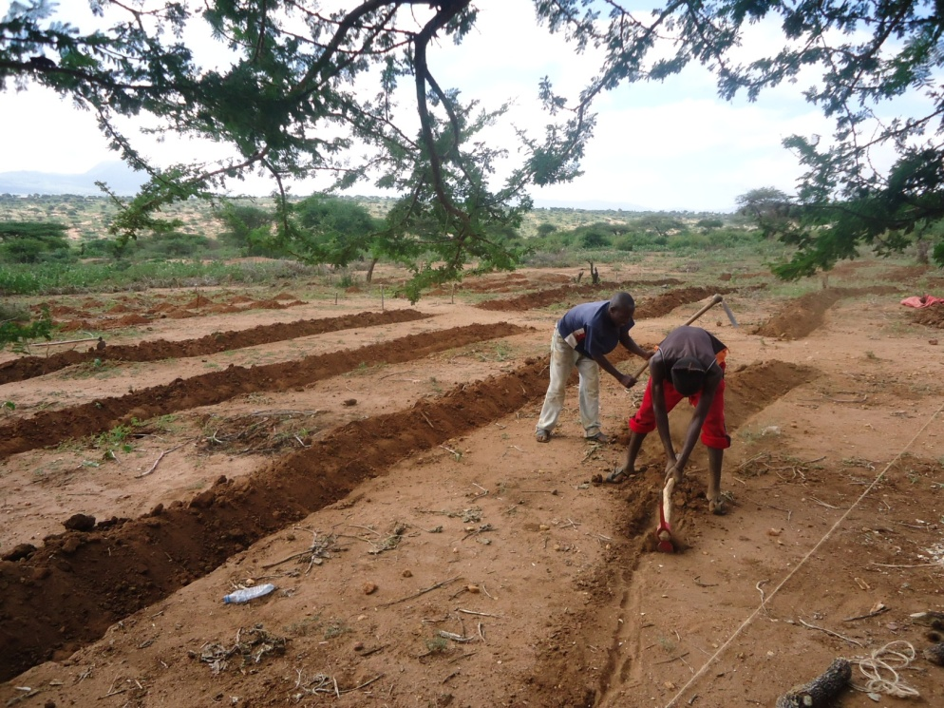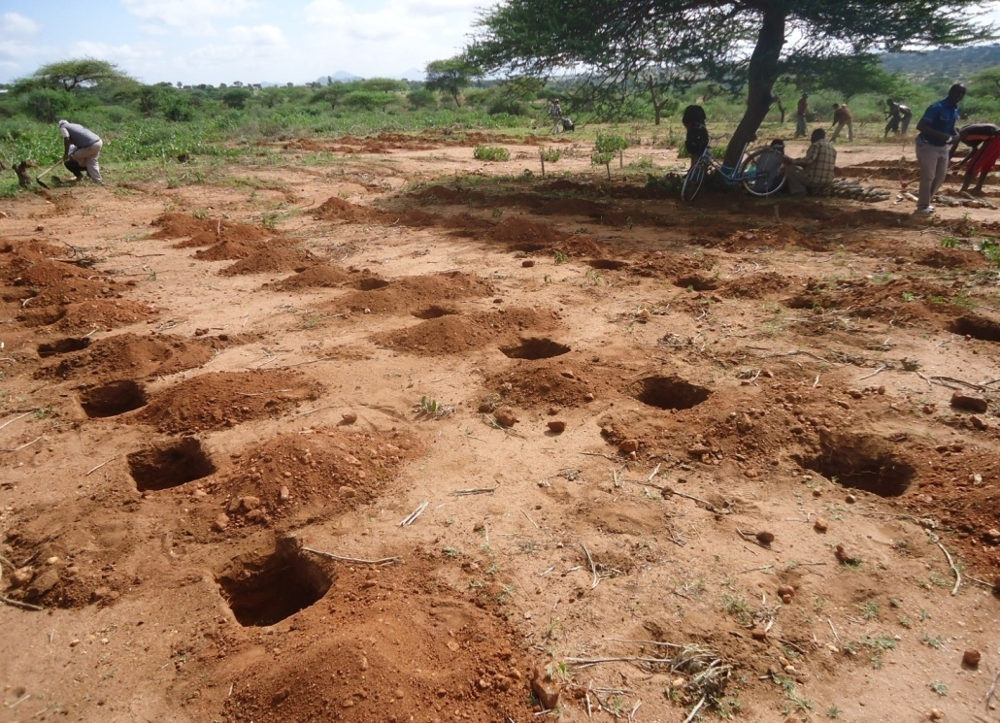
Figure 4 (i): Contouring for soil and water conservation at the Mkalama village rangeland improvement demonstration site (February, 2013). | Figure 4 (ii) Pitting for soil and water conservation at the Mkalama village rangeland improvement demonstration site (February, 2013).

In order to enhance the learning process a training of trainers (TOT) method was employed whereby, community members who participated in project activities were encouraged to share the knowledge to other community members. About 15 individuals per village, mostly male were trained and only few females were involved due to low turn up. Low turn up of females was later revealed that in Kaguru traditions livestock grazing and even milking is considered to be male work, so as range management. The responsibility of maintaining the demonstration plot was vested on community members those one that were trained by the project (TOTs)under the supervision of their livestock field officers. In which, there was a general agreement that each TOT members should train at least three (3) new individuals. Together with practicing the rain water harvesting and spreading practices in their farms whilst sensitizing others. The research team promised to come back at the end of rainy season to hold field days at the demonstration plots. The field days aimed at reaching the Majority of community members including engage more females and youths. Efforts were made to facilitate village leaders and extension officers to ensure that most villagers are informed and motivated to attend the rangeland field days.

Negative Experience with Range Rehabilitation Demonstration Sites

Late in May, 2013 the research team went back to the project villages to assess progress of the demonstration plots, hold filed days and collecting data for an evaluative study. To the dismay of the research team the demonstration plots at Leshata and Kinyolisi village were already vandalized; the fence was broken and livestock were deliberately grazed inside the plots. The poles which had been erected to demarcate the plots boundaries were uprooted and thrown away. At Kinyolisi village even the signboard that was erected by the project to show the direction and location of the demonstration was broken and thrown away. A further surprise was observed in this village – the presence of a pitfall and a charcoal kiln that were adjacent to the demonstration sites at Kinyolisi village. A thorough informal discussion was done between researchers and community members, and it was revealed that there were competing rangeland resource use interests. Whereby, it was learnt that vandalism of demonstration sites was supported by some influential community members who were running illegal charcoal making and timber harvesting businesses within the village grazing areas. Lack of strict bylaws to prevent village community members from farming and opening new farms in reserved grazing areas was another obstacle. Community members were asked whether they were willing to continue with the project or not and most said they are willing and promised that they would take actions to prevent those who were dragging back range rehabilitation efforts in their village through reporting them to respective authorities. In addition, during the discussion with the villagers it was learnt that already, there were existing laws and bylaws to prevent such acts.

Given the failures at Kinyolisi and Leshata villages, to the great surprise of researchers the demonstration plot at Mkalama village was found to be intact despite earlier resistances. Both the introduced and natural grasses inside the demonstrate site had grown well and there was the adjacent grazing areas outside it were still degraded. The demonstration site had higher grass cover compared to the adjacent continuous grazed area which was almost bare (Figures 5(i) and 5(ii)). The dominant vegetative cover was an invasive plant called Ipomea kituensis locally known as “Mahata,” which was not eaten by grazing animals. Informal discussion with the community members revealed that the success of the demonstration plot at Mkalama village despite earlier resistances was due to the village environmental committee chairperson who had worked in close collaboration with a villager residing near the demonstration plot, who provided informal guarding service of the plot.
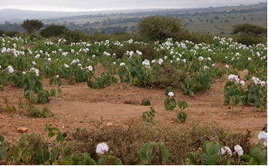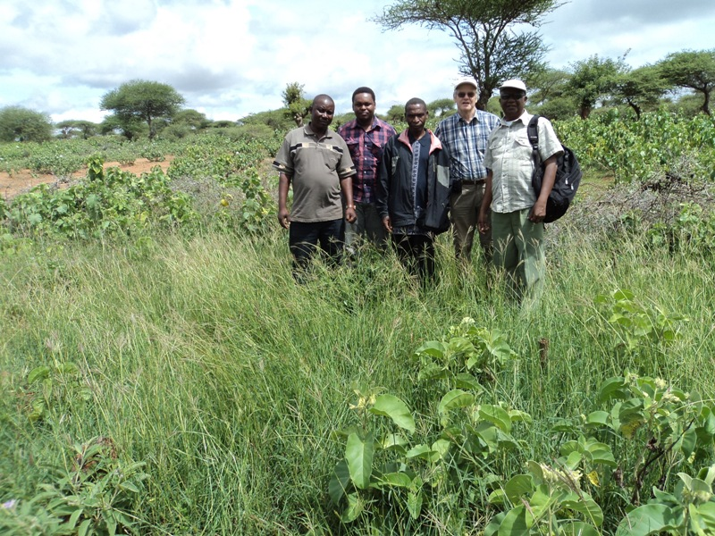
Figure 5 (i) Grazing field without soil and water conservation adjacent to FFS plot in Mkalama village; June 2013 | Figure 5 (ii) Area inside FFS plot showing improved grass cover after adopting soil and water conservation technologies in Mkalama village; June 2013
The Home Pasture Nursery (HPN): An Innovative Method for enhancing adoption of rangeland rehabilitation practices in semi-arid areas
Following the failure of demonstration sites to bring about desired change of imparting rangeland rehabilitation skills and knowledge to the agro-pastoral communities of Gairo, a new approach was innovated out of necessity. The Home pasture nursery (HPN) (Figures 7 and 8) for multiplication of pasture planting material was considered and introduced as an alternative to overcome the barriers towards adopting range rehabilitation practices. The reason behind trusting the new approach (HPN) would be accepted by farmers arose following a farm visit to a farmer at Gairo who has been receiving technical advice for range rehabilitation from the project members.

One of the project member recalled training the farmer on HPN way back in April 2012. This farmer was provided with a few Cencrus ciliairis tillers, which he planted in a 1.5 m x 6m sunken seedbed [Figures 7(i) and 7(ii)). The sunken seedbed was prepared like a contour furrow of around 50cm deep. In the semi-arid rangelands with unreliable and highly variable rainfall that is rarely 500 mm annually sunken a seedbed improves moisture availability to planted crops. The furrow was dug in such a way that the 15cm topsoil was heaped in one side and the subsoil was heaped on the other side (Figure 6). Then dry farmyard manure was added to the furrow up to around 10 cm and then the topsoil was returned back. Manure improves rain water holding capacity in these dry land soils. Manure and top soil were thoroughly mixed followed by planting the grass tillers (Figure 6).
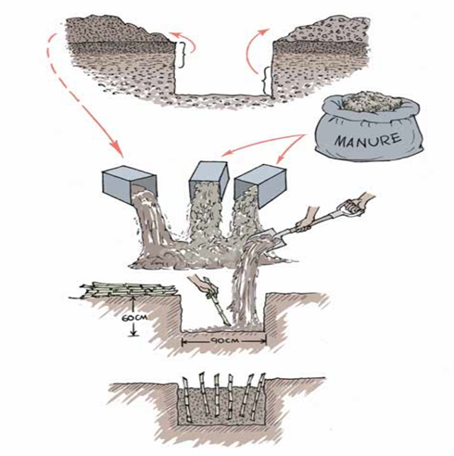

Figure 6: Farrow preparation and manure rations for planting of C. ciliaris through sunken seedbed or “Tumbukiza method” (Source: East Africa Dairy Development (EADD) Project, 2012)
The planted grass tillers were watered immediately after planting and watering continued until there was adequate rainfall. By May 2013 when the researchers visited the farmer it was noticed that from the initial HPN he has expanded the planted area to approximately 0.5 ha of C. ciliaris. At that time the farmer was planning to plant around 2 ha in the next season. Following the success of this farmer, the project team decided that there is a need to run FFS parallel with HPN to accelerate the adoption of the introduced knowledge and practices. The researchers working in close collaboration with livestock extension officers introduced the HPN model to one agro-pastoral household in Jan 2014 and by March the same year 30 households had already have adopted the innovation and established their won HPNs.

In late May 2014 (end of wet season), a farmers training workshop was organized, which was preceded by visits to individual farmers who has adopted HPN, to monitor progress of their plots. During the visits, it was noticed most plots were performing well especially those at Mkalama village. In Kinyolisi village, however, there was no adoption and it was observed that agro-pastoral household where the demonstration HPN was established there was no weeding and when asked his response was “I thought that because grasses are natural plants cannot be harmed with fellow natural plants (weeds), weeds just harm food crops and not forage.” Another farmer in Leshata village did not control animals from grazing at his HPN and when he was asked, his response was “I thought that this grass grows underground and even the seeds are produced underground and you told us that this grass tolerate both grazing and drought.” Out of these two unsuccessful farmers it was learnt the culture of growing and managing pasture was something completely new to most agro-pastoral community members in the project villages and support for further knowledge and practical skills was deemed necessary.

The farmers who have adopted the HPN together with village leaders were invited to a training workshop that was held at the farm of a successful farmer in Gairo. Most farmers were inspired seeing that someone was able to establish 0.5 ha of pasture out of a small pasture nursery plot of 1.5m x 6m within two rain seasons. At the end of the workshop the farmers promised to spread the knowledge and increase the number of HPN in their villages, as well as establishment of pasture farms.

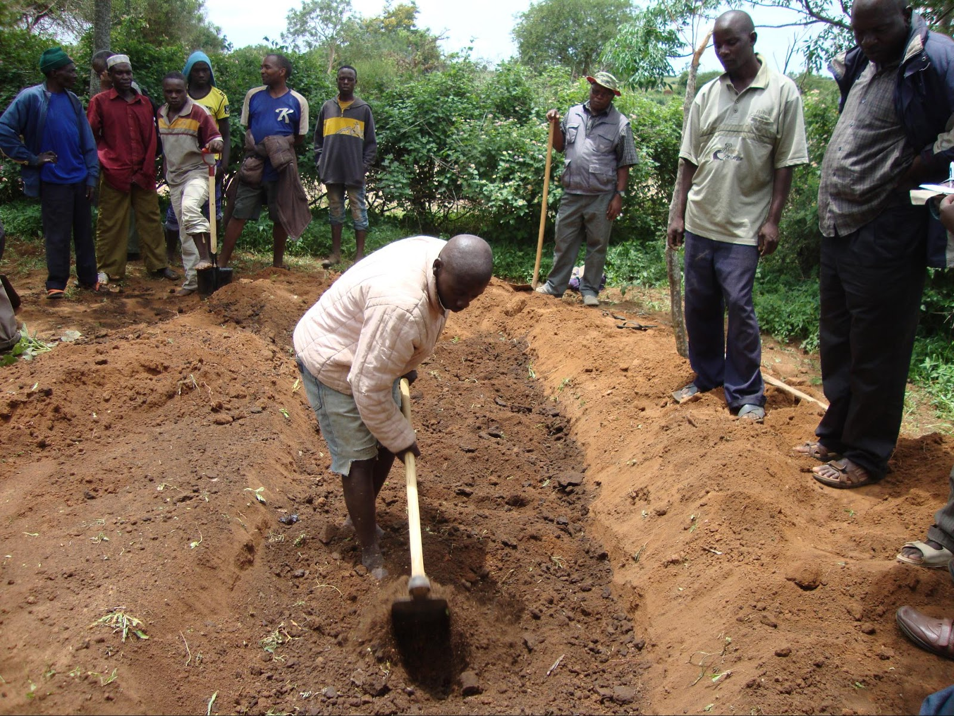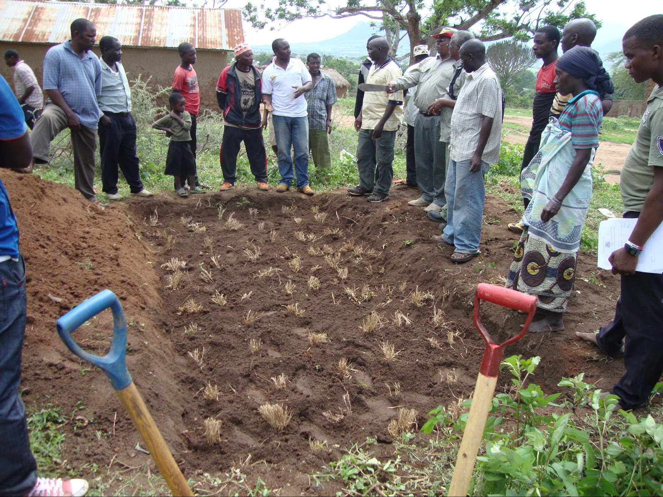
Figure 7. (i) Preparation of home pasture nursery by sunken bed technique | Figure 7 (ii) Planted C. Ciliaris tillers after thorough mixing of topsoil with manure

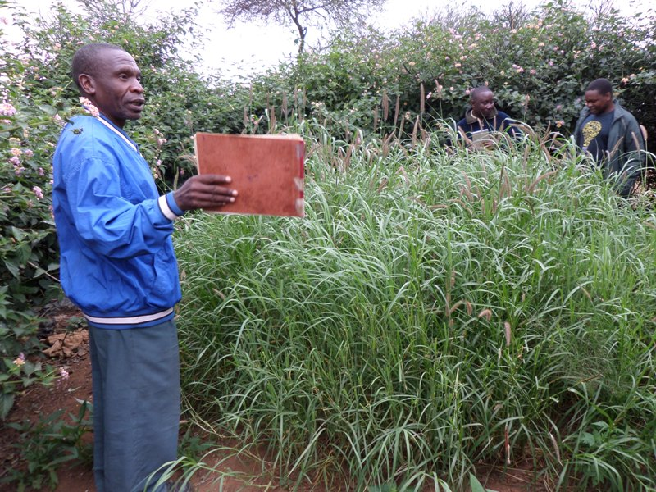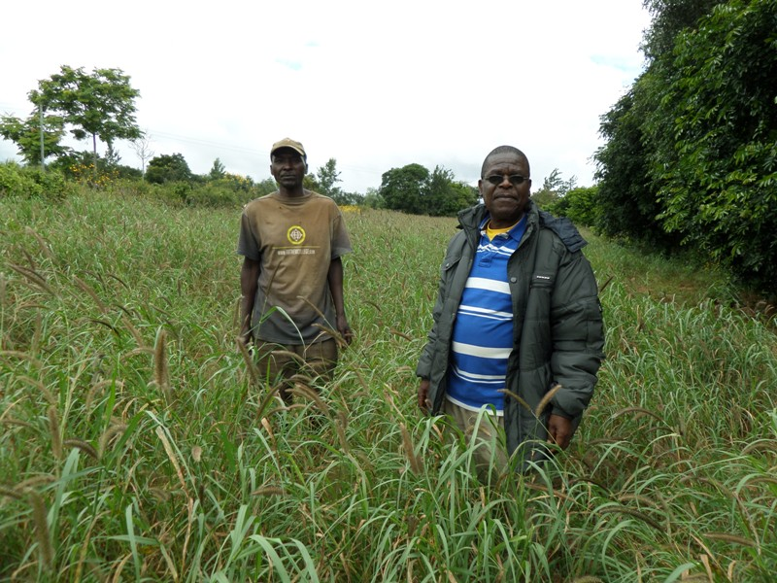
Figure 8. (i) Home pasture nursery with fully grown C. ciliaris at Mkalama village | Figure 8 (ii) A well established C. cilaris pasture field of about 2 acres

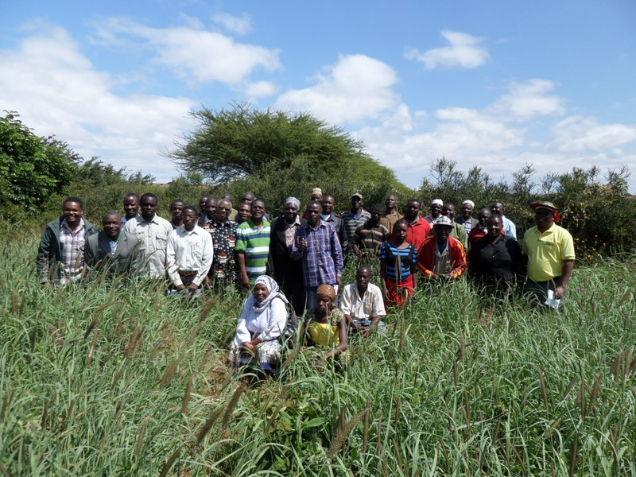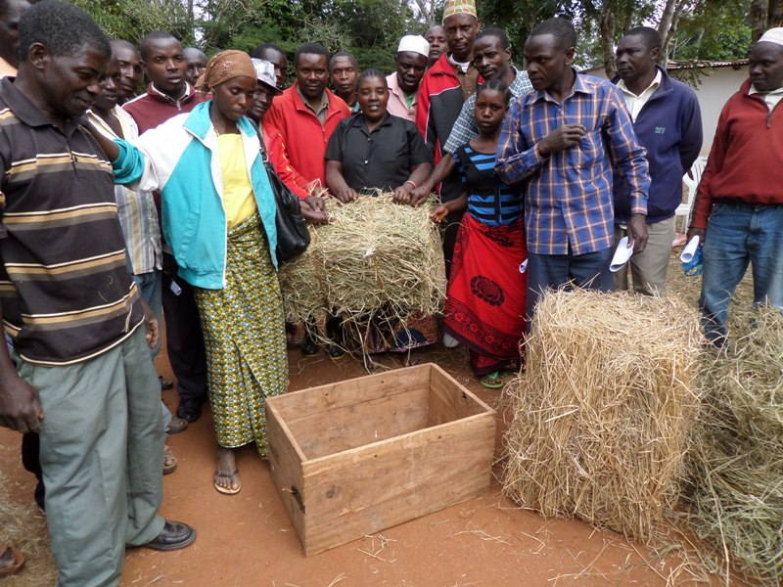
Figure 9. (i) Training farmers on home pasture nursery for upscaling the technology | Figure 9. (ii) Training farmers on pasture handling from home pasture nurseries

Lesson learnt from FFS failures and promotion of the home pasture nursery model in Gairo District
- Lack of strong institutional framework leads to under-participation in communal based activities.
- Increased corruptions and resources squandering among community leaders demotivate community member from active participation in development and environmental conservation initiatives.
- Adoption of new innovation is easier when farmers learn by seeing from fellow farmers than being taught by external researchers.
- Home pasture nursery using sunken bed techniques is superior compared to other soil and moisture conservation methods because of their good capacity to store moisture under semi-arid conditions

RECOMMENDATIONS
- HPN approach should be promoted in semi-arid rangelands because it can be easily adopted by individual agro-pastoralists and pastoralists at their homesteads (high sense of ownership). HPNs offer an opportunity for higher engagement of women, youths and even kids. This is based on the fact that the practice is simple, area occupied is small and it is easier even for the household members to water the HPNs in case of rain failure.
- Semi-arid rangeland rehabilitation initiatives should exploit great potential HPNs for increasing local production of pasture seeds and vegetative propagation materials that can be planted either in private or communal rangelands. Moreover, when there are adequate seeds that are locally produced it will be easier to rehabilitate degraded communal rangelands through deferment and rotational grazing to allow bush control, reseeding and over-sowing practices.
- There is need to upscale and out-scale the HPN method to other semi-arid areas through training of various stakeholders including agricultural and livestock extension officers who are better positioned to impart the skills to wider part of agro-pastoral and pastoral communities in Tanzania and elsewhere.

ACKNOWLEDGEMENT

The authors would like to extend their gratitude to the generous support of the Tanzania Norwegian Embassy under the Climate Change Impacts, Adaptation and Mitigation (CCIAM) Programme for funding the project titled “Rangeland management strategies for adaptation and mitigating climatic change in agro-pastoral communities in Gairo District, Tanzania.” which enabled us to gather this field experience.

